Christian Character
Barry G. Johnson, Sr.
Church of Christ, Brookfield
Christian Character
7 Ways to Increase Your Faith
Barry G. Johnson, Sr. / www.barrygjohnsonsr.com
Christian Character / Faith; Mature; Increase; Christian; Character / Luke 17:5
There are several things we can do to increase our faith.
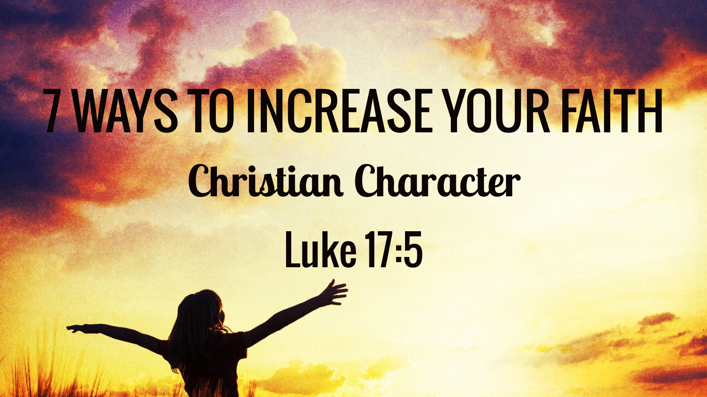
Luke 17:5 ESV
⁵ The apostles said to the Lord, “Increase our faith!”

I. Faith
Phil. 2:5
A. thinking must be discarded. It is displeasing to God.
B. Fill your mind with thoughts of and assurance. Think faith thoughts—thoughts about God’s presence and good will toward others.

II. Faith
John 5:24
A. We listen to many voices—voices of newscasters (who relay to us mostly bad news), voices of , doubts.
B. Faith is increased as we listen to the good, , and positive.
C. Listen to the voice of God. He speaks when we become and receptive (Ps. 46:10).

III. Faith
Heb. 12:2
A. Many have their eyes on things—they desire to obtain houses, land, automobiles, money.
B. Christians must keep their eyes on Christ, they must be concerned with giving Him place in their lives, and winning the lost.

IV. Faith
Ps. 105:2
A. Many women talk about , styles, neighbors, friends.
B. Many men talk about the news, , cars, houses, jobs.
C. All Christians should talk about the things of God—His , love, peace, blessings.

V. Your Faith
James 2:18
A. faith is effective.
B. Your faith grows as you it. Work your faith, then it works for you.
C. Jesus condemned the Pharisees when He said, “For they say and ” (Matt. 23:3). He wants workers, not talkers.

VI. By Faith
2 Cor. 5:7
A. Walk by faith in daily —in work, and in play.
B. Walk by faith in the hour of and temptation.
C. Walk by faith when the is shining.
D. Walking by faith our faith and brings God’s approval.

VII. Faith
Putting it all together

God’s Invitation and Plan of Salvation

Hear - Romans 10:17

Believe and Confess - Romans 10:9-10

Repent - Luke 13:3

Be Baptized - Romans 6:3-4

Remain Faithful - Revelation 2:10

New to the Faith
Take a First Principles Class
Have you fallen away from Faith
Ask about being Restored
My Decision Today
I would like to be baptized today
I would like to renew my life to Christ
I would like to learn more about Jesus and the Bible

Questions: What are my next steps?
Come forward to be baptized
Request a Bible Study to learn more
Attend Bible Class to grow and mature
Find a place to serve others
Apply today’s lesson to my life

