Barry G. Johnson, Sr. / www.bgjsr22.com
A Witness for Jesus / Evil; Problem Of Evil; Evil-speaking; Evildoer / Psalm 118:6–7
Scripture outlines several ways in which believers should respond to evil.
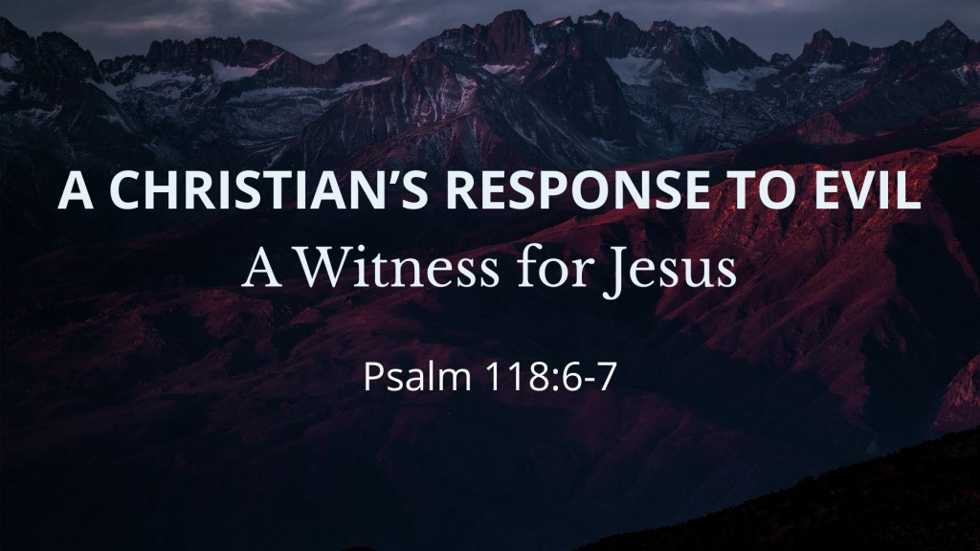
Psalm 118:6–7 ESV
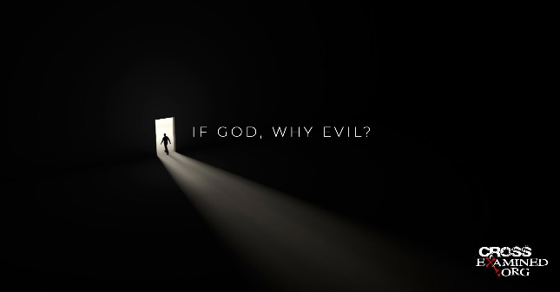
The Lord is on my side; I will not fear.
What can man do to me?
The Lord is on my side as my helper;
I shall look in triumph on those who hate me.
click graphic for presentation 1 Blog

Evil is to be avoided
1 Thessalonians 5:22 ESV
Abstain from every form of evil.

Evil is to be hated
Proverbs 8:13 ESV
The fear of the Lord is hatred of evil.
Pride and arrogance and the way of evil
and perverted speech I hate.

Evil is to be rebuked
Matthew 16:23 ESV
But he turned and said to Peter, “Get behind me, Satan! You are a hindrance to me. For you are not setting your mind on the things of God, but on the things of man.”

Evil is to be resisted
Ephesians 6:11 ESV
Put on the whole armor of God, that you may be able to stand against the schemes of the devil.

Evil is to be repaid with good
Luke 6:35 ESV
But love your enemies, and do good, and lend, expecting nothing in return, and your reward will be great, and you will be sons of the Most High, for he is kind to the ungrateful and the evil.
Romans 12:20–21 ESV
To the contrary, “if your enemy is hungry, feed him; if he is thirsty, give him something to drink; for by so doing you will heap burning coals on his head.” Do not be overcome by evil, but overcome evil with good.

Believers should pray in response to evil
Acts 4:29 ESV
And now, Lord, look upon their threats and grant to your servants to continue to speak your word with all boldness,

Believers should trust God in the face of evil
Psalm 23:4 ESV
Even though I walk through the valley of the shadow of death,
I will fear no evil,
for you are with me;
your rod and your staff,
they comfort me.
Matthew 26:39 ESV
And going a little farther he fell on his face and prayed, saying, “My Father, if it be possible, let this cup pass from me; nevertheless, not as I will, but as you will.”
Daniel 3:17–18 ESV
If this be so, our God whom we serve is able to deliver us from the burning fiery furnace, and he will deliver us out of your hand, O king. But if not, be it known to you, O king, that we will not serve your gods or worship the golden image that you have set up.”

God’s Plan for Saving Man
