Barry G. Johnson, Sr. / www.barrygjohnsonsr.com
Christian Character / Faith; Hope; Love; Boldness; Suffering; Evangelism; Godliness / 1 Peter 1:3–5
Hope gives believers confidence and reassurance in this present life, allowing them to lead effective lives for God. It also reassures them of the reality of eternal life, allowing them to face difficulties with confidence.
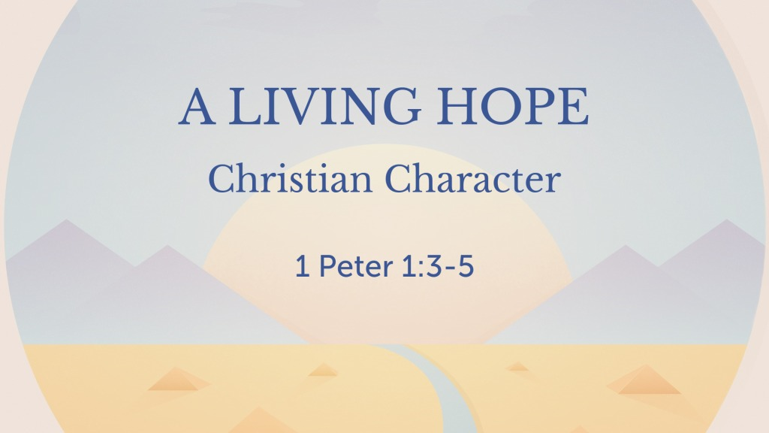
1 Peter 1:3–5 (ESV)
³ Blessed be the God and Father of our Lord Jesus Christ! According to his great mercy, he has caused us to be born again to a living hope through the resurrection of Jesus Christ from the dead, ⁴ to an inheritance that is imperishable, undefiled, and unfading, kept in heaven for you, ⁵ who by God’s power are being guarded through faith for a salvation ready to be revealed in the last time.

Hope leads to more effective Christian living and witness

A. Hope encourages believers to be bold
2 Corinthians 3:12

B. Hope encourages believers to evangelize
1 Peter 3:15

C. Hope leads to godly living
1 John 3:2
Psalm 25:21; Hebrews 6:1-12
Figure 1 Check out my blog from April 7, 2014
“What I Wish for You” (click on graphic to view)

D. Hope equips believers for spiritual warfare
1 Thessalonians 5:8

E. Hope enables believers to face suffering with confidence
Romans 5:3-5
Psalm 22:24; 147:11; Philippians 1:20

God’s Invitation and Plan of Salvation

Hear - Romans 10:17

Believe and Confess - Romans 10:9-10

Repent - Luke 13:3

Be Baptized - Romans 6:3-4

Remain Faithful - Revelation 2:10

New to the Faith?
• First Principles
Have you fallen away from Faith?
• Need to be Restored
My Decision Today
• I would like to be baptized today
• I would like to renew my life to Christ
• I would like to learn more about Jesus and the Bible
Questions: What are my next steps?
• Come forward to be baptized
• Request a Bible Study to learn more
• Attend Bible Class to grow and mature
• Find a place to serve others
• Apply today’s lesson to my life

