Thesis:
Scripture does not exclude ignorance of God or His commands.

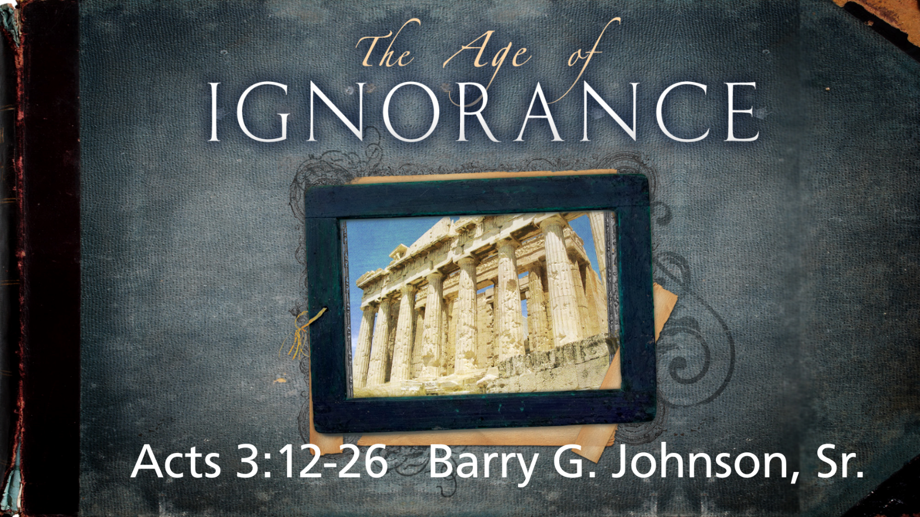

I. The Spirit Empowers The Church for Witness (1:1–2:47)
II. The Apostles Witness to the Jews In Jerusalem (3:1–5:42)
1. Peter’s Healing a Lame Beggar (3:1–11)
2. Peter’s Sermon from Solomon’s Colonnade (3:12–26)

I. Acting in Ignorance of God is inexcusable

A. God is made known through creation
Romans 1:18–20 ESV
For the wrath of God is revealed from heaven against all ungodliness and unrighteousness of men, who by their unrighteousness suppress the truth. For what can be known about God is plain to them, because God has shown it to them. For his invisible attributes, namely, his eternal power and divine nature, have been clearly perceived, ever since the creation of the world, in the things that have been made. So they are without excuse.
See also Ps 19:1–4; Ac 14:17; Ac 17:24–28; Ro 2:14–15

B. God revealed himself to Israel
Nehemiah 9:13–14 ESV
You came down on Mount Sinai and spoke with them from heaven and gave them right rules and true laws, good statutes and commandments, and you made known to them your holy Sabbath and commanded them commandments and statutes and a law by Moses your servant.
See also Ex 19:10–11; Ex 19:16–19; Ps 103:7; Ps 147:19–20; Eze 20:5

II. Acting in Ignorance of God is linked to sin and rebellion

A. Among the Gentiles
Ephesians 4:18–19 ESV
They are darkened in their understanding, alienated from the life of God because of the ignorance that is in them, due to their hardness of heart. They have become callous and have given themselves up to sensuality, greedy to practice every kind of impurity.
See also Ex 5:2; Jn 4:22; Ac 17:23; 1 Th 4:3–5

B. In Israel
Isaiah 1:2–3 ESV
Hear, O heavens, and give ear, O earth;
for the LORD has spoken:
“Children have I reared and brought up,
but they have rebelled against me.
The ox knows its owner,
and the donkey its master’s crib,
but Israel does not know,
my people do not understand.”
See also Is 56:10; Je 2:8–9; Je 4:22; Je 5:4–5; Je 8:7–12; Je 9:6; Je 10:21; Ho 4:1; Ho 4:6; Am 3:10

III. Acting in Ignorance of God in the ministry of Jesus Christ

A. Among the religious leaders
John 8:13–19 ESV
So the Pharisees said to him, “You are bearing witness about yourself; your testimony is not true.” Jesus answered, “Even if I do bear witness about myself, my testimony is true, for I know where I came from and where I am going, but you do not know where I come from or where I am going. You judge according to the flesh; I judge no one. Yet even if I do judge, my judgment is true, for it is not I alone who judge, but I and the Father who sent me. In your Law it is written that the testimony of two people is true. I am the one who bears witness about myself, and the Father who sent me bears witness about me.” They said to him therefore, “Where is your Father?” Jesus answered, “You know neither me nor my Father. If you knew me, you would know my Father also.”
See also Mt 22:23–32; Jn 8:54–55; Jn 16:2–3

B. Among his disciples
John 14:8–11 ESV
Philip said to him, “Lord, show us the Father, and it is enough for us.” Jesus said to him, “Have I been with you so long, and you still do not know me, Philip? Whoever has seen me has seen the Father. How can you say, ‘Show us the Father’? Do you not believe that I am in the Father and the Father is in me? The words that I say to you I do not speak on my own authority, but the Father who dwells in me does his works. Believe me that I am in the Father and the Father is in me, or else believe on account of the works themselves.
See also Lk 18:31–34; Jn 14:5–7

IV. God is not ignorant of human sin and motives
Genesis 6:5 (ESV)
⁵ The Lord saw that the wickedness of man was great in the earth, and that every intention of the thoughts of his heart was only evil continually.
Hebrews 4:13 (ESV)
¹³ And no creature is hidden from his sight, but all are naked and exposed to the eyes of him to whom we must give account.
See also Ex 3:7; Job 28:12–28; Ps 139:1–6; Ps 147:5; Eze 11:5; Mt 6:8; Ac 1:24

V. Human ignorance of sin and the revelation of God

A. The fall brought knowledge of sin
Genesis 3:22 ESV
Then the LORD God said, “Behold, the man has become like one of us in knowing good and evil. Now, lest he reach out his hand and take also of the tree of life and eat, and live forever—”
See also Ge 3:4–7

B. The OT law exposed the nature of sin
Romans 7:7 ESV
What then shall we say? That the law is sin? By no means! Yet if it had not been for the law, I would not have known sin. For I would not have known what it is to covet if the law had not said, “You shall not covet.”
See also Ro 3:20; Ro 4:15; Ro 5:13

VI. Human ignorance does not excuse sin

A. By individuals
The law made provision for atonement of sins committed as a result of ignorance.
Leviticus 5:17–19 (ESV)
¹⁷ “If anyone sins, doing any of the things that by the Lord’s commandments ought not to be done, though he did not know it, then realizes his guilt, he shall bear his iniquity. ¹⁸ He shall bring to the priest a ram without blemish out of the flock, or its equivalent, for a guilt offering, and the priest shall make atonement for him for the mistake that he made unintentionally, and he shall be forgiven. ¹⁹ It is a guilt offering; he has indeed incurred guilt before the Lord.”
See also Le 4:27–35; Nu 15:27–29; Eze 45:20

B. By the nation
Leviticus 4:13–21 (ESV)
¹³ “If the whole congregation of Israel sins unintentionally and the thing is hidden from the eyes of the assembly, and they do any one of the things that by the Lord’s commandments ought not to be done, and they realize their guilt, ¹⁴ when the sin which they have committed becomes known, the assembly shall offer a bull from the herd for a sin offering and bring it in front of the tent of meeting. ¹⁵ And the elders of the congregation shall lay their hands on the head of the bull before the Lord, and the bull shall be killed before the Lord. ¹⁶ Then the anointed priest shall bring some of the blood of the bull into the tent of meeting, ¹⁷ and the priest shall dip his finger in the blood and sprinkle it seven times before the Lord in front of the veil. ¹⁸ And he shall put some of the blood on the horns of the altar that is in the tent of meeting before the Lord, and the rest of the blood he shall pour out at the base of the altar of burnt offering that is at the entrance of the tent of meeting. ¹⁹ And all its fat he shall take from it and burn on the altar. ²⁰ Thus shall he do with the bull. As he did with the bull of the sin offering, so shall he do with this. And the priest shall make atonement for them, and they shall be forgiven. ²¹ And he shall carry the bull outside the camp and burn it up as he burned the first bull; it is the sin offering for the assembly.
See also Nu 15:22–26; Heb 9:7

C. By leaders
Leviticus 4:22–26 ESV
“When a leader sins, doing unintentionally any one of all the things that by the commandments of the LORD his God ought not to be done, and realizes his guilt, or the sin which he has committed is made known to him, he shall bring as his offering a goat, a male without blemish, and shall lay his hand on the head of the goat and kill it in the place where they kill the burnt offering before the LORD; it is a sin offering. Then the priest shall take some of the blood of the sin offering with his finger and put it on the horns of the altar of burnt offering and pour out the rest of its blood at the base of the altar of burnt offering. And all its fat he shall burn on the altar, like the fat of the sacrifice of peace offerings. So the priest shall make atonement for him for his sin, and he shall be forgiven.
See also Le 4:3–12

VII. Ignorance of God and salvation

A. There is no salvation outside Jesus Christ
Acts 4:12 ESV
And there is salvation in no one else, for there is no other name under heaven given among men by which we must be saved.”
See also Jn 14:6; 1 Ti 2:5–6

B. Believers have a responsibility to remove ignorance of the gospel
Romans 10:14–17 ESV
How then will they call on him in whom they have not believed? And how are they to believe in him of whom they have never heard? And how are they to hear without someone preaching? And how are they to preach unless they are sent? As it is written, “How beautiful are the feet of those who preach the good news!” But they have not all obeyed the gospel. For Isaiah says, “Lord, who has believed what he has heard from us?” So faith comes from hearing, and hearing through the word of Christ.
See also Mt 28:19–20

VIII. Ignorance and God’s judgment

A. The justice of God in salvation
Genesis 18:25 ESV
Far be it from you to do such a thing, to put the righteous to death with the wicked, so that the righteous fare as the wicked! Far be that from you! Shall not the Judge of all the earth do what is just?”
See also Dt 32:4; Ne 9:33; Pr 24:12; Da 4:37; Lk 12:47–48

B. God’s judgment falls on all who do not know him
2 Thessalonians 1:8–10 ESV
in flaming fire, inflicting vengeance on those who do not know God and on those who do not obey the gospel of our Lord Jesus. They will suffer the punishment of eternal destruction, away from the presence of the Lord and from the glory of his might, when he comes on that day to be glorified in his saints, and to be marveled at among all who have believed, because our testimony to you was believed.
See also Ps 79:6; Je 10:25; Ro 2:8

C. God’s judgment falls severely on those who choose to disobey him

On those who have heard the gospel:
Acts 17:29–31 ESV
Being then God’s offspring, we ought not to think that the divine being is like gold or silver or stone, an image formed by the art and imagination of man. The times of ignorance God overlooked, but now he commands all people everywhere to repent, because he has fixed a day on which he will judge the world in righteousness by a man whom he has appointed; and of this he has given assurance to all by raising him from the dead.”
Hebrews 2:2–3 ESV
For since the message declared by angels proved to be reliable, and every transgression or disobedience received a just retribution, how shall we escape if we neglect such a great salvation? It was declared at first by the Lord, and it was attested to us by those who heard,
2 Peter 2:20–22 ESV
For if, after they have escaped the defilements of the world through the knowledge of our Lord and Savior Jesus Christ, they are again entangled in them and overcome, the last state has become worse for them than the first. For it would have been better for them never to have known the way of righteousness than after knowing it to turn back from the holy commandment delivered to them. What the true proverb says has happened to them: “The dog returns to its own vomit, and the sow, after washing herself, returns to wallow in the mire.”

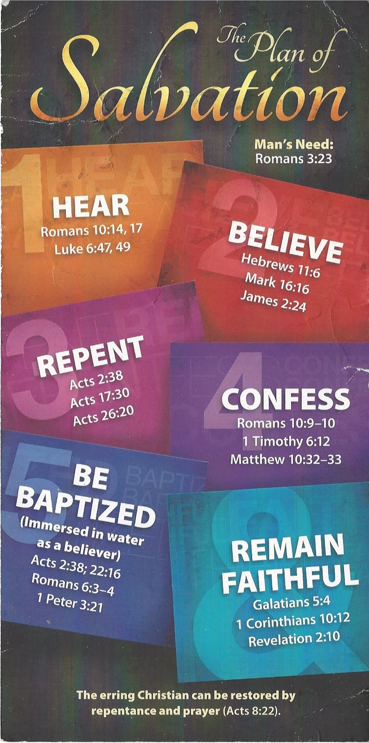
Hear - Romans 10:17 (NIV)
¹⁷ Consequently, faith comes from hearing the message, and the message is heard through the word about Christ.
Believe - Hebrews 11:6 (NIV)
⁶ And without faith it is impossible to please God, because anyone who comes to him must believe that he exists and that he rewards those who earnestly seek him.
Repent - Acts 17:30 (NIV)
³⁰ In the past God overlooked such ignorance, but now he commands all people everywhere to repent.
Confess - 1 Timothy 6:12 (NIV)
¹² Fight the good fight of the faith. Take hold of the eternal life to which you were called when you made your good confession in the presence of many witnesses.
Acts 2:38 (ESV)
³⁸ And Peter said to them, “Repent and be baptized every one of you in the name of Jesus Christ for the forgiveness of your sins, and you will receive the gift of the Holy Spirit.
Remain Steadfast - Revelation 2:10 (NIV)
¹⁰ Do not be afraid of what you are about to suffer. I tell you, the devil will put some of you in prison to test you, and you will suffer persecution for ten days. Be faithful, even to the point of death, and I will give you life as your victor’s crown.

