Are You Approved?
Barry G. Johnson, Sr. / www.barrygjohnsonsr.com
Evangelism 2019 / Evangelism / 2 Timothy 2:14–15
Those who are approved of God are willing to work; study and be set apart.
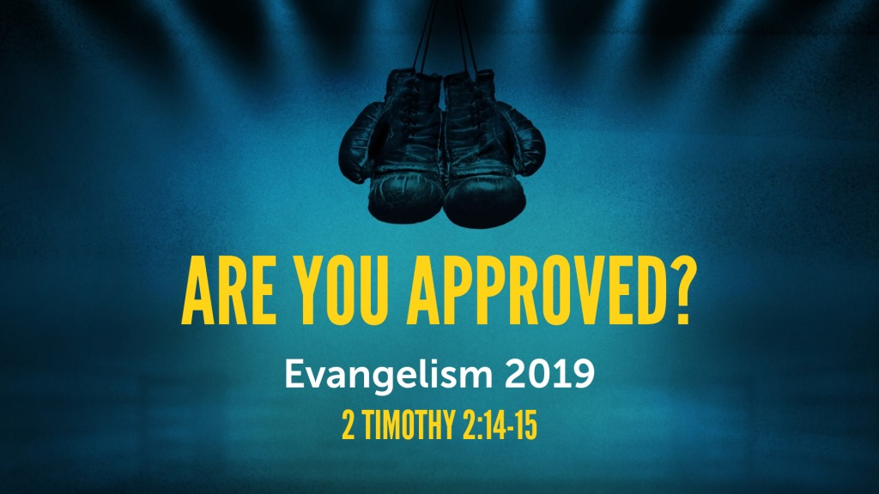
2 Timothy 2:14–15 ESV
¹⁴ Remind them of these things, and charge them before God not to quarrel about words, which does no good, but only ruins the hearers. ¹⁵ Do your best to present yourself to God as one approved, a worker who has no need to be ashamed, rightly handling the word of truth.

The Approved are Willing to Study/ Do Their Best
2 Peter 1:10–11 ESV
¹⁰ Therefore, brothers, be all the more diligent to confirm your calling and election, for if you practice these qualities you will never fall. ¹¹ For in this way there will be richly provided for you an entrance into the eternal kingdom of our Lord and Savior Jesus Christ.

The Approved are Willing to Work
1 Timothy 4:12–16 ESV
¹² Let no one despise you for your youth, but set the believers an example in speech, in conduct, in love, in faith, in purity. ¹³ Until I come, devote yourself to the public reading of Scripture, to exhortation, to teaching. ¹⁴ Do not neglect the gift you have, which was given you by prophecy when the council of elders laid their hands on you. ¹⁵ Practice these things, immerse yourself in them, so that all may see your progress. ¹⁶ Keep a close watch on yourself and on the teaching. Persist in this, for by so doing you will save both yourself and your hearers.

The Approved are Willing to Rightly Divide
2 Corinthians 4:1–6 ESV
¹ Therefore, having this ministry by the mercy of God, we do not lose heart. ² But we have renounced disgraceful, underhanded ways. We refuse to practice cunning or to tamper with God’s word, but by the open statement of the truth we would commend ourselves to everyone’s conscience in the sight of God. ³ And even if our gospel is veiled, it is veiled to those who are perishing. ⁴ In their case the god of this world has blinded the minds of the unbelievers, to keep them from seeing the light of the gospel of the glory of Christ, who is the image of God. ⁵ For what we proclaim is not ourselves, but Jesus Christ as Lord, with ourselves as your servants for Jesus’ sake. ⁶ For God, who said, “Let light shine out of darkness,” has shone in our hearts to give the light of the knowledge of the glory of God in the face of Jesus Christ.
2 Corinthians 10:17–18 ESV
¹⁷ “Let the one who boasts, boast in the Lord.” ¹⁸ For it is not the one who commends himself who is approved, but the one whom the Lord commen