Central Idea:

The assurance of believers is based upon the certain knowledge of God revealed in creation and his mighty acts in history, upon the certainty of his promises, the vindication and resurrection of Christ and the inward testimony and outward demonstration of the power of the Holy Spirit.

Objectives:

- Assurance is based upon certain knowledge of God
- Assurance is based upon the certainty of God’s word
- Assurance is based upon God’s vindication of his Son
- Assurance comes through the work of the Holy Spirit
- Assurance based upon the testimony of God’s people
- Assurance is based upon godly living

Sermon Outline:
- Assurance is based upon certain knowledge of God
- Assurance comes from knowing God through creation
Romans 1:19–20 (NIV) — 19 since what may be known about God is plain to them, because God has made it plain to them. 20 For since the creation of the world God’s invisible qualities—his eternal power and divine nature—have been clearly seen, being understood from what has been made, so that people are without excuse.
- Assurance comes from knowing God through his mighty acts
Exodus 6:7 (NIV) — 7 I will take you as my own people, and I will be your God. Then you will know that I am the Lord your God, who brought you out from under the yoke of the Egyptians.
- Assurance is based upon the certainty of God’s word
John 17:8 (NIV) — 8 For I gave them the words you gave me and they accepted them. They knew with certainty that I came from you, and they believed that you sent me.
- Assurance because of God’s oath
Hebrews 6:17 (NIV) — 17 Because God wanted to make the unchanging nature of his purpose very clear to the heirs of what was promised, he confirmed it with an oath.
- Assurance because of God’s promise
Romans 4:20–21 (NIV) — 20 Yet he did not waver through unbelief regarding the promise of God, but was strengthened in his faith and gave glory to God, 21 being fully persuaded that God had power to do what he had promised.
- Assurance is based upon God’s vindication of his Son
- Assurance because of the resurrection of Jesus Christ
Acts 17:31 (NIV) — 31 For he has set a day when he will judge the world with justice by the man he has appointed. He has given proof of this to everyone by raising him from the dead.”
- Assurance because of the miracles of Jesus Christ
Matthew 11:2–6 (NIV) — 2 When John, who was in prison, heard about the deeds of the Messiah, he sent his disciples 3 to ask him, “Are you the one who is to come, or should we expect someone else?” 4 Jesus replied, “Go back and report to John what you hear and see: 5 The blind receive sight, the lame walk, those who have leprosy are cleansed, the deaf hear, the dead are raised, and the good news is proclaimed to the poor. 6 Blessed is anyone who does not stumble on account of me.”
- Assurance comes through the work of the Holy Spirit
- The Holy Spirit assures believers by enabling outward demonstrations of God’s power
Hebrews 2:4 (NIV) — 4 God also testified to it by signs, wonders and various miracles, and by gifts of the Holy Spirit distributed according to his will.
- The Holy Spirit assures believers by giving inward conviction
Romans 8:16 (NIV) — 16 The Spirit himself testifies with our spirit that we are God’s children.
- The Holy Spirit assures believers by sealing God’s promise
Ephesians 1:13–14 (NIV) — 13 And you also were included in Christ when you heard the message of truth, the gospel of your salvation. When you believed, you were marked in him with a seal, the promised Holy Spirit, 14 who is a deposit guaranteeing our inheritance until the redemption of those who are God’s possession—to the praise of his glory.
- Assurance based upon the testimony of God’s people
- Assurance because of the testimony of eye-witnesses
2 Peter 1:16–19 (NIV) — 16 For we did not follow cleverly devised stories when we told you about the coming of our Lord Jesus Christ in power, but we were eyewitnesses of his majesty. 17 He received honor and glory from God the Father when the voice came to him from the Majestic Glory, saying, “This is my Son, whom I love; with him I am well pleased.” 18 We ourselves heard this voice that came from heaven when we were with him on the sacred mountain. 19 We also have the prophetic message as something completely reliable, and you will do well to pay attention to it, as to a light shining in a dark place, until the day dawns and the morning star rises in your hearts.
- Assurance because of the testimony of the apostles
Acts 22:14–15 (NIV) — 14 “Then he said: ‘The God of our ancestors has chosen you to know his will and to see the Righteous One and to hear words from his mouth. 15 You will be his witness to all people of what you have seen and heard.
- Assurance is based upon godly living
1 John 2:3–5 (NIV) — 3 We know that we have come to know him if we keep his commands. 4 Whoever says, “I know him,” but does not do what he commands is a liar, and the truth is not in that person. 5 But if anyone obeys his word, love for God is truly made complete in them. This is how we know we are in him:
1 John 5:18 (NIV) — 18 We know that anyone born of God does not continue to sin; the One who was born of God keeps them safe, and the evil one cannot harm them.

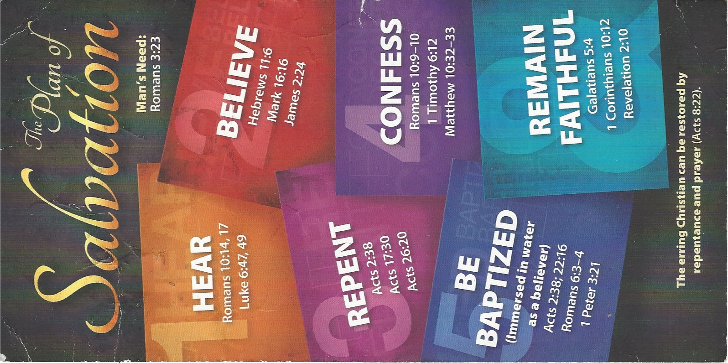
Invitation:
HEAR
Luke 6:47–49 (ESV)
⁴⁷ Everyone who comes to me and hears my words and does them, I will show you what he is like: ⁴⁸ he is like a man building a house, who dug deep and laid the foundation on the rock. And when a flood arose, the stream broke against that house and could not shake it, because it had been well built. ⁴⁹ But the one who hears and does not do them is like a man who built a house on the ground without a foundation. When the stream broke against it, immediately it fell, and the ruin of that house was great.”

BELIEVE
Hebrews 11:6 (ESV)
⁶ And without faith it is impossible to please him, for whoever would draw near to God must believe that he exists and that he rewards those who seek him.

REPENT
Luke 13:3 (ESV)
³ No, I tell you; but unless you repent, you will all likewise perish.
Acts 17:30 (ESV)
³⁰ The times of ignorance God overlooked, but now he commands all people everywhere to repent,

CONFESS
Matthew 10:32–33 (ESV)
³² So everyone who acknowledges me before men, I also will acknowledge before my Father who is in heaven, ³³ but whoever denies me before men, I also will deny before my Father who is in heaven.
Romans 10:9–10 (ESV)
⁹ because, if you confess with your mouth that Jesus is Lord and believe in your heart that God raised him from the dead, you will be saved. ¹⁰ For with the heart one believes and is justified, and with the mouth one confesses and is saved.

BE BAPTIZED
Romans 6:3–4 (ESV)
³ Do you not know that all of us who have been baptized into Christ Jesus were baptized into his death? ⁴ We were buried therefore with him by baptism into death, in order that, just as Christ was raised from the dead by the glory of the Father, we too might walk in newness of life.
1 Peter 3:21 (ESV)
²¹ Baptism, which corresponds to this, now saves you, not as a removal of dirt from the body but as an appeal to God for a good conscience, through the resurrection of Jesus Christ,

REMAIN STEADFAST
Galatians 5:4 (ESV)
⁴ You are severed from Christ, you who would be justified by the law; you have fallen away from grace.
1 Corinthians 10:12 (ESV)
¹² Therefore let anyone who thinks that he stands take heed lest he fall.

