Barry G. Johnson, Sr. / www.bgjsr22.com
Christian Character Courage / Courage; Strength; Person having Strong Faith; Courageous / Joshua 1:6–9
The ability to be strong and courageous comes from the Lord and not from man.
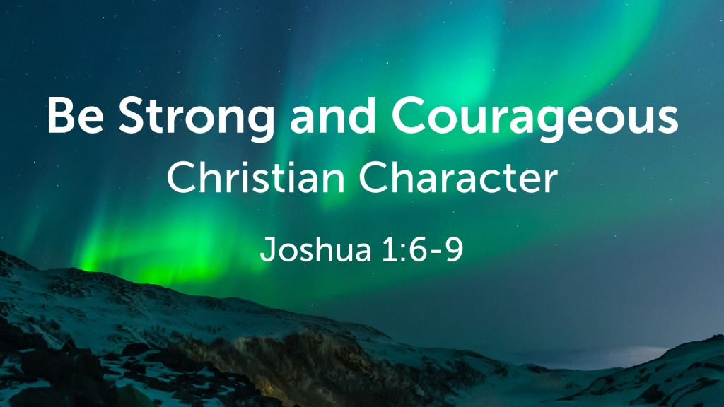
Joshua 1:6–9 ESV
⁶ Be strong and courageous, for you shall cause this people to inherit the land that I swore to their fathers to give them. ⁷ Only be strong and very courageous, being careful to do according to all the law that Moses my servant commanded you. Do not turn from it to the right hand or to the left, that you may have good success wherever you go. ⁸ This Book of the Law shall not depart from your mouth, but you shall meditate on it day and night, so that you may be careful to do according to all that is written in it. For then you will make your way prosperous, and then you will have good success. ⁹ Have I not commanded you? Be strong and courageous. Do not be frightened, and do not be dismayed, for the Lord your God is with you wherever you go.”

I. What it means to be Strong and Courageous
Ephesians 6:10 ESV
¹⁰ Finally, be strong in the Lord and in the strength of his might.
2 Timothy 2:1 ESV
¹ You then, my child, be strengthened by the grace that is in Christ Jesus,
1 Corinthians 16:13 ESV
¹³ Be watchful, stand firm in the faith, act like men, be strong.

II. The Lord is with us wherever we go
Deuteronomy 31:6–8 ESV
⁶ Be strong and courageous. Do not fear or be in dread of them, for it is the Lord your God who goes with you. He will not leave you or forsake you.”
⁷ Then Moses summoned Joshua and said to him in the sight of all Israel, “Be strong and courageous, for you shall go with this people into the land that the Lord has sworn to their fathers to give them, and you shall put them in possession of it. ⁸ It is the Lord who goes before you. He will be with you; he will not leave you or forsake you. Do not fear or be dismayed.”
1 Corinthians 3:16 ESV
¹⁶ Do you not know that you are God’s temple and that God’s Spirit dwells in you?
Philippians 4:13 ESV
¹³ I can do all things through him who strengthens me.

III. Things we can do to be Strong and Courageous
Psalm 1:1–3 ESV
¹ Blessed is the man
who walks not in the counsel of the wicked,
nor stands in the way of sinners,
nor sits in the seat of scoffers;
² but his delight is in the law of the Lord,
and on his law he meditates day and night.
³ He is like a tree
planted by streams of water
that yields its fruit in its season,
and its leaf does not wither.
In all that he does, he prospers.
Psalm 33:16–17 ESV
¹⁶ The king is not saved by his great army;
a warrior is not delivered by his great strength.
¹⁷ The war horse is a false hope for salvation,
and by its great might it cannot rescue.
Ecclesiastes 9:11 ESV
¹¹ Again I saw that under the sun the race is not to the swift, nor the battle to the strong, nor bread to the wise, nor riches to the intelligent, nor favor to those with knowledge, but time and chance happen to them all.
Jeremiah 9:23 ESV
²³ Thus says the Lord: “Let not the wise man boast in his wisdom, let not the mighty man boast in his might, let not the rich man boast in his riches,
Zechariah 4:6 ESV
⁶ Then he said to me, “This is the word of the Lord to Zerubbabel: Not by might, nor by power, but by my Spirit, says the Lord of hosts.

God’s Invitation and Plan of Salvation

Hear - Romans 10:17

Believe and Confess - Romans 10:9-10

Repent - Luke 13:3

Be Baptized - Acts 2:38

Remain Faithful - Revelation 2:10

