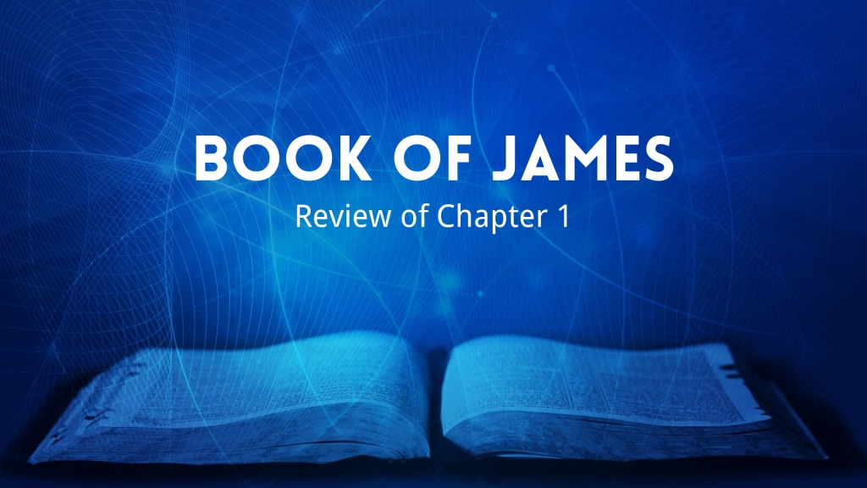

The Main Points Of This Chapter
- True religion endures trials and temptations (1-18)
- True religion consists of doing, not just hearing (19-27)

1) How should Christians view trials in their life? Why? (2-3)
- An occasion in which to ________________
- Knowing that testing one's faith produces ______________________

2) What is the value of developing patience? (4)
- It helps to make one _____________________________, lacking nothing

3) If we lack wisdom, what should we do? Why? How? (5-6)
- Ask of _____________________
- He gives to all liberally and without _______________________
- In faith, with no ______________________

4) What is one who doubts like? What can he expect? Why? (6-8)
- Like the wave of the sea driven and ____________________________________
- To receive ___________ from the Lord
- He is double-minded, and ____________________ in all his ways

5) In what should the lowly brother glory? The rich man? (9-10)
- The Lowly brother in his __________________
- The Rich brother in his _________________

6) What is the rich man like in his pursuits? (10-11)
- A flower of the field that soon ________________ from the heat of the
rising sun

7) When is the man who endures temptation blessed? How will he be
blessed? (12)
- When he has ____________________
- By receiving the ______________________ the Lord has promised to those who
love Him.

8) What should no one say when they are tempted? Why? (13)
- "I am tempted by ______"
- God cannot be tempted by evil, nor does He tempt ______________

9) Then how is one tempted? (14)
- When lured away _______________ desires and enticed

10) When is sin born? What does sin produce when full-grown? (15)
- When desire has ________________ and given birth
- Sin produces ______________

11) What is the source of every good gift and every perfect gift? (17)
- From ______________, coming down from the Father of lights

12) How has God brought us forth (given us birth)? Why did He do this?
(18)
- Of His own will, by __________________________
- That we might a kind of _________________ of His creatures

13) What does James desire of his "beloved brethren"? (19)
- To be swift to _______________________________________________

15) Why should one be "slow to wrath"? (20)
- The wrath of man does not produce the __________________ of God

15) What needs to be laid aside? (21)
- __________ filthiness and overflow of wickedness

16) What needs to be received with meekness? Why? (21)
- The ___________________________________
- It is able to ______________ your souls

17) To avoid deceiving ourselves, what must we be? (22)
- Doers of the word, and not _____________________

19) What is one like who hears the word but does not do it? (23-24)
- One who looks at himself in a mirror, only to go away and soon
_________________________________________

19) Who will be truly blessed in what they do? (25)
- He who looks into the ______________________, and continues in it
- He who is not a ________________ hearer, but a doer of the work

20) Whose religion is useless? (26)
- The one who thinks he is religious, but does not bridle his tongue
and ________________________ his own heart

21) What is pure and undefiled religion before God? (27)
- To __________________orphans and widows in their trouble
- To _______________ oneself unspotted from the world

