Barry G. Johnson, Sr. / General
Natural Evangelism: Preparing the Field / Evangelism; Mission; Blessing; Burden / 2 Corinthians 4:7–11
Christianity has received a bad rap and it's people must correct the record.
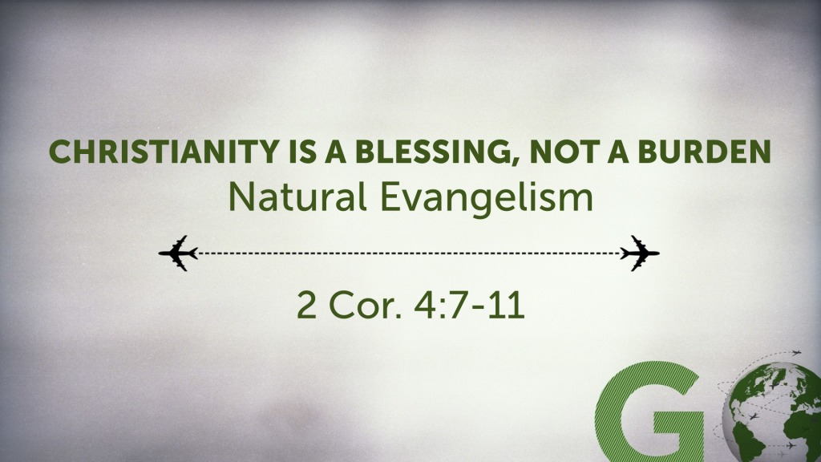
2 Corinthians 4:7–11 ESV
⁷ But we have this treasure in jars of clay, to show that the surpassing power belongs to God and not to us. ⁸ We are afflicted in every way, but not crushed; perplexed, but not driven to despair; ⁹ persecuted, but not forsaken; struck down, but not destroyed; ¹⁰ always carrying in the body the death of Jesus, so that the life of Jesus may also be manifested in our bodies. ¹¹ For we who live are always being given over to death for Jesus’ sake, so that the life of Jesus also may be manifested in our mortal flesh.

These questions can help with your story and recognition of the blessings of being in the Lord.
1. How did you come to the Lord?
2. Who influenced you to become a Christian?
3. How has Christ made a difference in your life?
4. Who might benefit from hearing your story?
5. How can your story help people who are searching for the Lord?
Natural Evangelism
An Everyday Approach to Sharing the Gospel
Part 1 - Preparing for the Field
Part 2 - Entering the Field
Part 3 - Words of Encouragement

I. Blessing not burden

II. Great Cost, Greater Blessing
2 Corinthians 4:13–15 ESV
¹³ Since we have the same spirit of faith according to what has been written, “I believed, and so I spoke,” we also believe, and so we also speak, ¹⁴ knowing that he who raised the Lord Jesus will raise us also with Jesus and bring us with you into his presence. ¹⁵ For it is all for your sake, so that as grace extends to more and more people it may increase thanksgiving, to the glory of God.

III. Speak up
Matthew 13:44–45 ESV
⁴⁴ “The kingdom of heaven is like treasure hidden in a field, which a man found and covered up. Then in his joy he goes and sells all that he has and buys that field.
⁴⁵ “Again, the kingdom of heaven is like a merchant in search of fine pearls,
2 Corinthians 4:15 ESV
¹⁵ For it is all for your sake, so that as grace extends to more and more people it may increase thanksgiving, to the glory of God.

God’s Invitation of Salvation
Hear - Believe - Confess - Repent

Be Baptized - Remain Steadfast

