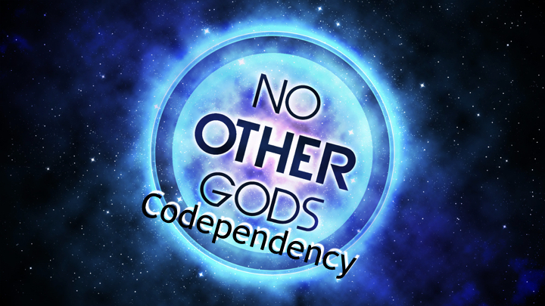
“You shall have no other gods before me.”
(Exodus 20:3)
I. Definitions
However, your biggest mistake is not what you said, but what you did—you let Delilah be your “god” instead of letting God be your God. (See Judges chapters 13–16.)
A. What Is Dependency?
In truth, Samson’s pride caused his own downfall, for he prioritized the words of Delilah over the words of God.
“Before his downfall a man’s heart is proud, but humility comes before honor.”
(Proverbs 18:12)
• A dependency is a reliance on something or someone else for support or existence.
“I have to have this to _______________.”
• A dependency can be either negative or positive, such as being dependent on cocaine versus being dependent on Christ.
“This is _______________ for my life.”
• A dependency can be an addiction to any object, behavior, or person that represents an underlying attempt to get emotional needs met.
“I must do this to _______________ my needs … to make me _______________.”
You Can Be Dependent on …
_______________—
• A chemical addiction to drugs (_______________, _______________, _______________)
• A sexual addiction to erotic items (_______________—magazines, _______________—_______________)
_______________—
• An addiction to behaviors that appear to be bad, those that are not widely socially acceptable and can be harmful (_______________, _______________, excessive _______________, compulsive _______________)
• An addiction to behaviors that appear to be good, those that are widely socially acceptable but may be equally harmful (_______________, _______________, _______________)
_______________—
• A “love” addiction in which you feel that your identity is in another person (A weak “love addict” is emotionally dependent on someone “strong.”)
• A “savior” addiction in which you feel that your identity is in your ability to meet the needs of another person (A strong “savior” needs to be needed by someone “weak.”)
Because addictions provide a momentary “high,” good feelings are associated with them. However, the Book of Proverbs gives this poignant warning.…
“There is a way that seems right to a man, but in the end it leads to death.”
(Proverbs 14:12)
Question: “What is wrong with people depending on people?”
Answer:

“… not rely on ourselves but on God.” (2 Corinthians 1:9)
B. What Is Codependency?

“Be strong in the Lord and in his mighty power.”
(Ephesians 6:10)
• Today, a codependent is anyone who is dependent on another person ________________________________________________________________________.
• The word codependent was first used in the 1970s to describe a family member living with an alcoholic. The prefix co- means ________________________________________________________________________.”
• Codependency became the word that describes the dysfunctional behavior of family members ________________________________________________________________________.
• Codependency is a _________________________. Just as the alcoholic is dependent on alcohol, the codependent is dependent on being needed by the alcoholic … or on being needed by someone who is dependent.
• The “enabler” is a codependent person who enables the alcoholic (or other dependent person) ________________________________________________________________________. Codependency involves being too dependent on someone or something that cannot meet your needs. Codependency can be compared to the sin of depending on false gods that are powerless to help or depending on a broken water well that won’t hold water. It simply won’t work!
“My people have committed two sins: They have forsaken me, the spring of living water, and have dug their own cisterns, broken cisterns that cannot hold water.”
(Jeremiah 2:13)
Question: “How can I know whether I’m an enabler?”
Answer:

— The enabling parent allows
________________________________________________________________________
— The enabling wife
________________________________________________________________________

“Whoever says to the guilty, ‘You are innocent’—peoples will curse him and nations denounce him.” (Proverbs 24:24)
C. What Are Common Codependent Relationships?

“He gives strength to the weary and increases the power of the weak.”
(Isaiah 40:29)
Common Codependent Relationships
• A _______________ is excessively helpless around her _______________ … and the husband needs his wife to stay helpless.
• A _______________ is excessively needy in how he relates to his _______________ … and the wife needs him to stay needy.
• A _______________ is excessively tied to a _______________ … and the teacher needs the student to stay tied.
• A _______________ is excessively pampered by the _______________ … and the parent needs the child to stay in need of pampering.
• A _______________ is excessively protected by the _______________ … and the child needs the parent to stay in need of protection.
• An _______________ is excessively entangled with an _______________ … and the employer needs the employee to stay entangled.
• A _______________ is excessively fixated on another _______________ … and that person needs the friend to stay fixated.
• A _______________ is excessively clinging to a _______________ … and the counselor needs the counselee to continue clinging.
• A _______________ is excessively dependent on a _______________ … and the discipler needs the disciple to stay dependent.
• A _______________ is excessively vulnerable to a _______________ … and the victimizer needs the victim to stay vulnerable.
• A _______________ is excessively leaning on a _______________ … and the leader needs the layperson to continue leaning.
When we have a misplaced _______________, we have a misplaced _______________. We are excessively trusting in the relationship to provide more than God intended. The Psalms describe a misplaced trust.…
“Some trust in chariots and some in horses, but we trust in the name of the Lord our God.”
(Psalm 20:7)
Question: “When I was a struggling addict, my wife held our home together. Now that I have truly changed, why is she continually upset and threatening divorce?”
Answer:

“Do not conform any longer to the pattern of this world, but be transformed by the renewing of your mind. Then you will be able to test and approve what God’s will is—his good, pleasing and perfect will.” (Romans 12:2)
Question: “In the parent-child relationship, what is the difference between bonding and enmeshment?”
Answer:
— Healthy bonding

— Unhealthy enmeshment

“Children should not have to save up for their parents, but parents for their children.” (2 Corinthians 12:14)
D. What Is Biblical Dependency?
• God wants you to depend on Him—________________________________________________________________________.
“My salvation and my honor depend on God; he is my mighty rock, my refuge.” (Psalm 62:7)
• God wants you to depend on Him—________________________________________________________________________.
“The Lord will guide you always; he will satisfy your needs in a sun-scorched land and will strengthen your frame. You will be like a well-watered garden, like a spring whose waters never fail.” (Isaiah 58:11)
• God wants you to depend on Him—________________________________________________________________________.
“Trust in him at all times, O people; pour out your hearts to him, for God is our refuge.” (Psalm 62:8)
• God wants you to depend on Him—________________________________________________________________________.
“The one [Christ] who is in you is greater than the one [Satan] who is in the world.” (1 John 4:4)
Question: “What is the difference between a codependent marriage and a healthy marriage?”
Answer:
— An Unhealthy, Codependent Marriage

— A Healthy, Interdependent Marriage

“Each of you should look not only to your own interests, but also to the interests of others.” (Philippians 2:4)
Hunt, J. (2008). Biblical Counseling Keys on Codependency: Balancing an Unbalanced Relationship (pp. 1–6). Dallas, TX: Hope For The Heart.

