Barry G. Johnson, Sr. / www.barrygjohnsonsr.com
Christian Character: Boldness / Boldness; Courage; Confidence / Ephesians 3:12
Both in the OT and in the NT faith is a basis for confidence. Faith is a means by which confidence in Christ matures and blessings flow.
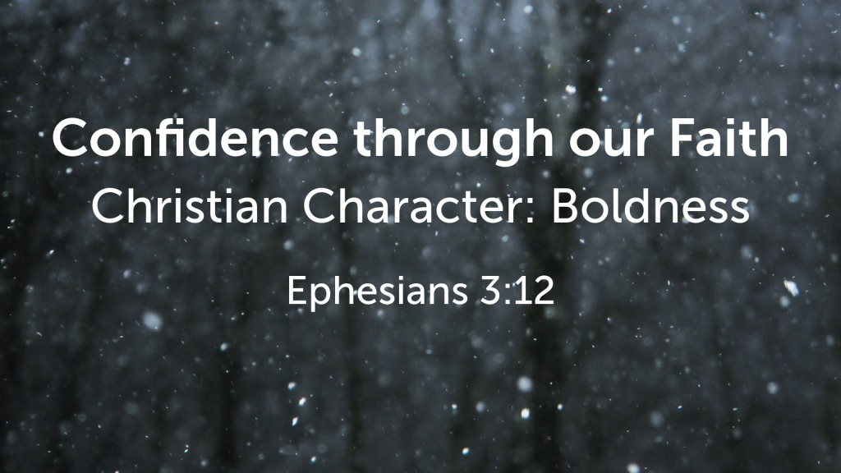
Ephesians 3:12 (ESV)
¹² in whom we have boldness and access with confidence through our faith in him.

I. Confidence by faith in the OT
Habakkuk 2:4 ESV
⁴ “Behold, his soul is puffed up; it is not upright within him,
but the righteous shall live by his faith.

The faith of Abraham
Genesis 15:6 ESV
⁶ And he believed the Lord, and he counted it to him as righteousness.

II. Confidence by faith in the NT
Romans 1:16–17 ESV
¹⁶ For I am not ashamed of the gospel, for it is the power of God for salvation to everyone who believes, to the Jew first and also to the Greek. ¹⁷ For in it the righteousness of God is revealed from faith for faith, as it is written, “The righteous shall live by faith.”

Confidence through faith
Ephesians 2:8–9 ESV
⁸ For by grace you have been saved through faith. And this is not your own doing; it is the gift of God, ⁹ not a result of works, so that no one may boast.

Confidence is for those who persevere in their faith
Colossians 1:21–23 ESV
²¹ And you, who once were alienated and hostile in mind, doing evil deeds, ²² he has now reconciled in his body of flesh by his death, in order to present you holy and blameless and above reproach before him, ²³ if indeed you continue in the faith, stable and steadfast, not shifting from the hope of the gospel that you heard, which has been proclaimed in all creation under heaven, and of which I, Paul, became a minister.

Confident faith shows itself in action
James 2:14 ESV
¹⁴ What good is it, my brothers, if someone says he has faith but does not have works? Can that faith save him?

III. Blessings of confidence received through faith

Peace with God
Romans 5:1–2 ESV
¹ Therefore, since we have been justified by faith, we have peace with God through our Lord Jesus Christ. ² Through him we have also obtained access by faith into this grace in which we stand, and we rejoice in hope of the glory of God.

Forgiveness
Acts 10:43 ESV
⁴³ To him all the prophets bear witness that everyone who believes in him receives forgiveness of sins through his name.”

Victory over death
John 11:25–27 ESV
²⁵ Jesus said to her, “I am the resurrection and the life. Whoever believes in me, though he die, yet shall he live, ²⁶ and everyone who lives and believes in me shall never die. Do you believe this?” ²⁷ She said to him, “Yes, Lord; I believe that you are the Christ, the Son of God, who is coming into the world.”

The Holy Spirit
Galatians 3:2 ESV
² Let me ask you only this: Did you receive the Spirit by works of the law or by hearing with faith?

Jesus Christ in the heart
Ephesians 3:17 ESV
¹⁷ so that Christ may dwell in your hearts through faith—that you, being rooted and grounded in love,

Protection through God’s power
1 Peter 1:5 ESV
⁵ who by God’s power are being guarded through faith for a salvation ready to be revealed in the last time.

Access to God
Hebrews 10:22 ESV
²² let us draw near with a true heart in full assurance of faith, with our hearts sprinkled clean from an evil conscience and our bodies washed with pure water.

Sanctification
Acts 26:17–18 ESV
¹⁷ delivering you from your people and from the Gentiles—to whom I am sending you ¹⁸ to open their eyes, so that they may turn from darkness to light and from the power of Satan to God, that they may receive forgiveness of sins and a place among those who are sanctified by faith in me.’

New life
Galatians 2:20 ESV
²⁰ I have been crucified with Christ. It is no longer I who live, but Christ who lives in me. And the life I now live in the flesh I live by faith in the Son of God, who loved me and gave himself for me.
God’s Plan of Redemption
Hear - Romans 10:17
Romans 10:17 (ESV)
¹⁷ So faith comes from hearing, and hearing through the word of Christ.
Believe - John 1:7
John 1:7 (ESV)
⁷ He came as a witness, to bear witness about the light, that all might believe through him.
Confess - Hebrews 4:14
Hebrews 4:14 (ESV)
¹⁴ Since then we have a great high priest who has passed through the heavens, Jesus, the Son of God, let us hold fast our confession.
Repent and Be Baptized - Acts 2:38
Acts 2:38 (ESV)
³⁸ And Peter said to them, “Repent and be baptized every one of you in the name of Jesus Christ for the forgiveness of your sins, and you will receive the gift of the Holy Spirit.
Remain Faithful - Matthew 25:21
Matthew 25:21 (ESV)
²¹ His master said to him, ‘Well done, good and faithful servant. You have been faithful over a little; I will set you over much. Enter into the joy of your master.’

