Barry G. Johnson, Sr. / www.barrygjohnsonsr.com
Judges: A Modern-Day Spiral Downward / Discipline; Punish; Punishments; Mature; Cycle; Spiritual growth; Training; God: Grace; Preparation / Judges 4:1–3
God disciplines his people through his word, through their experiences and through punishment, so that they may live in ways pleasing to him.
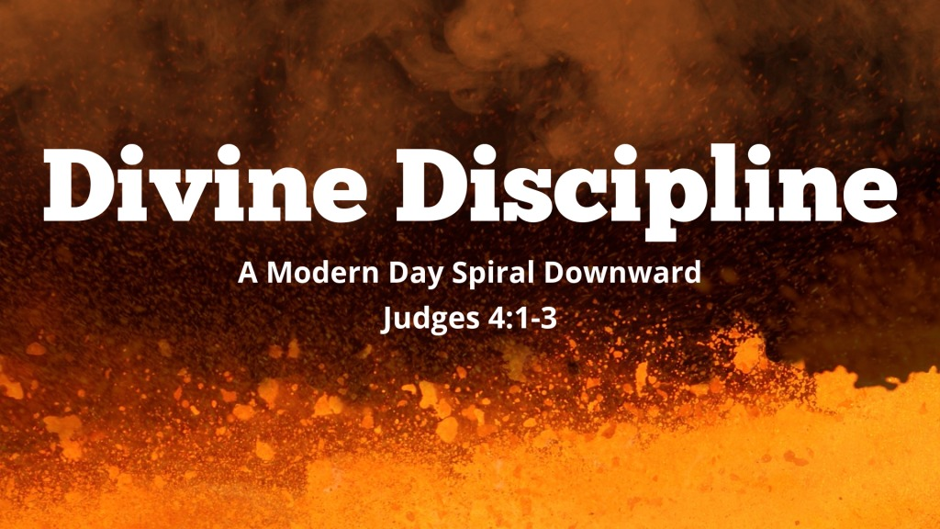
Judges 4:1–3 ESV
¹ And the people of Israel again did what was evil in the sight of the Lord after Ehud died. ² And the Lord sold them into the hand of Jabin king of Canaan, who reigned in Hazor. The commander of his army was Sisera, who lived in Harosheth-hagoyim. ³ Then the people of Israel cried out to the Lord for help, for he had 900 chariots of iron and he oppressed the people of Israel cruelly for twenty years.

The nature of God’s discipline

It is a sign of God’s love
Hebrews 12:6 ESV
⁶ For the Lord disciplines the one he loves, and chastises every son whom he receives.”

It is a sign of belonging to God’s family
Hebrews 12:7 ESV
⁷ It is for discipline that you have to endure. God is treating you as sons. For what son is there whom his father does not discipline?

It trains God’s people
Hebrews 12:11 ESV
¹¹ For the moment all discipline seems painful rather than pleasant, but later it yields the peaceful fruit of righteousness to those who have been trained by it.

The means of God’s discipline

The use of Scripture
2 Timothy 3:16 ESV
¹⁶ All Scripture is breathed out by God and profitable for teaching, for reproof, for correction, and for training in righteousness,

The knowledge of God’s grace
Titus 2:11–12 ESV
¹¹ For the grace of God has appeared, bringing salvation for all people, ¹² training us to renounce ungodliness and worldly passions, and to live self-controlled, upright, and godly lives in the present age,

Instructive experiences
Isaiah 48:17 ESV
¹⁷ Thus says the Lord, your Redeemer, the Holy One of Israel: “I am the Lord your God, who teaches you to profit, who leads you in the way you should go.
1 Peter 1:6–7 ESV
⁶ In this you rejoice, though now for a little while, if necessary, you have been grieved by various trials, ⁷ so that the tested genuineness of your faith—more precious than gold that perishes though it is tested by fire—may be found to result in praise and glory and honor at the revelation of Jesus Christ.

Punishment
1 Corinthians 11:32 ESV
³² But when we are judged by the Lord, we are disciplined so that we may not be condemned along with the world.

The goals of God’s discipline

Respectful submission to God
Hebrews 12:9 ESV
⁹ Besides this, we have had earthly fathers who disciplined us and we respected them. Shall we not much more be subject to the Father of spirits and live?

The good of God’s people
Hebrews 12:10 ESV
¹⁰ For they disciplined us for a short time as it seemed best to them, but he disciplines us for our good, that we may share his holiness.

Spiritual growth
Romans 5:3–5 ESV
³ Not only that, but we rejoice in our sufferings, knowing that suffering produces endurance, ⁴ and endurance produces character, and character produces hope, ⁵ and hope does not put us to shame, because God’s love has been poured into our hearts through the Holy Spirit who has been given to us.

Preparation for heaven
2 Corinthians 4:17–18 ESV
¹⁷ For this light momentary affliction is preparing for us an eternal weight of glory beyond all comparison, ¹⁸ as we look not to the things that are seen but to the things that are unseen. For the things that are seen are transient, but the things that are unseen are eternal.

Believers should not despise God’s discipline
Job 5:17 ESV
¹⁷ “Behold, blessed is the one whom God reproves;
therefore despise not the discipline of the Almighty.

Divine Discipline in God’s Plan of Salvation

Hear - Believe - Confess - Repent - Be Baptized - Remain Faithful
Romans 10:17 ESV
¹⁷ So faith comes from hearing, and hearing through the word of Christ.
Matthew 21:32 (ESV)
³² For John came to you in the way of righteousness, and you did not believe him, but the tax collectors and the prostitutes believed him. And even when you saw it, you did not afterward change your minds and believe him.
John 9:22 ESV
²² (His parents said these things because they feared the Jews, for the Jews had already agreed that if anyone should confess Jesus to be Christ, he was to be put out of the synagogue.)
Luke 15:7 ESV
⁷ Just so, I tell you, there will be more joy in heaven over one sinner who repents than over ninety-nine righteous persons who need no repentance.
Acts 8:36 ESV
³⁶ And as they were going along the road they came to some water, and the eunuch said, “See, here is water! What prevents me from being baptized?”
Acts 11:23 ESV
²³ When he came and saw the grace of God, he was glad, and he exhorted them all to remain faithful to the Lord with steadfast purpose,

