Barry G. Johnson, Sr. / www.barrygjohnsonsr.com
Romans: The Just Shall Live by Faith / Criticism; Stumble; Murmur; Complaining / Romans 14:13–23
Harsh criticism is out of place among believers, who are urged to see each other in the best possible light. Criticism of God arises from a failure to understand his actions and purposes.
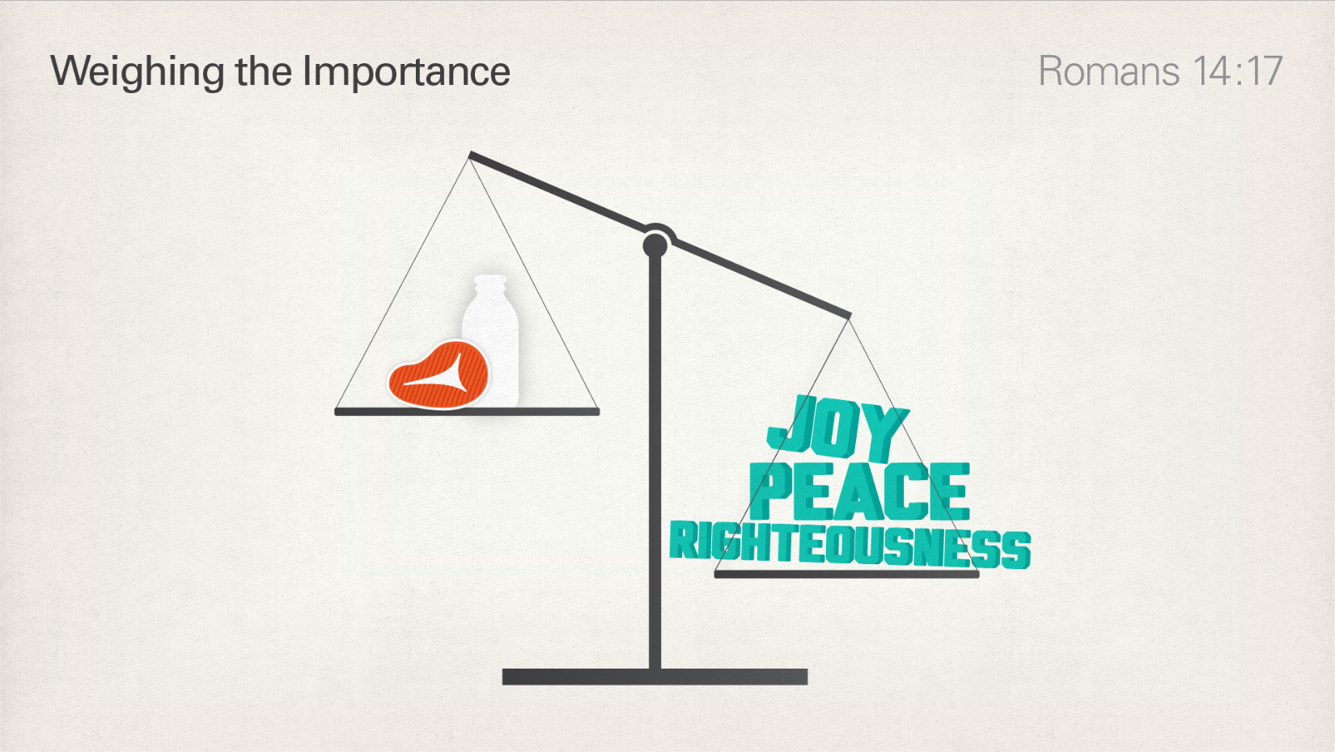
Romans 14:13–19 ESV
Therefore let us not pass judgment on one another any longer, but rather decide never to put a stumbling block or hindrance in the way of a brother. I know and am persuaded in the Lord Jesus that nothing is unclean in itself, but it is unclean for anyone who thinks it unclean. For if your brother is grieved by what you eat, you are no longer walking in love. By what you eat, do not destroy the one for whom Christ died. So do not let what you regard as good be spoken of as evil. For the kingdom of God is not a matter of eating and drinking but of righteousness and peace and joy in the Holy Spirit. Whoever thus serves Christ is acceptable to God and approved by men. So then let us pursue what makes for peace and for mutual upbuilding.

Grumbling forbidden among believers
James 5:9 ESV
Do not grumble against one another, brothers, so that you may not be judged; behold, the Judge is standing at the door.
- See also Mt 7:1–5; Ro 14:1–4; Ro 14:10–13; 1 Co 10:10; Ga 5:15; Php 2:14–16; Jas 4:11–12

Reacting to criticism

Some criticism can be disregarded
Ecclesiastes 7:21–22 ESV
Do not take to heart all the things that people say, lest you hear your servant cursing you. Your heart knows that many times you yourself have cursed others.

Stumbling blocks can be removed by settling the dispute
Matthew 18:15 ESV
“If your brother sins against you, go and tell him his fault, between you and him alone. If he listens to you, you have gained your brother.
Proverbs 15:1 ESV
A soft answer turns away wrath,
but a harsh word stirs up anger.

Integrity is a defence against criticism
Daniel 6:4 ESV
Then the high officials and the satraps sought to find a ground for complaint against Daniel with regard to the kingdom, but they could find no ground for complaint or any fault, because he was faithful, and no error or fault was found in him.
2 Corinthians 8:20–21 ESV
We take this course so that no one should blame us about this generous gift that is being administered by us, for we aim at what is honorable not only in the Lord’s sight but also in the sight of man.
Titus 2:7–8 ESV
Show yourself in all respects to be a model of good works, and in your teaching show integrity, dignity, and sound speech that cannot be condemned, so that an opponent may be put to shame, having nothing evil to say about us.

Criticism can be constructive
Psalm 141:5 ESV
Let a righteous man strike me—it is a kindness;
let him rebuke me—it is oil for my head;
let my head not refuse it.
Yet my prayer is continually against their evil deeds.
- See also Pr 10:17; Pr 15:5; Pr 27:6; Pr 27:9; Pr 28:23

Criticism and complaint directed against God

Criticism of God for his apparent injustice
Deuteronomy 1:26–27 ESV
“Yet you would not go up, but rebelled against the command of the Lord your God. And you murmured in your tents and said, ‘Because the Lord hated us he has brought us out of the land of Egypt, to give us into the hand of the Amorites, to destroy us.
Romans 9:19–21 ESV
You will say to me then, “Why does he still find fault? For who can resist his will?” But who are you, O man, to answer back to God? Will what is molded say to its molder, “Why have you made me like this?” Has the potter no right over the clay, to make out of the same lump one vessel for honorable use and another for dishonorable use?

God’s Plan of Salvation
Romans 10:17 ESV Salvation begins with Hearing
So faith comes from hearing, and hearing through the word of Christ.
2 Corinthians 10:5 ESV Salvation continues by believing truth not opinions
We destroy arguments and every lofty opinion raised against the knowledge of God, and take every thought captive to obey Christ,
Matthew 10:32 ESV Jesus says we must confess Him before men
So everyone who acknowledges me before men, I also will acknowledge before my Father who is in heaven,
Luke 13:3 ESV Salvation requires repentance
No, I tell you; but unless you repent, you will all likewise perish.
Romans 6:3 ESV If one is to be saved, one must be Baptized
Do you not know that all of us who have been baptized into Christ Jesus were baptized into his death?
1 Corinthians 10:12 ESV Salvation is a lifetime call and one must make that calling sure
Therefore let anyone who thinks that he stands take heed lest he fall.

