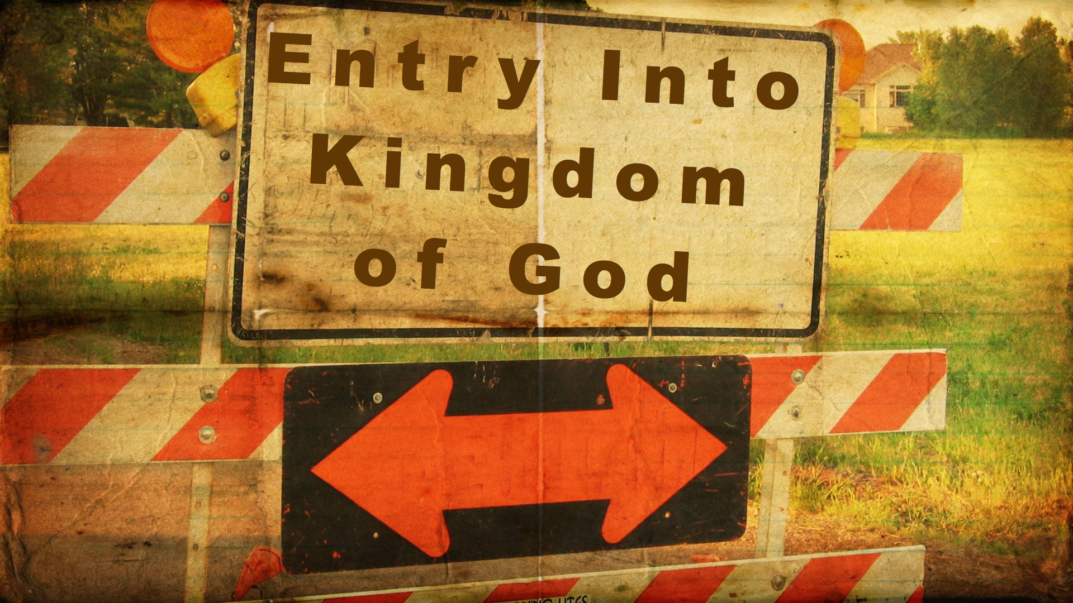
Synopsis
Entering or inheriting the kingdom of God is the privilege of those who acknowledge and live by the rule of God and have become part of the new order of salvation and righteousness in Christ.

- Entry into the Kingdom of God is of vital importance
- It is costly
Matthew 13:44 (NIV) — 44 “The kingdom of heaven is like treasure hidden in a field. When a man found it, he hid it again, and then in his joy went and sold all he had and bought that field.
Acts 14:22 (NIV) — 22 strengthening the disciples and encouraging them to remain true to the faith. “We must go through many hardships to enter the kingdom of God,” they said.
See also Mt 8:19–20 ; Mt 13:45–46 ; Lk 18:29–30 ; 2 Th 1:5 ; Re 1:9
- It is a matter of urgency
Luke 9:59–62 (NIV) — 59 He said to another man, “Follow me.” But he replied, “Lord, first let me go and bury my father.” 60 Jesus said to him, “Let the dead bury their own dead, but you go and proclaim the kingdom of God.” 61 Still another said, “I will follow you, Lord; but first let me go back and say goodbye to my family.” 62 Jesus replied, “No one who puts a hand to the plow and looks back is fit for service in the kingdom of God.”
- Conditions of entry into the Kingdom of God
- Childlike trust
Mark 10:15 (NIV) — 15 Truly I tell you, anyone who will not receive the kingdom of God like a little child will never enter it.”
See also Mt 18:3
- To be born again of God’s Spirit
John 3:3 (NIV) — 3 Jesus replied, “Very truly I tell you, no one can see the kingdom of God unless they are born again.”
See also Jn 3:5 ; 1 Co 15:50
- Obedience to God’s will
Matthew 7:21 (NIV) — 21 “Not everyone who says to me, ‘Lord, Lord,’ will enter the kingdom of heaven, but only the one who does the will of my Father who is in heaven.
- Warnings about entry into the Kingdom of God
- The way is narrow
Luke 13:24–28 (NIV) — 24 “Make every effort to enter through the narrow door, because many, I tell you, will try to enter and will not be able to. 25 Once the owner of the house gets up and closes the door, you will stand outside knocking and pleading, ‘Sir, open the door for us.’ “But he will answer, ‘I don’t know you or where you come from.’ 26 “Then you will say, ‘We ate and drank with you, and you taught in our streets.’ 27 “But he will reply, ‘I don’t know you or where you come from. Away from me, all you evildoers!’ 28 “There will be weeping there, and gnashing of teeth, when you see Abraham, Isaac and Jacob and all the prophets in the kingdom of God, but you yourselves thrown out.
See also Mt 7:13–14 ; Mt 23:13
- The wicked will not inherit the kingdom
1 Corinthians 6:9–10 (NIV) — 9 Or do you not know that wrongdoers will not inherit the kingdom of God? Do not be deceived: Neither the sexually immoral nor idolaters nor adulterers nor men who have sex with men 10 nor thieves nor the greedy nor drunkards nor slanderers nor swindlers will inherit the kingdom of God.
See also Mt 5:20 ; Mk 9:43–47 ; Ga 5:19–21 ; Eph 5:5
- The need for readiness and watchfulness
Matthew 24:42–44 (NIV) — 42 “Therefore keep watch, because you do not know on what day your Lord will come. 43 But understand this: If the owner of the house had known at what time of night the thief was coming, he would have kept watch and would not have let his house be broken into. 44 So you also must be ready, because the Son of Man will come at an hour when you do not expect him.
See also Mt 24:37–39 ; Mt 25:13 ; Lk 12:35–40
- Entry is not based on outward appearances nor granted to all who claim to know the Lord
Matthew 7:21–23 (NIV) — 21 “Not everyone who says to me, ‘Lord, Lord,’ will enter the kingdom of heaven, but only the one who does the will of my Father who is in heaven. 22 Many will say to me on that day, ‘Lord, Lord, did we not prophesy in your name and in your name drive out demons and in your name perform many miracles?’ 23 Then I will tell them plainly, ‘I never knew you. Away from me, you evildoers!’
See also Mt 13:24–30 ; Mt 13:47–50 ; Lk 13:25–27
- The Kingdom of God is a Kingdom of Grace
- It belongs to those qualified by God
Colossians 1:12–13 (NIV) — 12 and giving joyful thanks to the Father, who has qualified you to share in the inheritance of his holy people in the kingdom of light. 13 For he has rescued us from the dominion of darkness and brought us into the kingdom of the Son he loves,
See also Lk 12:32 ; Lk 22:29–30
- It belongs to the poor and the poor in spirit
Luke 6:20 (NIV) — 20 Looking at his disciples, he said: “Blessed are you who are poor, for yours is the kingdom of God.
See also Mt 11:5 ; Mt 19:23–24 It is hard for the rich to enter the kingdom of God ; Jas 2:5 ; Jas 5:1
- It belongs to the childlike
Matthew 19:14 (NIV) — 14 Jesus said, “Let the little children come to me, and do not hinder them, for the kingdom of heaven belongs to such as these.”
- It belongs to sinners
Mark 2:17 (NIV) — 17 On hearing this, Jesus said to them, “It is not the healthy who need a doctor, but the sick. I have not come to call the righteous, but sinners.”
See also Mt 21:31
- It belongs to those who are persecuted for Jesus Christ’s sake
Matthew 5:10 (NIV) — 10 Blessed are those who are persecuted because of righteousness, for theirs is the kingdom of heaven.
- It belongs to Gentiles as well as to Jews
Matthew 8:11 (NIV) — 11 I say to you that many will come from the east and the west, and will take their places at the feast with Abraham, Isaac and Jacob in the kingdom of heaven.
See also Mt 21:43 ; Mt 22:8–10 those initially uninvited represent the Gentiles ; Lk 14:21–24

Hear - Romans 10:17 (NIV)
¹⁷ Consequently, faith comes from hearing the message, and the message is heard through the word about Christ.
Believe - Hebrews 11:6 (NIV)
⁶ And without faith it is impossible to please God, because anyone who comes to him must believe that he exists and that he rewards those who earnestly seek him.
Repent - Acts 17:30 (NIV)
³⁰ In the past God overlooked such ignorance, but now he commands all people everywhere to repent.
Confess - Matthew 10:32–33 (NIV)
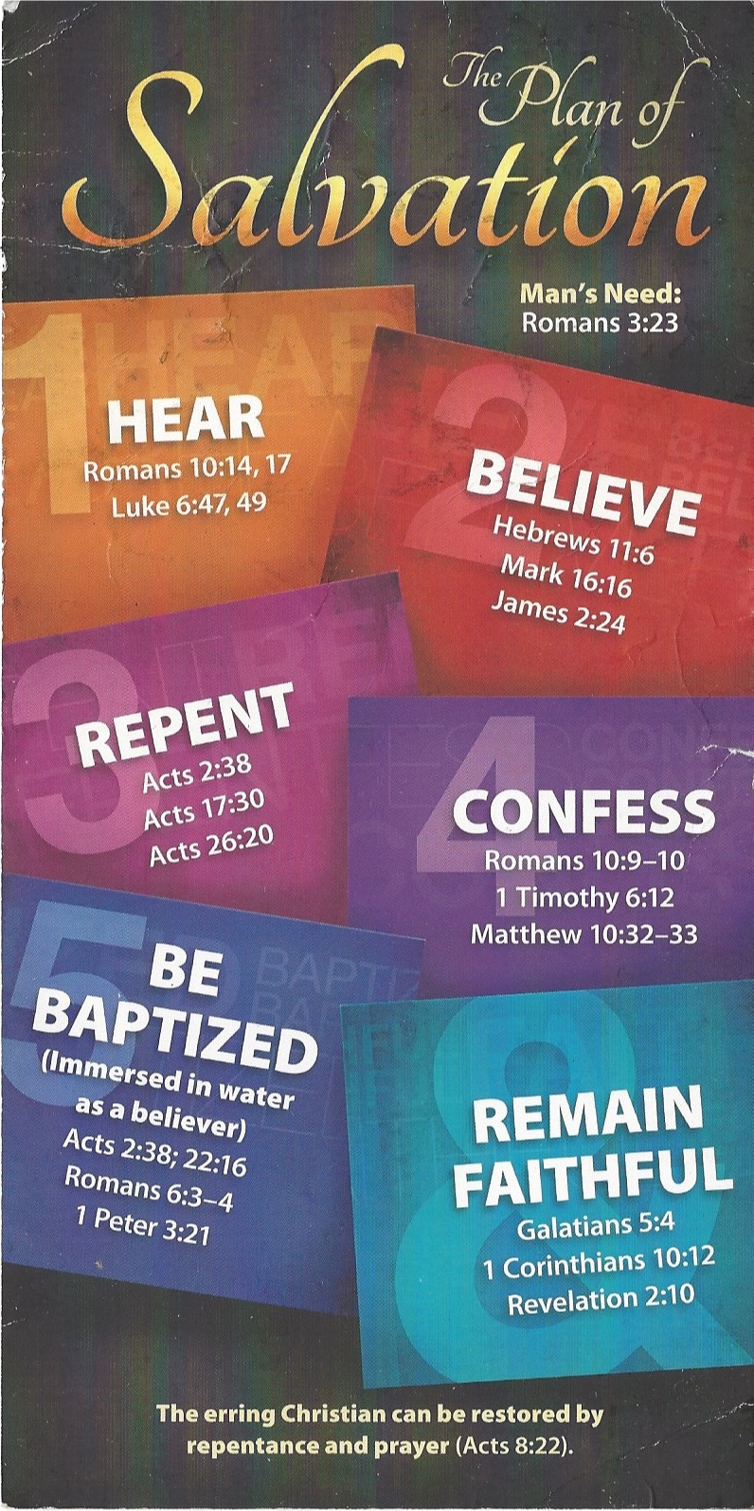
³² “Whoever acknowledges me before others, I will also acknowledge before my Father in heaven. ³³ But whoever disowns me before others, I will disown before my Father in heaven.
Be Baptized - Acts 22:16 (NIV)
¹⁶ And now what are you waiting for? Get up, be baptized and wash your sins away, calling on his name.’
Remain Steadfast - Revelation 2:10 (NIV)
¹⁰ Do not be afraid of what you are about to suffer. I tell you, the devil will put some of you in prison to test you, and you will suffer persecution for ten days. Be faithful, even to the point of death, and I will give you life as your victor’s crown.

