Barry G. Johnson, Sr. / www.barrygjohnsonsr.com
Romans: The Righteous Shall Live By Faith / Life; Eternal life; Gift / Romans 6:22–23
Eternal life cannot be earned or merited but must be received as a gift from God.
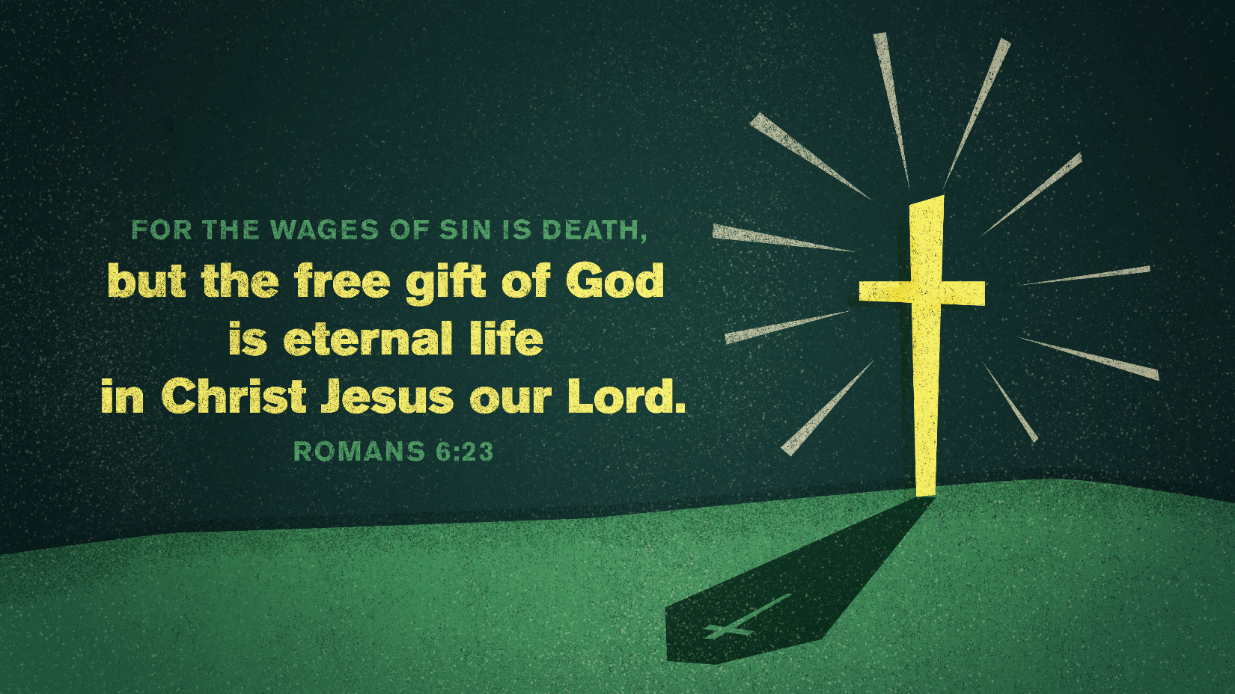
Romans 6:22–23 (ESV)
²² But now that you have been set free from sin and have become slaves of God, the fruit you get leads to sanctification and its end, eternal life. ²³ For the wages of sin is death, but the free gift of God is eternal life in Christ Jesus our Lord.

I. Fruitless attempts to earn eternal life
John 5:39–40 ESV
³⁹ You search the Scriptures because you think that in them you have eternal life; and it is they that bear witness about me, ⁴⁰ yet you refuse to come to me that you may have life.
Galatians 3:11–12 ESV
¹¹ Now it is evident that no one is justified before God by the law, for “The righteous shall live by faith.” ¹² But the law is not of faith, rather “The one who does them shall live by them.”
Romans 3:20 ESV
²⁰ For by works of the law no human being will be justified in his sight, since through the law comes knowledge of sin.
Romans 3:28 ESV
²⁸ For we hold that one is justified by faith apart from works of the law.

II. Jesus Christ is the source of eternal life
1 John 5:11–12 ESV
¹¹ And this is the testimony, that God gave us eternal life, and this life is in his Son. ¹² Whoever has the Son has life; whoever does not have the Son of God does not have life.

III. Eternal life is a gift
Romans 6:23 ESV
²³ For the wages of sin is death, but the free gift of God is eternal life in Christ Jesus our Lord.
John 6:27 ESV
²⁷ Do not work for the food that perishes, but for the food that endures to eternal life, which the Son of Man will give to you. For on him God the Father has set his seal.”
John 10:28 ESV
²⁸ I give them eternal life, and they will never perish, and no one will snatch them out of my hand.
Romans 2:7 ESV
⁷ to those who by patience in well-doing seek for glory and honor and immortality, he will give eternal life;
Romans 5:15–17 ESV
¹⁵ But the free gift is not like the trespass. For if many died through one man’s trespass, much more have the grace of God and the free gift by the grace of that one man Jesus Christ abounded for many. ¹⁶ And the free gift is not like the result of that one man’s sin. For the judgment following one trespass brought condemnation, but the free gift following many trespasses brought justification. ¹⁷ For if, because of one man’s trespass, death reigned through that one man, much more will those who receive the abundance of grace and the free gift of righteousness reign in life through the one man Jesus Christ.
Ephesians 2:8–9 ESV
⁸ For by grace you have been saved through faith. And this is not your own doing; it is the gift of God, ⁹ not a result of works, so that no one may boast.

IV. Received by faith
John 3:36 ESV
³⁶ Whoever believes in the Son has eternal life; whoever does not obey the Son shall not see life, but the wrath of God remains on him.
John 3:16 ESV
¹⁶ “For God so loved the world, that he gave his only Son, that whoever believes in him should not perish but have eternal life.
John 5:24 ESV
²⁴ Truly, truly, I say to you, whoever hears my word and believes him who sent me has eternal life. He does not come into judgment, but has passed from death to life.
John 6:40 ESV
⁴⁰ For this is the will of my Father, that everyone who looks on the Son and believes in him should have eternal life, and I will raise him up on the last day.”
John 20:31 ESV
³¹ but these are written so that you may believe that Jesus is the Christ, the Son of God, and that by believing you may have life in his name.
1 Timothy 1:16 ESV
¹⁶ But I received mercy for this reason, that in me, as the foremost, Jesus Christ might display his perfect patience as an example to those who were to believe in him for eternal life.

V. The need for personal commitment
John 12:25–26 ESV
²⁵ Whoever loves his life loses it, and whoever hates his life in this world will keep it for eternal life. ²⁶ If anyone serves me, he must follow me; and where I am, there will my servant be also. If anyone serves me, the Father will honor him.
Matthew 7:14 ESV
¹⁴ For the gate is narrow and the way is hard that leads to life, and those who find it are few.
Mark 8:37–38 ESV
³⁷ For what can a man give in return for his soul? ³⁸ For whoever is ashamed of me and of my words in this adulterous and sinful generation, of him will the Son of Man also be ashamed when he comes in the glory of his Father with the holy angels.”
Romans 6:8–11 ESV
⁸ Now if we have died with Christ, we believe that we will also live with him. ⁹ We know that Christ, being raised from the dead, will never die again; death no longer has dominion over him. ¹⁰ For the death he died he died to sin, once for all, but the life he lives he lives to God. ¹¹ So you also must consider yourselves dead to sin and alive to God in Christ Jesus.

God’s Gift of Eternal Life is Salvation

The Requirements

Hear - Believe - Repent - Confess - Be Baptized - Remain Faithful
Romans 10:17 ESV
¹⁷ So faith comes from hearing, and hearing through the word of Christ.
Hebrews 11:6 ESV
⁶ And without faith it is impossible to please him, for whoever would draw near to God must believe that he exists and that he rewards those who seek him.
Acts 17:30 ESV
³⁰ The times of ignorance God overlooked, but now he commands all people everywhere to repent,
1 John 4:15 (ESV)
¹⁵ Whoever confesses that Jesus is the Son of God, God abides in him, and he in God.
1 Peter 3:21 ESV
²¹ Baptism, which corresponds to this, now saves you, not as a removal of dirt from the body but as an appeal to God for a good conscience, through the resurrection of Jesus Christ,
Revelation 2:10 ESV
¹⁰ Do not fear what you are about to suffer. Behold, the devil is about to throw some of you into prison, that you may be tested, and for ten days you will have tribulation. Be faithful unto death, and I will give you the crown of life.

