Barry G. Johnson, Sr. / www.barrygjohnsonsr.com
Discovering the Church / Mind; Right Mind; Discern; Discernment; Foolishness; A Witness / Acts 26:24–29
The world puts those on trial who proclaim the foolishness of the Gospel, believing we have lost our minds.
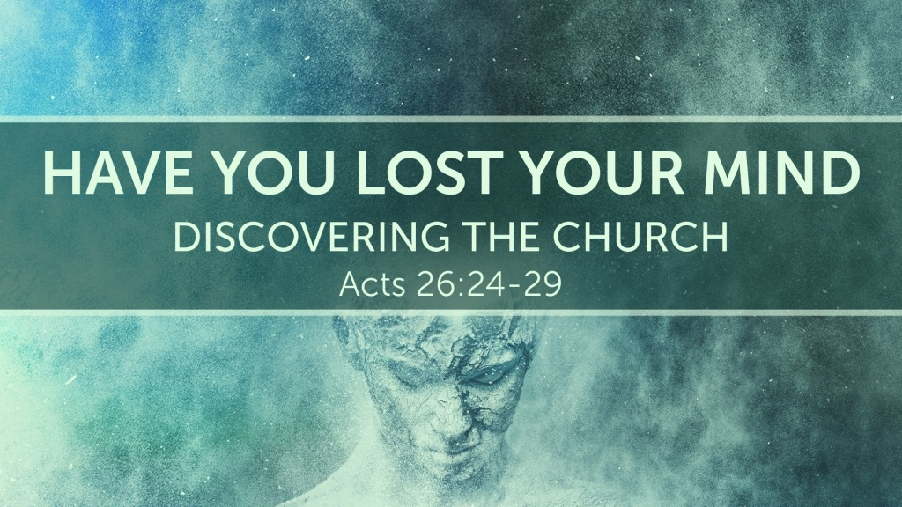
Acts 26:24–29 ESV
²⁴ And as he was saying these things in his defense, Festus said with a loud voice, “Paul, you are out of your mind; your great learning is driving you out of your mind.” ²⁵ But Paul said, “I am not out of my mind, most excellent Festus, but I am speaking true and rational words. ²⁶ For the king knows about these things, and to him I speak boldly. For I am persuaded that none of these things has escaped his notice, for this has not been done in a corner. ²⁷ King Agrippa, do you believe the prophets? I know that you believe.” ²⁸ And Agrippa said to Paul, “In a short time would you persuade me to be a Christian?” ²⁹ And Paul said, “Whether short or long, I would to God that not only you but also all who hear me this day might become such as I am—except for these chains.”

Introduction
John 10:20 ESV
²⁰ Many of them said, “He has a demon, and is insane; why listen to him?”
Mark 3:21 ESV
²¹ And when his family heard it, they went out to seize him, for they were saying, “He is out of his mind.”
Acts 12:15 ESV
¹⁵ They said to her, “You are out of your mind.” But she kept insisting that it was so, and they kept saying, “It is his angel!”

On Trial by the World
Acts 17:32 ESV
³² Now when they heard of the resurrection of the dead, some mocked. But others said, “We will hear you again about this.”
Jeremiah 29:26 ESV
²⁶ ‘The Lord has made you priest instead of Jehoiada the priest, to have charge in the house of the Lord over every madman who prophesies, to put him in the stocks and neck irons.

Witnessing to Worldly Foolishness
Romans 1:14 ESV
¹⁴ I am under obligation both to Greeks and to barbarians, both to the wise and to the foolish.
1 Corinthians 1:20 ESV
²⁰ Where is the one who is wise? Where is the scribe? Where is the debater of this age? Has not God made foolish the wisdom of the world?
1 Corinthians 1:27 ESV
²⁷ But God chose what is foolish in the world to shame the wise; God chose what is weak in the world to shame the strong;
Titus 3:3 ESV
³ For we ourselves were once foolish, disobedient, led astray, slaves to various passions and pleasures, passing our days in malice and envy, hated by others and hating one another.

Speaking True and Rational Words
2 Peter 1:16 ESV
¹⁶ For we did not follow cleverly devised myths when we made known to you the power and coming of our Lord Jesus Christ, but we were eyewitnesses of his majesty.
2 Corinthians 5:13 ESV
¹³ For if we are beside ourselves, it is for God; if we are in our right mind, it is for you.
1 Corinthians 1:21 ESV
²¹ For since, in the wisdom of God, the world did not know God through wisdom, it pleased God through the folly of what we preach to save those who believe.
1 Corinthians 2:13–14 ESV
¹³ And we impart this in words not taught by human wisdom but taught by the Spirit, interpreting spiritual truths to those who are spiritual. ¹⁴ The natural person does not accept the things of the Spirit of God, for they are folly to him, and he is not able to understand them because they are spiritually discerned.

Conclusion

Are you on trial today?

Have you been proclaiming the foolishness of the Gospel?

Do you know the true and rational words that saves the souls of men?

God’s Foolish Plan of Salvation

Hear His Foolishness
Romans 10:17 ESV
¹⁷ So faith comes from hearing, and hearing through the word of Christ.

Believe His Foolishness
Hebrews 11:6 ESV
⁶ And without faith it is impossible to please him, for whoever would draw near to God must believe that he exists and that he rewards those who seek him.

Repent of Worldly Wisdom
Luke 13:3 ESV
³ No, I tell you; but unless you repent, you will all likewise perish.

Confess Jesus the Simple Truth
Matthew 10:32–33 ESV
³² So everyone who acknowledges me before men, I also will acknowledge before my Father who is in heaven, ³³ but whoever denies me before men, I also will deny before my Father who is in heaven.

An Act of Foolishness “Be Baptized”
Acts 2:38 ESV
³⁸ And Peter said to them, “Repent and be baptized every one of you in the name of Jesus Christ for the forgiveness of your sins, and you will receive the gift of the Holy Spirit.

Remain Steadfast in the Foolishness of God
Revelation 2:10 ESV
¹⁰ Do not fear what you are about to suffer. Behold, the devil is about to throw some of you into prison, that you may be tested, and for ten days you will have tribulation. Be faithful unto death, and I will give you the crown of life.

