Barry G. Johnson, Sr. / www.bgjsr22.com
Christianity is Reality: Love Conquers Hate / Love; Hate; Scoffer; Ungodliness; Spirit; Faith; Edification; Mercy; Means of Grace / Jude 17–23
Jude reminds us of how to love in a hostile world, by remembering, strengthening, and showing Mercy.
Jude 17–23 ESV
¹⁷ But you must remember, beloved, the predictions of the apostles of our Lord Jesus Christ. ¹⁸ They said to you, “In the last time there will be scoffers, following their own ungodly passions.” ¹⁹ It is these who cause divisions, worldly people, devoid of the Spirit. ²⁰ But you, beloved, building yourselves up in your most holy faith and praying in the Holy Spirit, ²¹ keep yourselves in the love of God, waiting for the mercy of our Lord Jesus Christ that leads to eternal life. ²² And have mercy on those who doubt; ²³ save others by snatching them out of the fire; to others show mercy with fear, hating even the garment stained by the flesh.

Remember what the Apostles said
1 Corinthians 15:2 ESV
² and by which you are being saved, if you hold fast to the word I preached to you—unless you believed in vain.
Acts 20:28–31 ESV
²⁸ Pay careful attention to yourselves and to all the flock, in which the Holy Spirit has made you overseers, to care for the church of God, which he obtained with his own blood. ²⁹ I know that after my departure fierce wolves will come in among you, not sparing the flock; ³⁰ and from among your own selves will arise men speaking twisted things, to draw away the disciples after them. ³¹ Therefore be alert, remembering that for three years I did not cease night or day to admonish every one with tears.
1 Timothy 4:1 ESV
¹ Now the Spirit expressly says that in later times some will depart from the faith by devoting themselves to deceitful spirits and teachings of demons,

Strengthen your Faith
Psalm 119:9 ESV
⁹ How can a young man keep his way pure? By guarding it according to your word.
1 Thessalonians 5:25 ESV
²⁵ Brothers, pray for us.

Expect the Mercy of God
Matthew 5:7 ESV
⁷ “Blessed are the merciful, for they shall receive mercy.
Matthew 9:27 ESV
²⁷ And as Jesus passed on from there, two blind men followed him, crying aloud, “Have mercy on us, Son of David.”
Matthew 15:22 ESV
²² And behold, a Canaanite woman from that region came out and was crying, “Have mercy on me, O Lord, Son of David; my daughter is severely oppressed by a demon.”
Matthew 17:15 ESV
¹⁵ said, “Lord, have mercy on my son, for he has seizures and he suffers terribly. For often he falls into the fire, and often into the water.
Matthew 20:30 ESV
³⁰ And behold, there were two blind men sitting by the roadside, and when they heard that Jesus was passing by, they cried out, “Lord, have mercy on us, Son of David!”
Galatians 6:10 ESV
¹⁰ So then, as we have opportunity, let us do good to everyone, and especially to those who are of the household of faith.
1 Timothy 1:5 ESV
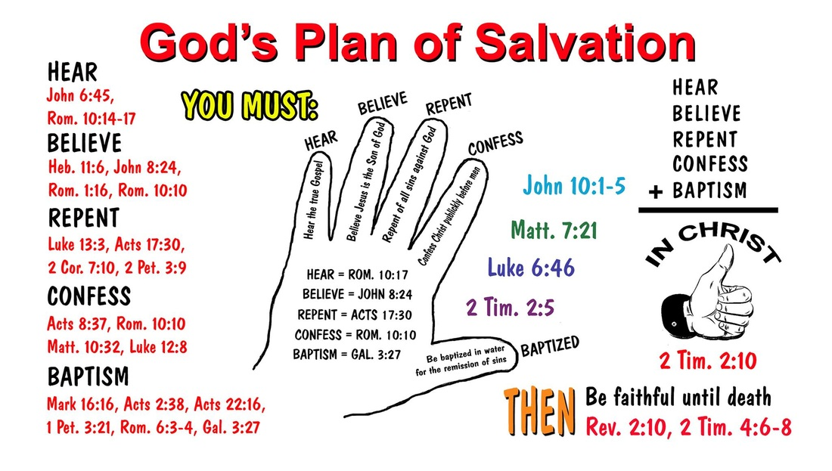
⁵ The aim of our charge is love that issues from a pure heart and a good conscience and a sincere faith.

