Jesus, The Way Series
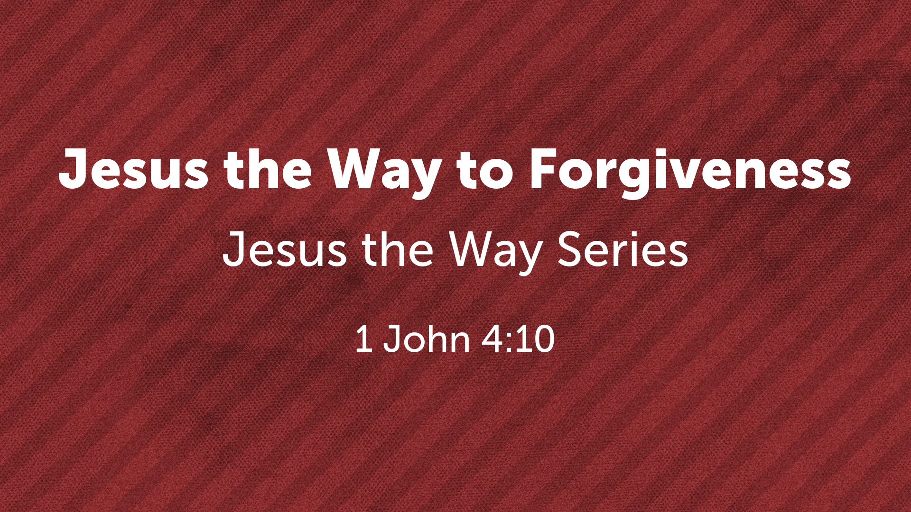
Barry G. Johnson, Sr. / www.barrygjohnsonsr.com
Jesus the Way / Forgiveness; Sin / 1 John 4:10

I. THE DEFINITION OF SIN

A. SOME MISCONCEPTIONS OF SIN...

B. THE BIBLICAL DEFINITION OF SIN...
1 John 3:4 ESV
⁴ Everyone who makes a practice of sinning also practices lawlessness; sin is lawlessness.
James 4:17 ESV
¹⁷ So whoever knows the right thing to do and fails to do it, for him it is sin.
Romans 14:23 ESV
²³ But whoever has doubts is condemned if he eats, because the eating is not from faith. For whatever does not proceed from faith is sin.
Romans 6:23 ESV
²³ For the wages of sin is death, but the free gift of God is eternal life in Christ Jesus our Lord.
Revelation 21:8 ESV
⁸ But as for the cowardly, the faithless, the detestable, as for murderers, the sexually immoral, sorcerers, idolaters, and all liars, their portion will be in the lake that burns with fire and sulfur, which is the second death.”
Revelation 20:10 ESV
¹⁰ and the devil who had deceived them was thrown into the lake of fire and sulfur where the beast and the false prophet were, and they will be tormented day and night forever and ever.

II. THE NATURE OF GOD AND THE PROBLEM OF SIN

A. GOD’S NATURE...
Psalm 5:4–6 ESV
⁴ For you are not a God who delights in wickedness; evil may not dwell with you.
⁵ The boastful shall not stand before your eyes; you hate all evildoers.
⁶ You destroy those who speak lies; the Lord abhors the bloodthirsty and deceitful man.
Isaiah 59:1–2 ESV
¹ Behold, the Lord’s hand is not shortened, that it cannot save, or his ear dull, that it cannot hear;
² but your iniquities have made a separation between you and your God, and your sins have hidden his face from you so that he does not hear.

B. SIN’S PROBLEM...
Romans 3:23 ESV
²³ for all have sinned and fall short of the glory of God,
Revelation 21:8 ESV
⁸ But as for the cowardly, the faithless, the detestable, as for murderers, the sexually immoral, sorcerers, idolaters, and all liars, their portion will be in the lake that burns with fire and sulfur, which is the second death.”
James 2:10 ESV
¹⁰ For whoever keeps the whole law but fails in one point has become guilty of all of it.

III.JESUS, THE WAY TO FORGIVENESS OF SINS

A. HE IS THE PROPITIATION FOR SIN...
1 John 4:10 ESV
¹⁰ In this is love, not that we have loved God but that he loved us and sent his Son to be the propitiation for our sins.
Isaiah 53:5–6 ESV
⁵ But he was pierced for our transgressions; he was crushed for our iniquities; upon him was the chastisement that brought us peace, and with his wounds we are healed.
⁶ All we like sheep have gone astray; we have turned—every one—to his own way; and the Lord has laid on him the iniquity of us all.
Isaiah 53:10–11 ESV
¹⁰ Yet it was the will of the Lord to crush him; he has put him to grief; when his soul makes an offering for guilt, he shall see his offspring; he shall prolong his days; the will of the Lord shall prosper in his hand.
¹¹ Out of the anguish of his soul he shall see and be satisfied; by his knowledge shall the righteous one, my servant, make many to be accounted righteous, and he shall bear their iniquities.
Isaiah 53:11 ESV
¹¹ Out of the anguish of his soul he shall see and be satisfied; by his knowledge shall the righteous one, my servant, make many to be accounted righteous, and he shall bear their iniquities.
Ephesians 1:7 ESV
⁷ In him we have redemption through his blood, the forgiveness of our trespasses, according to the riches of his grace,

B. RECEIVING JESUS AS THE WAY TO FORGIVENESS...
Acts 2:36 ESV
³⁶ Let all the house of Israel therefore know for certain that God has made him both Lord and Christ, this Jesus whom you crucified.”
Acts 2:37 ESV
³⁷ Now when they heard this they were cut to the heart, and said to Peter and the rest of the apostles, “Brothers, what shall we do?”
Acts 2:38 ESV
³⁸ And Peter said to them, “Repent and be baptized every one of you in the name of Jesus Christ for the forgiveness of your sins, and you will receive the gift of the Holy Spirit.
Acts 22:16 ESV
¹⁶ And now why do you wait? Rise and be baptized and wash away your sins, calling on his name.’
Galatians 3:27 ESV
²⁷ For as many of you as were baptized into Christ have put on Christ.
Hebrews 5:9 ESV
⁹ And being made perfect, he became the source of eternal salvation to all who obey him,

God’s Salvation Invitation

Hear - Believe - Confess - Repent - Be Baptized - Be Faithful
Matthew 7:24 ESV
²⁴ “Everyone then who hears these words of mine and does them will be like a wise man who built his house on the rock.
John 1:12 ESV
¹² But to all who did receive him, who believed in his name, he gave the right to become children of God,
1 John 2:23 ESV
²³ No one who denies the Son has the Father. Whoever confesses the Son has the Father also.
Luke 13:3 ESV
³ No, I tell you; but unless you repent, you will all likewise perish.
Galatians 3:27 ESV
²⁷ For as many of you as were baptized into Christ have put on Christ.
James 1:3–4 ESV
³ for you know that the testing of your faith produces steadfastness. ⁴ And let steadfastness have its full effect, that you may be perfect and complete, lacking in nothing.

