Jesus the Way to God
Jesus the Way to God
Barry G. Johnson, Sr. / General
Jesus the Way / God; Jesus / John 14:6
It is Jesus that shows us the Father that we might draw closer to Him in relationship as the family of God.
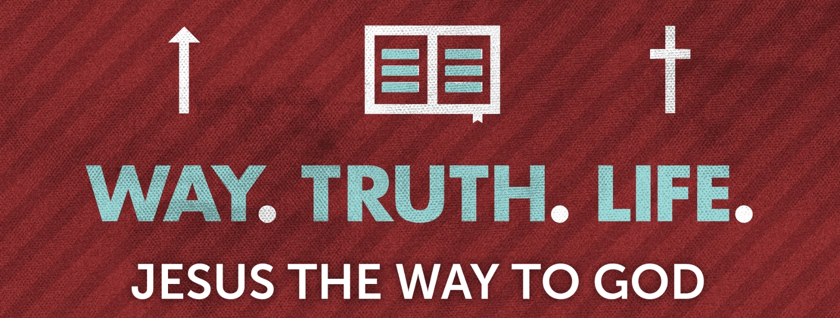

Questions to Stimulate Your Thinking...
1. What did Job wished he had between himself and God? (Job 9:33)
A mediator.
2. How is Jesus described in John 1:18?
The only begotten Son.
3. How can Jesus be a sympathetic High Priest? (Hebrews 4:15)
He was in all points tempted as we are, yet without sin.
4. If one does not have the Son, what else do they not have? (1 John 5:12)
Life.

5. What is the only way to the Father? (John 14:6)
Through Jesus.
6. What do we have through the blood of Jesus? (Ephesians 1:7)
Redemption, the forgiveness of sins.
7. How can both Jew and Gentile have access to the Father? (Ephesians 2:18)
Through Jesus.
8. What has God done through Jesus Christ? (2 Corinthians 5:18)
Reconciled us unto Himself.
9. What do we become through faith in Christ Jesus? (Galatians 3:26)
Sons of God.
10. Where is the eternal life that God gives? (1 John 5:11)
In His Son.
11. What is Jesus called in these passages: 1 Timothy 2:5; Hebrews 4:14; John 14:6; Ephesians 2:14?
Mediator between God and man; a great High Priest; the way, the truth, and the life; our peace.

