Synopsis
The death of Jesus Christ by crucifixion is of central importance to the NT. Through the faithful, obedient death of Christ, God grants sinners forgiveness and eternal life. The Christian sacraments of baptism and the Lord’s Supper focus upon the death of Christ.
- Jesus Christ’s death was foretold
It has always been in the mind of God to redeem His creation in this fashion. Principalities, Dominions, Rulers, Authorities could not stop Him.
- In time and in eternity
The oracles of God promised a Messiah, a sacrifice, a Lamb for us.
Revelation 13:8 (NIV) — 8 All inhabitants of the earth will worship the beast—all whose names have not been written in the Lamb’s book of life, the Lamb who was slain from the creation of the world.
Also ref.
Isaiah 53:10–12 (NIV) — 10 Yet it was the Lord’s will to crush him and cause him to suffer, and though the Lord makes his life an offering for sin, he will see his offspring and prolong his days, and the will of the Lord will prosper in his hand. 11 After he has suffered, he will see the light of life and be satisfied; by his knowledge my righteous servant will justify many, and he will bear their iniquities. 12 Therefore I will give him a portion among the great, and he will divide the spoils with the strong, because he poured out his life unto death, and was numbered with the transgressors. For he bore the sin of many, and made intercession for the transgressors.
Zechariah 12:10 (NIV) — 10 “And I will pour out on the house of David and the inhabitants of Jerusalem a spirit of grace and supplication. They will look on me, the one they have pierced, and they will mourn for him as one mourns for an only child, and grieve bitterly for him as one grieves for a firstborn son.
John 1:29 (NIV) — 29 The next day John saw Jesus coming toward him and said, “Look, the Lamb of God, who takes away the sin of the world!
- By Jesus Christ himself
Jesus prediction of His death aligns who He is with scripture.
Matthew 16:21 (NIV) — 21 From that time on Jesus began to explain to his disciples that he must go to Jerusalem and suffer many things at the hands of the elders, the chief priests and the teachers of the law, and that he must be killed and on the third day be raised to life.
Also ref.
Matthew 17:22–23 (NIV) — 22 When they came together in Galilee, he said to them, “The Son of Man is going to be delivered into the hands of men. 23 They will kill him, and on the third day he will be raised to life.” And the disciples were filled with grief.
Matthew 26:12 (NIV) — 12 When she poured this perfume on my body, she did it to prepare me for burial.
John 16:16 (NIV) — 16 Jesus went on to say, “In a little while you will see me no more, and then after a little while you will see me.”
John 16:28 (NIV) — 28 I came from the Father and entered the world; now I am leaving the world and going back to the Father.”
John 18:4 (NIV) — 4 Jesus, knowing all that was going to happen to him, went out and asked them, “Who is it you want?”
- Jesus Christ willingly planned to give his life
We should never forget that Jesus did what He did knowing full well what was ahead.
John 10:11 (NIV) — 11 “I am the good shepherd. The good shepherd lays down his life for the sheep.
Also ref.
John 10:15 (NIV) — 15 just as the Father knows me and I know the Father—and I lay down my life for the sheep.
John 10:17–18 (NIV) — 17 The reason my Father loves me is that I lay down my life—only to take it up again. 18 No one takes it from me, but I lay it down of my own accord. I have authority to lay it down and authority to take it up again. This command I received from my Father.”
John 13:1 (NIV) — 1 It was just before the Passover Festival. Jesus knew that the hour had come for him to leave this world and go to the Father. Having loved his own who were in the world, he loved them to the end.
John 15:13 (NIV) — 13 Greater love has no one than this: to lay down one’s life for one’s friends.
1 John 3:16 (NIV) — 16 This is how we know what love is: Jesus Christ laid down his life for us. And we ought to lay down our lives for our brothers and sisters.
- Plots to kill Jesus Christ
Understand that there were plots to kill Jesus, just like there are plots to kill His followers.
Mark 3:6 (NIV) — 6 Then the Pharisees went out and began to plot with the Herodians how they might kill Jesus.
Also ref.
Matthew 26:4 (NIV) — 4 and they schemed to arrest Jesus secretly and kill him.
Luke 13:31 (NIV) — 31 At that time some Pharisees came to Jesus and said to him, “Leave this place and go somewhere else. Herod wants to kill you.”
Luke 19:47 (NIV) — 47 Every day he was teaching at the temple. But the chief priests, the teachers of the law and the leaders among the people were trying to kill him.
John 5:18 (NIV) — 18 For this reason they tried all the more to kill him; not only was he breaking the Sabbath, but he was even calling God his own Father, making himself equal with God.
John 7:25 (NIV) — 25 At that point some of the people of Jerusalem began to ask, “Isn’t this the man they are trying to kill?
John 8:37 (NIV) — 37 I know that you are Abraham’s descendants. Yet you are looking for a way to kill me, because you have no room for my word.
John 8:40 (NIV) — 40 As it is, you are looking for a way to kill me, a man who has told you the truth that I heard from God. Abraham did not do such things.
- Believers identify with Jesus Christ in his death
Jesus prediction of His death points to the importance of His death for us. That is why He tells us.
Romans 6:3–8 (NIV) — 3 Or don’t you know that all of us who were baptized into Christ Jesus were baptized into his death? 4 We were therefore buried with him through baptism into death in order that, just as Christ was raised from the dead through the glory of the Father, we too may live a new life. 5 For if we have been united with him in a death like his, we will certainly also be united with him in a resurrection like his. 6 For we know that our old self was crucified with him so that the body ruled by sin might be done away with, that we should no longer be slaves to sin—7 because anyone who has died has been set free from sin. 8 Now if we died with Christ, we believe that we will also live with him.
Also ref.
2 Corinthians 5:14–15 (NIV) — 14 For Christ’s love compels us, because we are convinced that one died for all, and therefore all died. 15 And he died for all, that those who live should no longer live for themselves but for him who died for them and was raised again.
Galatians 2:20 (NIV) — 20 I have been crucified with Christ and I no longer live, but Christ lives in me. The life I now live in the body, I live by faith in the Son of God, who loved me and gave himself for me.
Colossians 2:11 (NIV) — 11 In him you were also circumcised with a circumcision not performed by human hands. Your whole self ruled by the flesh was put off when you were circumcised by Christ,
2 Timothy 2:11 (NIV) — 11 Here is a trustworthy saying: If we died with him, we will also live with him;

Invitation
Hear - Romans 10:17 (NIV)
¹⁷ Consequently, faith comes from hearing the message, and the message is heard through the word about Christ.
Believe - Hebrews 11:6 (NIV)
⁶ And without faith it is impossible to please God, because anyone who comes to him must believe that he exists and that he rewards those who earnestly seek him.
Repent - Acts 17:30 (NIV)
³⁰ In the past God overlooked such ignorance, but now he commands all people everywhere to repent.
Confess - Matthew 10:32–33 (NIV)
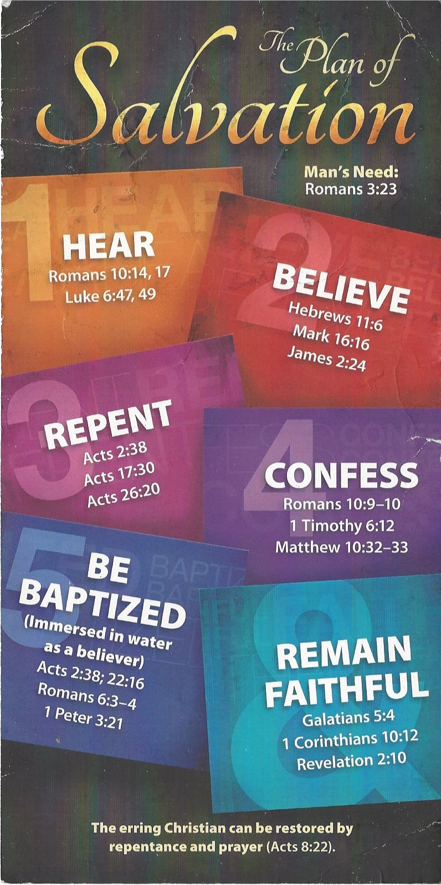
³² “Whoever acknowledges me before others, I will also acknowledge before my Father in heaven. ³³ But whoever disowns me before others, I will disown before my Father in heaven.
Be Baptized - Acts 22:16 (NIV)
¹⁶ And now what are you waiting for? Get up, be baptized and wash your sins away, calling on his name.’
Remain Steadfast - Revelation 2:10 (NIV)
¹⁰ Do not be afraid of what you are about to suffer. I tell you, the devil will put some of you in prison to test you, and you will suffer persecution for ten days. Be faithful, even to the point of death, and I will give you life as your victor’s crown.

