Barry G. Johnson, Sr.
Discovering the Church / Idolatry; Gospel; Humility; Worship; Apostleship / Acts 14:8–18

Paul and Barnabas are mistakenly received as gods. They quickly correct the mistake of the Gentiles about who the real God is and that they are only men.
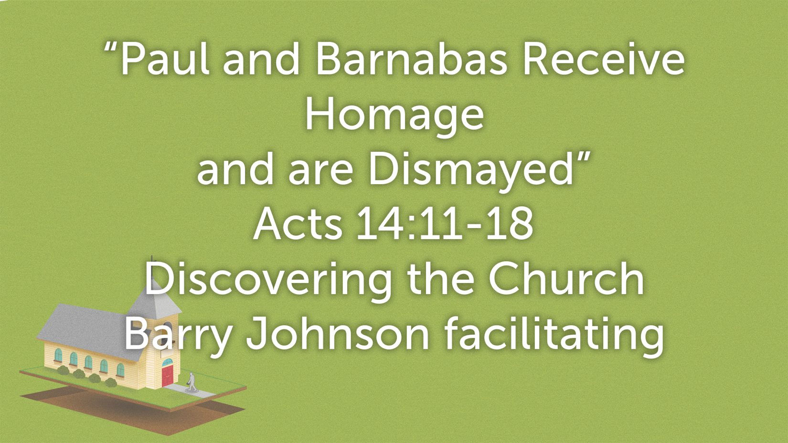

Wrong Response to the Miracle
Acts 14:11–13 ESV
¹¹ And when the crowds saw what Paul had done, they lifted up their voices, saying in Lycaonian, “The gods have come down to us in the likeness of men!”
¹² Barnabas they called Zeus, and Paul, Hermes, because he was the chief speaker.
¹³ And the priest of Zeus, whose temple was at the entrance to the city, brought oxen and garlands to the gates and wanted to offer sacrifice with the crowds.
Question: Who did the crowds mistake Paul and Barnabas to be?

Right Response to the Praise of Men
Acts 14:14–15 ESV
¹⁴ But when the apostles Barnabas and Paul heard of it, they tore their garments and rushed out into the crowd, crying out,
¹⁵ “Men, why are you doing these things? We also are men, of like nature with you, and we bring you good news, that you should turn from these vain things to a living God, who made the heaven and the earth and the sea and all that is in them.

Designation of Apostles

Jesus Christ as an Apostle
See also Mt 10:40; Mk 9:37; Jn 5:23–24; Jn 12:44–45

The Twelve Apostles called by Jesus Christ

Their appointment
Mk 3:13–19

Their number
John 6:70 ESV
⁷⁰ Jesus answered them, “Did I not choose you, the twelve? And yet one of you is a devil.”
See also Mt 19:28; Mt 20:17; Mk 11:11; Lk 8:1; Ac 6:2; 1 Co 15:5; Re 21:14

Their commissioning by the risen Christ
Mt 28:18–20

The replacement for Judas
See also Ac 1:15–26 The symbolic number (twelve) is thus preserved.

The qualifications for being an Apostle
Ac 1:21–22

Paul as an Apostle

His self-designation
Ga 1:1
See also Ro 1:1; 1 Co 1:1; 1 Ti 2:7

His commissioning by Jesus Christ
Ac 26:12–18 Although not one of the Twelve, Paul saw the risen Christ and was directly commissioned by him, sent especially to the Gentiles; 1 Co 15:3–10; Ga 2:8

Paul’s Apostleship and the Church
1 Co 9:1–2 In Paul’s case the sense of title or office and the ministry and function virtually coincide. He is an apostle both because he has seen and been commissioned by the risen Christ and because he functioned as an apostle by founding churches.

Other Apostles

Barnabas
Here “apostles” may refer to their ministry as missionary evangelists or to their role as “sent” by the church at Antioch:
Ac 13:1-3; Ac 14:4; Ac 14:14

James, the Lord’s brother
1 Co 15:7 The most natural meaning of the words is that James is an apostle. This interpretation is confirmed by other references to James; Ga 1:19; Ga 2:9

Andronicus? and Junias?
Ro 16:7

Silas
1 Th 2:6

False apostles
2 Co 11:5 Paul ironically refers to his opponents as “super-apostles”; 2 Co 11:13; 2 Co 12:11; Re 2:2

Setting the Record Straight
Acts 14:15–17 ESV
¹⁵ “Men, why are you doing these things? We also are men, of like nature with you, and we bring you good news, that you should turn from these vain things to a living God, who made the heaven and the earth and the sea and all that is in them.
¹⁶ In past generations he allowed all the nations to walk in their own ways.
¹⁷ Yet he did not leave himself without witness, for he did good by giving you rains from heaven and fruitful seasons, satisfying your hearts with food and gladness.”
Question: Why didn’t Paul and Barnabas accept the worship of the crowd?

Old Habits Die Hard
Acts 14:18 ESV
¹⁸ Even with these words they scarcely restrained the people from offering sacrifice to them.
Question: What tendency do people demonstrate when moving from one faith to another in view of verse 18?

Acts 14:11–18

