Barry G. Johnson, Sr. / www.bgjsr22.com
Christianity is Reality: There is Good and Evil / Good; Evil; Tree of the Knowledge of Good and Evil; Tree of Knowledge / Genesis 2:15–17
We need God in order to deal with our knowledge of Good and Evil.
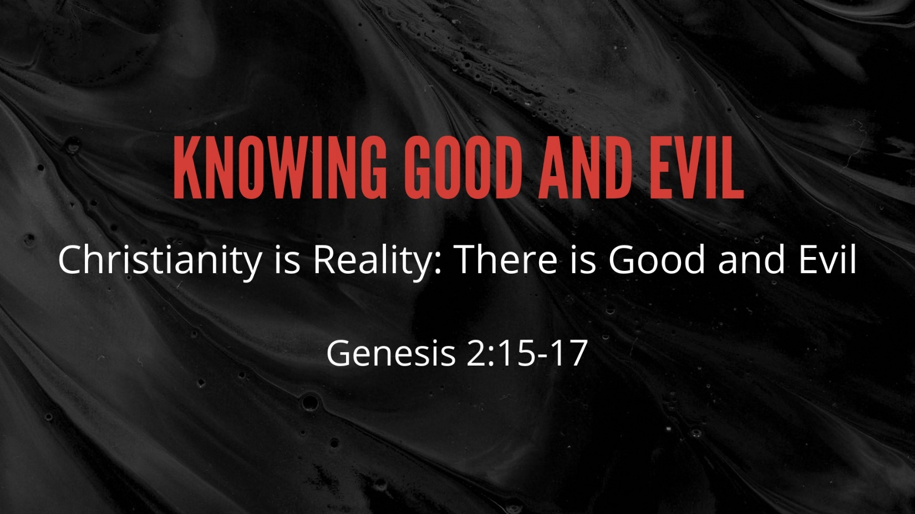
Genesis 2:15–17 ESV
¹⁵ The Lord God took the man and put him in the garden of Eden to work it and keep it. ¹⁶ And the Lord God commanded the man, saying, “You may surely eat of every tree of the garden, ¹⁷ but of the tree of the knowledge of good and evil you shall not eat, for in the day that you eat of it you shall surely die.”
Central Idea:
We need God in order to deal with our knowledge of Good and Evil.

The Definition of Evil
Evil is a deprivation of Good
• It is like rust in a car
• it is like rot in a tree
• It is like the cut on your arm
• It cannot exist on its own it can only exist as a lack in a good thing

The Definition of Good
Good is the character of God and the standard that is established by His Being.
• Good is God’s purpose
• Good is God’s intent
• Good is what God would call well pleasing
• Good is desirable

The Reality of Evil
Romans 3:23 ESV
²³ for all have sinned and fall short of the glory of God,
1 John 1:8 ESV
⁸ If we say we have no sin, we deceive ourselves, and the truth is not in us.

The Reality of Good
Romans 7:18 ESV
¹⁸ For I know that nothing good dwells in me, that is, in my flesh. For I have the desire to do what is right, but not the ability to carry it out.
Mark 10:18 ESV
¹⁸ And Jesus said to him, “Why do you call me good? No one is good except God alone.
Romans 12:2 ESV
² Do not be conformed to this world, but be transformed by the renewal of your mind, that by testing you may discern what is the will of God, what is good and acceptable and perfect.
Acts 10:38 ESV
³⁸ how God anointed Jesus of Nazareth with the Holy Spirit and with power. He went about doing good and healing all who were oppressed by the devil, for God was with him.
2 Corinthians 9:8 ESV
⁸ And God is able to make all grace abound to you, so that having all sufficiency in all things at all times, you may abound in every good work.
Ephesians 2:10 ESV
¹⁰ For we are his workmanship, created in Christ Jesus for good works, which God prepared beforehand, that we should walk in them.
Philippians 2:13 ESV
¹³ for it is God who works in you, both to will and to work for his good pleasure.

The Knowledge of Good and Evil
Romans 1:21 ESV
²¹ For although they knew God, they did not honor him as God or give thanks to him, but they became futile in their thinking, and their foolish hearts were darkened.
Romans 1:23 ESV
²³ and exchanged the glory of the immortal God for images resembling mortal man and birds and animals and creeping things.
Romans 1:25 ESV
²⁵ because they exchanged the truth about God for a lie and worshiped and served the creature rather than the Creator, who is blessed forever! Amen.
Romans 1:28 ESV
²⁸ And since they did not see fit to acknowledge God, God gave them up to a debased mind to do what ought not to be done.

The Effects of the Reality of Good and Evil

Lack of peace of mind
Isaiah 57:20–21 ESV
²⁰ But the wicked are like the tossing sea;
for it cannot be quiet,
and its waters toss up mire and dirt.
²¹ There is no peace,” says my God, “for the wicked.”

Bondage to a continuing habit of sin
John 8:34 ESV
³⁴ Jesus answered them, “Truly, truly, I say to you, everyone who practices sin is a slave to sin.

Physical death
1 Corinthians 15:56 ESV
⁵⁶ The sting of death is sin, and the power of sin is the law.

The sinful life is equivalent to death
Ephesians 2:1 ESV
¹ And you were dead in the trespasses and sins

Separation from God
Isaiah 59:2 ESV
² but your iniquities have made a separation between you and your God,
and your sins have hidden his face from you
so that he does not hear.
Ephesians 2:12 ESV
¹² remember that you were at that time separated from Christ, alienated from the commonwealth of Israel and strangers to the covenants of promise, having no hope and without God in the world.

God’s Plan of Salvation

Hear – Romans 10:17

Believe – John 8:24

Confess - 1 Timothy 6:13

Repent - Luke 13:3

Be Baptized – Acts 2:38

Be Faithful – Revelation 2:10

