Barry G. Johnson, Sr. / www.barrygjohnsonsr.com
Natural Evangelism: Entering the Field / Evangelism; Friendship; A Friend / Acts 16:30–34
An attitude of care and concern, toward others. Christian compassion towards others should reflect the compassion of God for his people.
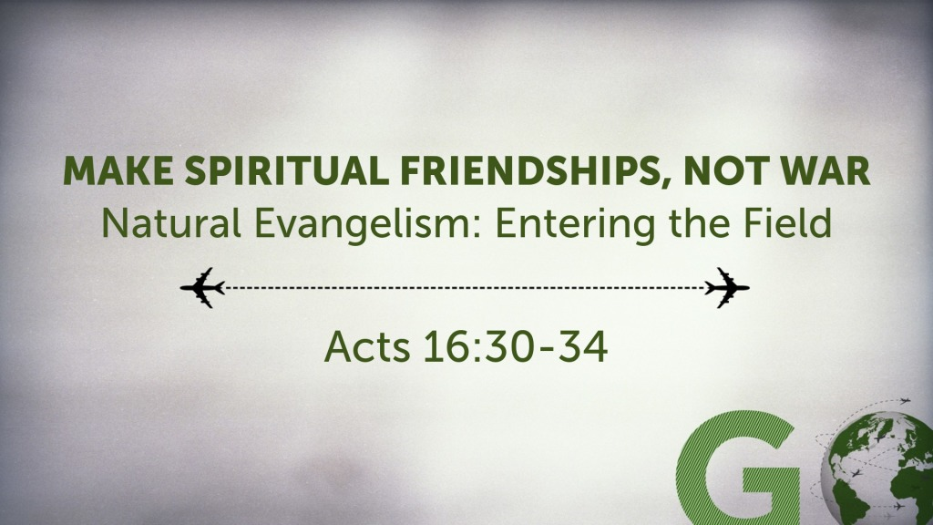
Acts 16:30–34 (ESV)
³⁰ Then he brought them out and said, “Sirs, what must I do to be saved?” ³¹ And they said, “Believe in the Lord Jesus, and you will be saved, you and your household.” ³² And they spoke the word of the Lord to him and to all who were in his house. ³³ And he took them the same hour of the night and washed their wounds; and he was baptized at once, he and all his family. ³⁴ Then he brought them up into his house and set food before them. And he rejoiced along with his entire household that he had believed in God.

I. Compassion a vital Christian character
Ephesians 4:32 ESV
³² Be kind to one another, tenderhearted, forgiving one another, as God in Christ forgave you.
Colossians 3:12 ESV
¹² Put on then, as God’s chosen ones, holy and beloved, compassionate hearts, kindness, humility, meekness, and patience,

II. Compassion needs to be shown in actions
1 John 3:17 ESV
¹⁷ But if anyone has the world’s goods and sees his brother in need, yet closes his heart against him, how does God’s love abide in him?
Matthew 10:42 ESV
⁴² And whoever gives one of these little ones even a cup of cold water because he is a disciple, truly, I say to you, he will by no means lose his reward.”
Matthew 25:35–36 ESV
³⁵ For I was hungry and you gave me food, I was thirsty and you gave me drink, I was a stranger and you welcomed me, ³⁶ I was naked and you clothed me, I was sick and you visited me, I was in prison and you came to me.’
Acts 20:35 ESV
³⁵ In all things I have shown you that by working hard in this way we must help the weak and remember the words of the Lord Jesus, how he himself said, ‘It is more blessed to give than to receive.’ ”

III. God inspires human compassion
Daniel 1:9 ESV
⁹ And God gave Daniel favor and compassion in the sight of the chief of the eunuchs,
Exodus 3:21 ESV
²¹ And I will give this people favor in the sight of the Egyptians; and when you go, you shall not go empty,

Psalm 106:46 ESV
⁴⁶ He caused them to be pitied
by all those who held them captive.

IV. God rewards compassion
Proverbs 14:21 ESV
²¹ Whoever despises his neighbor is a sinner,
but blessed is he who is generous to the poor.
Psalm 112:4–5 ESV
⁴ Light dawns in the darkness for the upright;
he is gracious, merciful, and righteous.
⁵ It is well with the man who deals generously and lends;
who conducts his affairs with justice.
Proverbs 19:17 ESV
¹⁷ Whoever is generous to the poor lends to the Lord,
and he will repay him for his deed.

V. Lack of compassion
Psalm 69:20 ESV
²⁰ Reproaches have broken my heart,
so that I am in despair.
I looked for pity, but there was none,
and for comforters, but I found none.
Psalm 109:16 ESV
¹⁶ For he did not remember to show kindness,
but pursued the poor and needy
and the brokenhearted, to put them to death.

God’s Salvation Invitation

Hear - Believe - Confess - Repent - Be Baptized - Be Faithful
Matthew 7:24 ESV
²⁴ “Everyone then who hears these words of mine and does them will be like a wise man who built his house on the rock.
John 1:12 ESV
¹² But to all who did receive him, who believed in his name, he gave the right to become children of God,
1 John 2:23 ESV
²³ No one who denies the Son has the Father. Whoever confesses the Son has the Father also.
Luke 13:3 ESV
³ No, I tell you; but unless you repent, you will all likewise perish.
Galatians 3:27 ESV
²⁷ For as many of you as were baptized into Christ have put on Christ.
James 1:3–4 ESV
³ for you know that the testing of your faith produces steadfastness. ⁴ And let steadfastness have its full effect, that you may be perfect and complete, lacking in nothing.

