Barry G. Johnson, Sr. / www.bgjsr22.com
Christianity is Reality: All Have Sinned / Sin; Realism; Critical Realism; Truth; Healing / Jeremiah 2:13
Humanity is broken; furthermore, his problem is sin. Man has determined to forsake God and pursue Satan, the world, and the self.
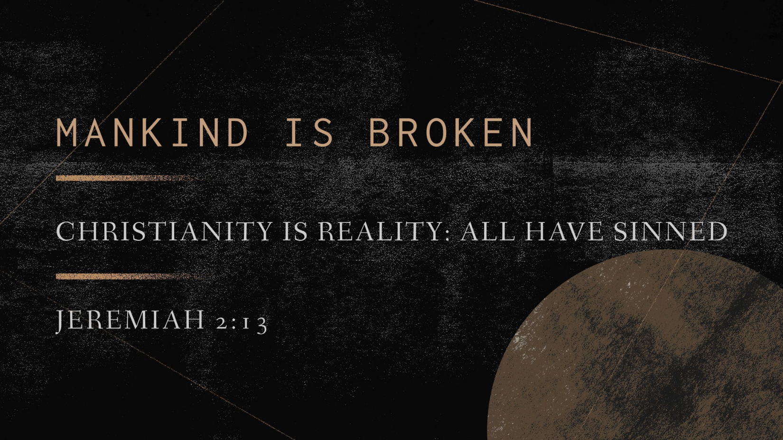
Jeremiah 2:13 ESV
¹³ for my people have committed two evils:
they have forsaken me,
the fountain of living waters,
and hewed out cisterns for themselves,
broken cisterns that can hold no water.

I. The Fountain of living waters—Jesus Christ.

A. No drought can lessen the abundant flow of “living water.”
Revelation 21:6 ESV
⁶ And he said to me, “It is done! I am the Alpha and the Omega, the beginning and the end. To the thirsty I will give from the spring of the water of life without payment.
Revelation 22:1 ESV
¹ Then the angel showed me the river of the water of life, bright as crystal, flowing from the throne of God and of the Lamb

B. No amount of drinking from the Fountain diminishes it; there is no “water rationing.”
John 7:37 ESV
³⁷ On the last day of the feast, the great day, Jesus stood up and cried out, “If anyone thirsts, let him come to me and drink.

II. Man’s isolation from the Fountain.

A. He has forsaken God—the eternal Fountain of living water.
Jeremiah 17:13 ESV
¹³ O Lord, the hope of Israel,
all who forsake you shall be put to shame;
those who turn away from you shall be written in the earth,
for they have forsaken the Lord, the fountain of living water.
John 4:14 ESV
¹⁴ but whoever drinks of the water that I will give him will never be thirsty again. The water that I will give him will become in him a spring of water welling up to eternal life.”

B. He has dug for himself broken cisterns that can hold no water. The broken cisterns consist of any objective, any pursuit, anything that occupies men and excludes God.
Jeremiah 2:11 ESV
¹¹ Has a nation changed its gods,
even though they are no gods?
But my people have changed their glory
for that which does not profit.

III. Man’s invitation to the Fountain.

A. The Lord calls all men to the Fountain (Isa. 55:1).
Isaiah 55:1 ESV
¹ “Come, everyone who thirsts,
come to the waters;
and he who has no money,
come, buy and eat!
Come, buy wine and milk
without money and without price.

B. Jesus calls all men to the Fountain (John 7:37–39).
John 7:37–39 ESV
³⁷ On the last day of the feast, the great day, Jesus stood up and cried out, “If anyone thirsts, let him come to me and drink. ³⁸ Whoever believes in me, as the Scripture has said, ‘Out of his heart will flow rivers of living water.’ ” ³⁹ Now this he said about the Spirit, whom those who believed in him were to receive, for as yet the Spirit had not been given, because Jesus was not yet glorified.

C. The Church calls all men to the Fountain (Rev. 22:17).
Revelation 22:17 ESV
¹⁷ The Spirit and the Bride say, “Come.” And let the one who hears say, “Come.” And let the one who is thirsty come; let the one who desires take the water of life without price.

How to Come to the Living Waters

Hear God’s Word - Romans 10:17

Believe God’s Word - Hebrews 11:6

Repent of your Sins - Luke 13:3

Confess Jesus as the Son of God - 1 John 4:3

Be Baptized for the Remission of Sin - Acts 22:16

Remain Steadfast for Life - 1 Corinthians 15:58

