Barry G. Johnson, Sr. / www.barrygjohnsonsr.com
Discovering the Church / Legalism; False Teaching; Conflict over circumcision in Antioch; New Covenant; New wine; Old Testament / Acts 15:1–5

The natural inclination to infuse ourselves into Christ is better suited to allow Christ to be infused into us.
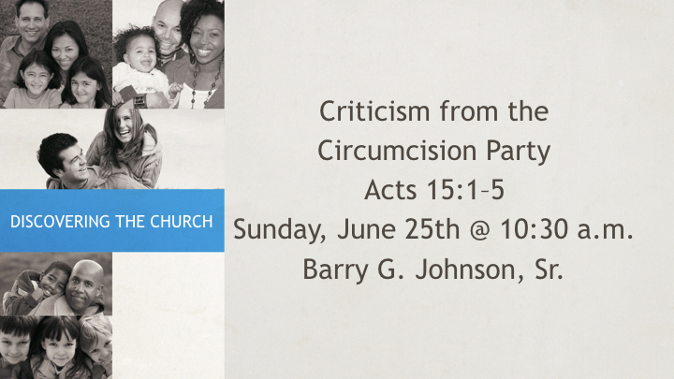
Acts 15:1–5 (ESV)
15 But some men came down from Judea and were teaching the brothers, “Unless you are circumcised according to the custom of Moses, you cannot be saved.” ² And after Paul and Barnabas had no small dissension and debate with them, Paul and Barnabas and some of the others were appointed to go up to Jerusalem to the apostles and the elders about this question. ³ So, being sent on their way by the church, they passed through both Phoenicia and Samaria, describing in detail the conversion of the Gentiles, and brought great joy to all the brothers. ⁴ When they came to Jerusalem, they were welcomed by the church and the apostles and the elders, and they declared all that God had done with them. ⁵ But some believers who belonged to the party of the Pharisees rose up and said, “It is necessary to circumcise them and to order them to keep the law of Moses.”

Matthew 9:16–17 ESV
¹⁶ No one puts a piece of unshrunk cloth on an old garment, for the patch tears away from the garment, and a worse tear is made. ¹⁷ Neither is new wine put into old wineskins. If it is, the skins burst and the wine is spilled and the skins are destroyed. But new wine is put into fresh wineskins, and so both are preserved.”

I. God’s Way versus Man’s Way
John 3:31 ESV
³¹ He who comes from above is above all. He who is of the earth belongs to the earth and speaks in an earthly way. He who comes from heaven is above all.
Matthew 4:4 ESV
⁴ But he answered, “It is written, “ ‘Man shall not live by bread alone, but by every word that comes from the mouth of God.’ ”
Matthew 16:23 ESV
²³ But he turned and said to Peter, “Get behind me, Satan! You are a hindrance to me. For you are not setting your mind on the things of God, but on the things of man.”
Matthew 19:26 ESV
²⁶ But Jesus looked at them and said, “With man this is impossible, but with God all things are possible.”

II. Heaven versus Earth
John 3:12 ESV
¹² If I have told you earthly things and you do not believe, how can you believe if I tell you heavenly things?
1 Corinthians 15:40 ESV
⁴⁰ There are heavenly bodies and earthly bodies, but the glory of the heavenly is of one kind, and the glory of the earthly is of another.
1 Corinthians 15:47 ESV
⁴⁷ The first man was from the earth, a man of dust; the second man is from heaven.
2 Corinthians 5:1 ESV
¹ For we know that if the tent that is our earthly home is destroyed, we have a building from God, a house not made with hands, eternal in the heavens.

III. New Testament versus Old Testament
John 5:22–25 ESV
²² For the Father judges no one, but has given all judgment to the Son, ²³ that all may honor the Son, just as they honor the Father. Whoever does not honor the Son does not honor the Father who sent him. ²⁴ Truly, truly, I say to you, whoever hears my word and believes him who sent me has eternal life. He does not come into judgment, but has passed from death to life. ²⁵ “Truly, truly, I say to you, an hour is coming, and is now here, when the dead will hear the voice of the Son of God, and those who hear will live.
Romans 7:6 ESV
⁶ But now we are released from the law, having died to that which held us captive, so that we serve in the new way of the Spirit and not in the old way of the written code.
1 Corinthians 5:7 ESV
⁷ Cleanse out the old leaven that you may be a new lump, as you really are unleavened. For Christ, our Passover lamb, has been sacrificed.
2 Corinthians 5:17 ESV
¹⁷ Therefore, if anyone is in Christ, he is a new creation. The old has passed away; behold, the new has come.
Hebrews 8:13 ESV
¹³ In speaking of a new covenant, he makes the first one obsolete. And what is becoming obsolete and growing old is ready to vanish away.

Invitation God’s Plan of Salvation
