Barry G. Johnson, Sr. / www.bgjsr22.com
Christianity is Reality: Oneness of Scripture / One; Particular / Isaiah 40:25
The quality of being without an equal. Scripture stresses the uniqueness of God and of the salvation that is available only from him. Jesus Christ is the unique mediator between God and humanity.
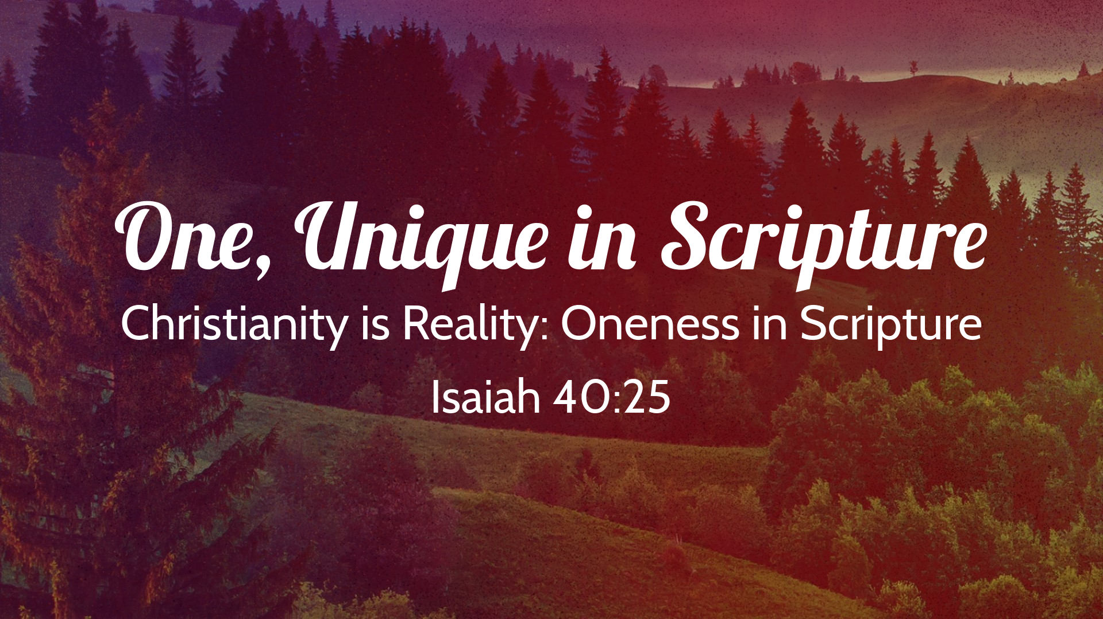

The uniqueness of God
Isaiah 40:25 ESV
To whom then will you compare me,
that I should be like him? says the Holy One.

As a forgiver of sins
Mark 2:7 ESV
“Why does this man speak like that? He is blaspheming! Who can forgive sins but God alone?”

The uniqueness of the Trinity

The three persons are distinct

All use the first-person singular pronoun:
John 12:28 ESV
Father, glorify your name.” Then a voice came from heaven: “I have glorified it, and I will glorify it again.”
John 17:4 ESV
I glorified you on earth, having accomplished the work that you gave me to do.
Acts 13:2 ESV
While they were worshiping the Lord and fasting, the Holy Spirit said, “Set apart for me Barnabas and Saul for the work to which I have called them.”

God is one
Deuteronomy 6:4 ESV
“Hear, O Israel: The Lord our God, the Lord is one.

There is plurality in the Godhead
2 Corinthians 13:14 ESV
The grace of the Lord Jesus Christ and the love of God and the fellowship of the Holy Spirit be with you all.

The uniqueness of Jesus Christ

As God’s Son
John 3:16 ESV
“For God so loved the world, that he gave his only Son, that whoever believes in him should not perish but have eternal life.

As the mediator between God and humanity
1 Timothy 2:5 ESV
For there is one God, and there is one mediator between God and men, the man Christ Jesus,

As the sacrifice for sin
Hebrews 7:27 ESV
He has no need, like those high priests, to offer sacrifices daily, first for his own sins and then for those of the people, since he did this once for all when he offered up himself.

As the Saviour
Acts 4:12 ESV
And there is salvation in no one else, for there is no other name under heaven given among men by which we must be saved.”

As the foundation
1 Corinthians 3:11 ESV
For no one can lay a foundation other than that which is laid, which is Jesus Christ.

The uniqueness of Scripture
Jude 3 ESV
Beloved, although I was very eager to write to you about our common salvation, I found it necessary to write appealing to you to contend for the faith that was once for all delivered to the saints.
