Synopsis
The death of Jesus Christ fulfills OT predictions and was clearly anticipated in his teaching.
- The cross foreshadowed in the OT
Psalm 22:1 (NIV) — 1 My God, my God, why have you forsaken me? Why are you so far from saving me, so far from my cries of anguish?
See also:
Genesis 3:15 (NIV) — 15 And I will put enmity between you and the woman, and between your offspring and hers; he will crush your head, and you will strike his heel.”
Psalm 22:6–7 (NIV) — 6 But I am a worm and not a man, scorned by everyone, despised by the people. 7 All who see me mock me; they hurl insults, shaking their heads.
Psalm 22:16–18 (NIV) — 16 Dogs surround me, a pack of villains encircles me; they pierce my hands and my feet. 17 All my bones are on display; people stare and gloat over me. 18 They divide my clothes among them and cast lots for my garment.
Psalm 31:5 (NIV) — 5 Into your hands I commit my spirit; deliver me, Lord, my faithful God.
Psalm 69:21 (NIV) — 21 They put gall in my food and gave me vinegar for my thirst.
Isaiah 52:12–13 (NIV) — 12 But you will not leave in haste or go in flight; for the Lord will go before you, the God of Israel will be your rear guard. 13 See, my servant will act wisely; he will be raised and lifted up and highly exalted.
Zechariah 12:10 (NIV) — 10 “And I will pour out on the house of David and the inhabitants of Jerusalem a spirit of grace and supplication. They will look on me, the one they have pierced, and they will mourn for him as one mourns for an only child, and grieve bitterly for him as one grieves for a firstborn son.
Zechariah 13:7 (NIV) — 7 “Awake, sword, against my shepherd, against the man who is close to me!” declares the Lord Almighty. “Strike the shepherd, and the sheep will be scattered, and I will turn my hand against the little ones.
- Jesus Christ predicts his death on the cross
- Jesus Christ’s first announcement of his death
Matthew 16:21 (NIV) — 21 From that time on Jesus began to explain to his disciples that he must go to Jerusalem and suffer many things at the hands of the elders, the chief priests and the teachers of the law, and that he must be killed and on the third day be raised to life.
- Jesus Christ’s second announcement of his death
Matthew 17:22–23 (NIV) — 22 When they came together in Galilee, he said to them, “The Son of Man is going to be delivered into the hands of men. 23 They will kill him, and on the third day he will be raised to life.” And the disciples were filled with grief.
See also:
Mark 9:31 (NIV) — 31 because he was teaching his disciples. He said to them, “The Son of Man is going to be delivered into the hands of men. They will kill him, and after three days he will rise.”
- Jesus Christ’s third announcement of his death
Matthew 20:18–19 (NIV) — 18 “We are going up to Jerusalem, and the Son of Man will be delivered over to the chief priests and the teachers of the law. They will condemn him to death 19 and will hand him over to the Gentiles to be mocked and flogged and crucified. On the third day he will be raised to life!”
- Other allusions to the cross
- In the teaching of Jesus Christ
Matthew 26:31 (NIV) — 31 Then Jesus told them, “This very night you will all fall away on account of me, for it is written: “ ‘I will strike the shepherd, and the sheep of the flock will be scattered.’
See also:
Matthew 20:22 (NIV) — 22 “You don’t know what you are asking,” Jesus said to them. “Can you drink the cup I am going to drink?” “We can,” they answered.
Matthew 26:2 (NIV) — 2 “As you know, the Passover is two days away—and the Son of Man will be handed over to be crucified.”
Mark 2:19–20 (NIV) — 19 Jesus answered, “How can the guests of the bridegroom fast while he is with them? They cannot, so long as they have him with them. 20 But the time will come when the bridegroom will be taken from them, and on that day they will fast.
Mark 10:45 (NIV) — 45 For even the Son of Man did not come to be served, but to serve, and to give his life as a ransom for many.”
Luke 9:44 (NIV) — 44 “Listen carefully to what I am about to tell you: The Son of Man is going to be delivered into the hands of men.”
Luke 22:42 (NIV) — 42 “Father, if you are willing, take this cup from me; yet not my will, but yours be done.”
- “lifted up” is used in John’s Gospel as a reference to the crucifixion:
John 3:14 (NIV) — 14 Just as Moses lifted up the snake in the wilderness, so the Son of Man must be lifted up,
John 8:28 (NIV) — 28 So Jesus said, “When you have lifted up the Son of Man, then you will know that I am he and that I do nothing on my own but speak just what the Father has taught me.
John 12:32–33 (NIV) — 32 And I, when I am lifted up from the earth, will draw all people to myself.” 33 He said this to show the kind of death he was going to die.
John 18:11 (NIV) — 11 Jesus commanded Peter, “Put your sword away! Shall I not drink the cup the Father has given me?”
- In history
Mt 17:9–13 John the Baptist’s fate indicates what is to happen to Jesus Christ.
Matthew 17:9–13 (NIV) — 9 As they were coming down the mountain, Jesus instructed them, “Don’t tell anyone what you have seen, until the Son of Man has been raised from the dead.” 10 The disciples asked him, “Why then do the teachers of the law say that Elijah must come first?” 11 Jesus replied, “To be sure, Elijah comes and will restore all things. 12 But I tell you, Elijah has already come, and they did not recognize him, but have done to him everything they wished. In the same way the Son of Man is going to suffer at their hands.” 13 Then the disciples understood that he was talking to them about John the Baptist.
- In the experience of Jesus Christ
Mt 26:12 Jesus Christ’s reaction to the woman anointing him seems to suggest that he will die the death of a criminal.
Matthew 26:12 (NIV) — 12 When she poured this perfume on my body, she did it to prepare me for burial.
- In the Lord’s Supper
Matthew 26:26–28 (NIV) — 26 While they were eating, Jesus took bread, and when he had given thanks, he broke it and gave it to his disciples, saying, “Take and eat; this is my body.” 27 Then he took a cup, and when he had given thanks, he gave it to them, saying, “Drink from it, all of you. 28 This is my blood of the covenant, which is poured out for many for the forgiveness of sins.
- God’s perfect timing for Jesus Christ’s death on the cross
John 2:4 (NIV) — 4 “Woman, why do you involve me?” Jesus replied. “My hour has not yet come.”
See also:
John 7:6 (NIV) — 6 Therefore Jesus told them, “My time is not yet here; for you any time will do.
John 7:8 (NIV) — 8 You go to the festival. I am not going up to this festival, because my time has not yet fully come.”
John 7:30 (NIV) — 30 At this they tried to seize him, but no one laid a hand on him, because his hour had not yet come.
John 8:20 (NIV) — 20 He spoke these words while teaching in the temple courts near the place where the offerings were put. Yet no one seized him, because his hour had not yet come.
John 13:1 (NIV) — 1 It was just before the Passover Festival. Jesus knew that the hour had come for him to leave this world and go to the Father. Having loved his own who were in the world, he loved them to the end.
John 17:1 (NIV) — 1 After Jesus said this, he looked toward heaven and prayed: “Father, the hour has come. Glorify your Son, that your Son may glorify you.
- The curse of the cross
Dt 21:22–23 To be nailed to a cross is the equivalent of being hanged on a tree.
Deuteronomy 21:22–23 (NIV) — 22 If someone guilty of a capital offense is put to death and their body is exposed on a pole, 23 you must not leave the body hanging on the pole overnight. Be sure to bury it that same day, because anyone who is hung on a pole is under God’s curse. You must not desecrate the land the Lord your God is giving you as an inheritance.
See also:
Acts 5:30 (NIV) — 30 The God of our ancestors raised Jesus from the dead—whom you killed by hanging him on a cross.
Galatians 3:10–13 (NIV) — 10 For all who rely on the works of the law are under a curse, as it is written: “Cursed is everyone who does not continue to do everything written in the Book of the Law.” 11 Clearly no one who relies on the law is justified before God, because “the righteous will live by faith.” 12 The law is not based on faith; on the contrary, it says, “The person who does these things will live by them.” 13 Christ redeemed us from the curse of the law by becoming a curse for us, for it is written: “Cursed is everyone who is hung on a pole.”
1 Peter 2:24 (NIV) — 24 “He himself bore our sins” in his body on the cross, so that we might die to sins and live for righteousness; “by his wounds you have been healed.”

Hear - Romans 10:17 (NIV)
¹⁷ Consequently, faith comes from hearing the message, and the message is heard through the word about Christ.
Believe - Hebrews 11:6 (NIV)
⁶ And without faith it is impossible to please God, because anyone who comes to him must believe that he exists and that he rewards those who earnestly seek him.
Repent - Acts 17:30 (NIV)
³⁰ In the past God overlooked such ignorance, but now he commands all people everywhere to repent.
Confess - Matthew 10:32–33 (NIV)
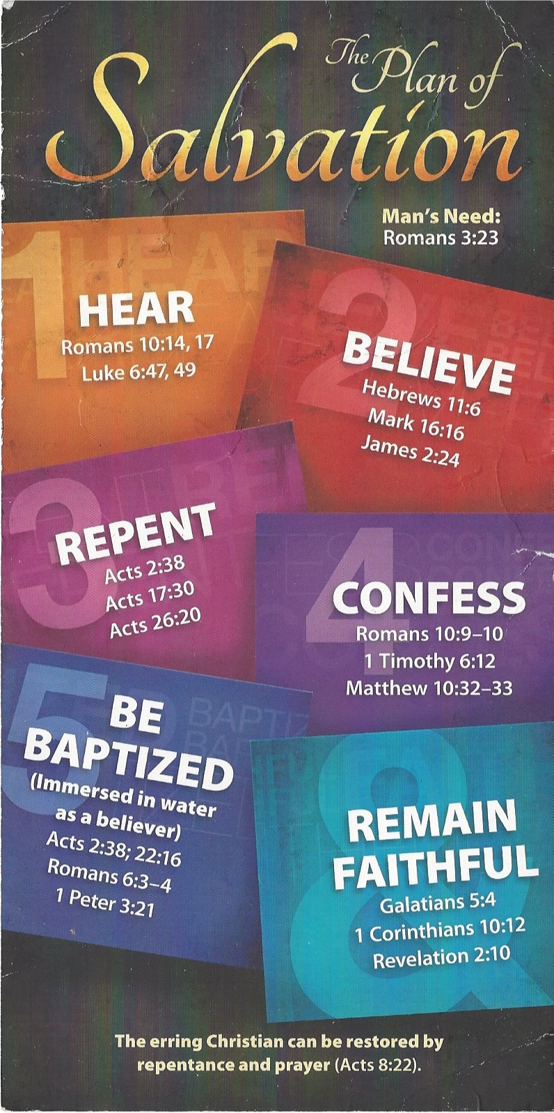
³² “Whoever acknowledges me before others, I will also acknowledge before my Father in heaven. ³³ But whoever disowns me before others, I will disown before my Father in heaven.
Be Baptized - Acts 22:16 (NIV)
¹⁶ And now what are you waiting for? Get up, be baptized and wash your sins away, calling on his name.’
Remain Steadfast - Revelation 2:10 (NIV)
¹⁰ Do not be afraid of what you are about to suffer. I tell you, the devil will put some of you in prison to test you, and you will suffer persecution for ten days. Be faithful, even to the point of death, and I will give you life as your victor’s crown.

