Prophecy in the New Testament
Prophecy in the New Testament
Barry G. Johnson, Sr. / General
Discovering the Church / Prophecy; Agabus; Agabus predicts a famine; Gift of Prophecy / Acts 11:27–30

The NT describes the prophetic aspect of the ministry of Jesus Christ, and also recognises that prophetic gifts are given to believers through the Holy Spirit. It provides guidance on how such prophetic gifts are to be used.
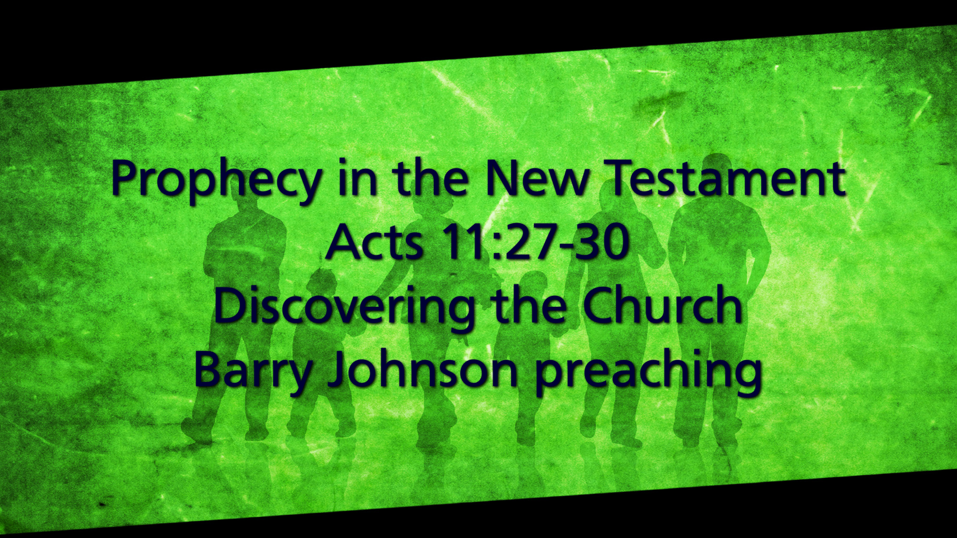

I. Jesus Christ Recognized as a Prophet
Mark 6:4 ESV
⁴ And Jesus said to them, “A prophet is not without honor, except in his hometown and among his relatives and in his own household.”
Mark 8:27–28 ESV
²⁷ And Jesus went on with his disciples to the villages of Caesarea Philippi. And on the way he asked his disciples, “Who do people say that I am?”
²⁸ And they told him, “John the Baptist; and others say, Elijah; and others, one of the prophets.”
Luke 7:16 ESV
¹⁶ Fear seized them all, and they glorified God, saying, “A great prophet has arisen among us!” and “God has visited his people!”
Luke 24:17–19 ESV
¹⁷ And he said to them, “What is this conversation that you are holding with each other as you walk?” And they stood still, looking sad.
¹⁸ Then one of them, named Cleopas, answered him, “Are you the only visitor to Jerusalem who does not know the things that have happened there in these days?”
¹⁹ And he said to them, “What things?” And they said to him, “Concerning Jesus of Nazareth, a man who was a prophet mighty in deed and word before God and all the people,
John 4:19 ESV
¹⁹ The woman said to him, “Sir, I perceive that you are a prophet.

II. Prophecy in the Church

A. Prophecy is one among many spiritual gifts
1 Corinthians 12:28–29 ESV
²⁸ And God has appointed in the church first apostles, second prophets, third teachers, then miracles, then gifts of healing, helping, administrating, and various kinds of tongues.
²⁹ Are all apostles? Are all prophets? Are all teachers? Do all work miracles?
1 Corinthians 12:10 ESV
¹⁰ to another the working of miracles, to another prophecy, to another the ability to distinguish between spirits, to another various kinds of tongues, to another the interpretation of tongues.

B. Not all are called to be prophets
Ephesians 4:11 ESV
¹¹ And he gave the apostles, the prophets, the evangelists, the shepherds and teachers,

C. Prophecy is valueless without love
1 Corinthians 13:1–2 ESV
¹ If I speak in the tongues of men and of angels, but have not love, I am a noisy gong or a clanging cymbal.
² And if I have prophetic powers, and understand all mysteries and all knowledge, and if I have all faith, so as to remove mountains, but have not love, I am nothing.

D. Prophecy is for the building up of the church
1 Corinthians 14:26 ESV
²⁶ What then, brothers? When you come together, each one has a hymn, a lesson, a revelation, a tongue, or an interpretation. Let all things be done for building up.
1 Corinthians 14:3–5 ESV
³ On the other hand, the one who prophesies speaks to people for their upbuilding and encouragement and consolation.
⁴ The one who speaks in a tongue builds up himself, but the one who prophesies builds up the church.
⁵ Now I want you all to speak in tongues, but even more to prophesy. The one who prophesies is greater than the one who speaks in tongues, unless someone interprets, so that the church may be built up.
1 Peter 4:10 ESV
¹⁰ As each has received a gift, use it to serve one another, as good stewards of God’s varied grace:

E. Prophecy superior to speaking in tongues
1 Corinthians 14:5 ESV
⁵ Now I want you all to speak in tongues, but even more to prophesy. The one who prophesies is greater than the one who speaks in tongues, unless someone interprets, so that the church may be built up.

III. Prophecy in the early church
Acts 11:27–28 ESV
²⁷ Now in these days prophets came down from Jerusalem to Antioch.
²⁸ And one of them named Agabus stood up and foretold by the Spirit that there would be a great famine over all the world (this took place in the days of Claudius).
Acts 15:32 ESV
³² And Judas and Silas, who were themselves prophets, encouraged and strengthened the brothers with many words.
Acts 21:9 ESV
⁹ He had four unmarried daughters, who prophesied.

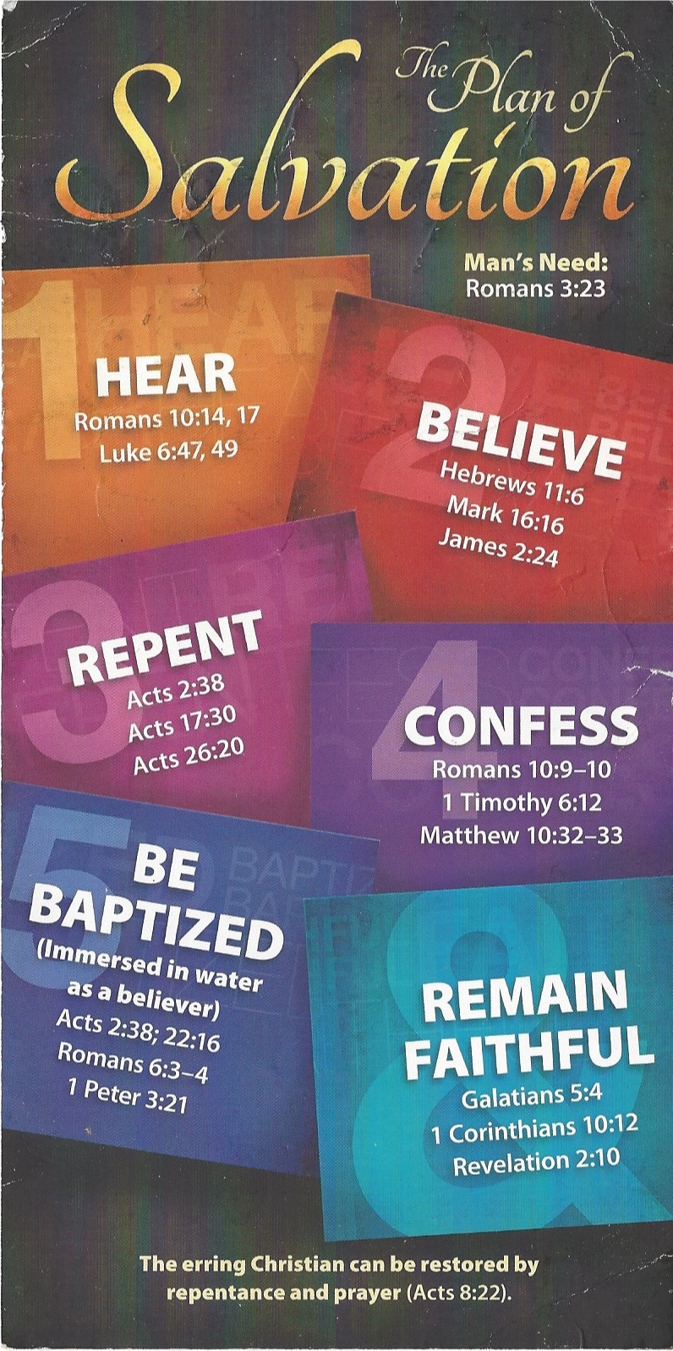
Hear - Romans 10:17 (NIV)
¹⁷ Consequently, faith comes from hearing the message, and the message is heard through the word about Christ.
Believe - Hebrews 11:6 (NIV)
⁶ And without faith it is impossible to please God, because anyone who comes to him must believe that he exists and that he rewards those who earnestly seek him.
Repent - Acts 17:30 (NIV)
³⁰ In the past God overlooked such ignorance, but now he commands all people everywhere to repent.
Confess - 1 Timothy 6:12 (NIV)
¹² Fight the good fight of the faith. Take hold of the eternal life to which you were called when you made your good confession in the presence of many witnesses.
Be Baptized - Acts 2:38 (ESV)
³⁸ And Peter said to them, “Repent and be baptized every one of you in the name of Jesus Christ for the forgiveness of your sins, and you will receive the gift of the Holy Spirit.
Remain Steadfast - Revelation 2:10 (NIV)
¹⁰ Do not be afraid of what you are about to suffer. I tell you, the devil will put some of you in prison to test you, and you will suffer persecution for ten days. Be faithful, even to the point of death, and I will give you life as your victor’s crown.

