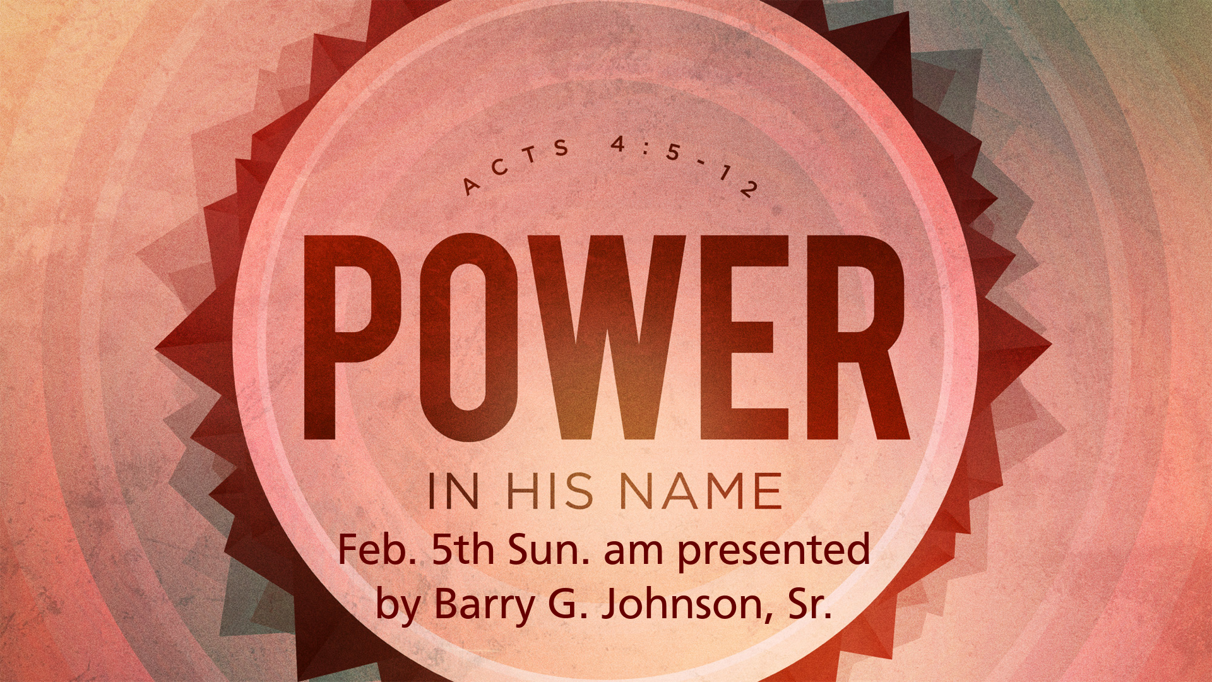
Thesis:

Obedience is a willingness to submit oneself to the will of God and to put it into effect. Scripture emphasizes the necessity for God’s laws to be followed, gives examples and reasons, and describes the rewards.

- Obedience is Demanded of God’s People
Leviticus 25:18 ESV
“Therefore you shall do my statutes and keep my rules and perform them, and then you will dwell in the land securely.
1 Samuel 15:22 ESV
And Samuel said,
“Has the LORD as great delight in burnt offerings and sacrifices,
as in obeying the voice of the LORD?
Behold, to obey is better than sacrifice,
and to listen than the fat of rams.
See also Dt 26:16; Dt 32:46; Ro 6:16–18; 1 Pe 1:14–16
- Examples of Obedience in the OT
Joshua 11:15 ESV
Just as the LORD had commanded Moses his servant, so Moses commanded Joshua, and so Joshua did. He left nothing undone of all that the LORD had commanded Moses.
See also Ge 6:22; Ge 12:1–4; Ge 22:2–3; Ex 40:16; Jon 3:3
- The Example of Jesus Christ
Matthew 26:39 ESV
And going a little farther he fell on his face and prayed, saying, “My Father, if it be possible, let this cup pass from me; nevertheless, not as I will, but as you will.”
John 14:31 ESV
but I do as the Father has commanded me, so that the world may know that I love the Father. Rise, let us go from here.
See also Jn 17:4; Ro 5:19; Php 2:8; Heb 5:8
- Jesus Christ is Obeyed
- By the wind and the waves
Matthew 8:26–27 ESV
And he said to them, “Why are you afraid, O you of little faith?” Then he rose and rebuked the winds and the sea, and there was a great calm. And the men marveled, saying, “What sort of man is this, that even winds and sea obey him?”
- By evil spirits
Mark 1:27 ESV
And they were all amazed, so that they questioned among themselves, saying, “What is this? A new teaching with authority! He commands even the unclean spirits, and they obey him.”
- Obedience is a Matter of Love
John 14:15 ESV
“If you love me, you will keep my commandments.
1 John 5:3 ESV
For this is the love of God, that we keep his commandments. And his commandments are not burdensome.
See also Ps 119:167; 1 Jn 2:5; 1 Jn 3:10; 2 Jn 6
- Obedience is a Matter of Faith
Hebrews 11:8 ESV
By faith Abraham obeyed when he was called to go out to a place that he was to receive as an inheritance. And he went out, not knowing where he was going.
Matthew 7:21 ESV
“Not everyone who says to me, ‘Lord, Lord,’ will enter the kingdom of heaven, but the one who does the will of my Father who is in heaven.
See also Ro 1:5; Jas 2:14–26
- God Rewards Those Who Obey Him
Exodus 19:5 ESV
Now therefore, if you will indeed obey my voice and keep my covenant, you shall be my treasured possession among all peoples, for all the earth is mine;
John 15:10 ESV
If you keep my commandments, you will abide in my love, just as I have kept my Father’s commandments and abide in his love.
See also Dt 5:29; 1 Ki 3:14; 2 Ki 18:5–7; Mt 7:21; Mt 7:24–25; Mt 12:50; Jn 12:26; Jn 14:21; Jn 14:23; Jn 21:4–6; 1 Jn 2:17
- Obedience to the Word of God
Matthew 7:24–27 ESV
“Everyone then who hears these words of mine and does them will be like a wise man who built his house on the rock. And the rain fell, and the floods came, and the winds blew and beat on that house, but it did not fall, because it had been founded on the rock. And everyone who hears these words of mine and does not do them will be like a foolish man who built his house on the sand. And the rain fell, and the floods came, and the winds blew and beat against that house, and it fell, and great was the fall of it.”
James 1:22 ESV
But be doers of the word, and not hearers only, deceiving yourselves.
See also Ps 119:9–11; Jon 3:3; Lk 11:28; Jn 17:6; Jas 2:14–20

Hear - Romans 10:17 (NIV)
¹⁷ Consequently, faith comes from hearing the message, and the message is heard through the word about Christ.
Believe - Hebrews 11:6 (NIV)
⁶ And without faith it is impossible to please God, because anyone who comes to him must believe that he exists and that he rewards those who earnestly seek him.
Repent - Acts 17:30 (NIV)
³⁰ In the past God overlooked such ignorance, but now he commands all people everywhere to repent.
Confess - 1 Timothy 6:12 (NIV)
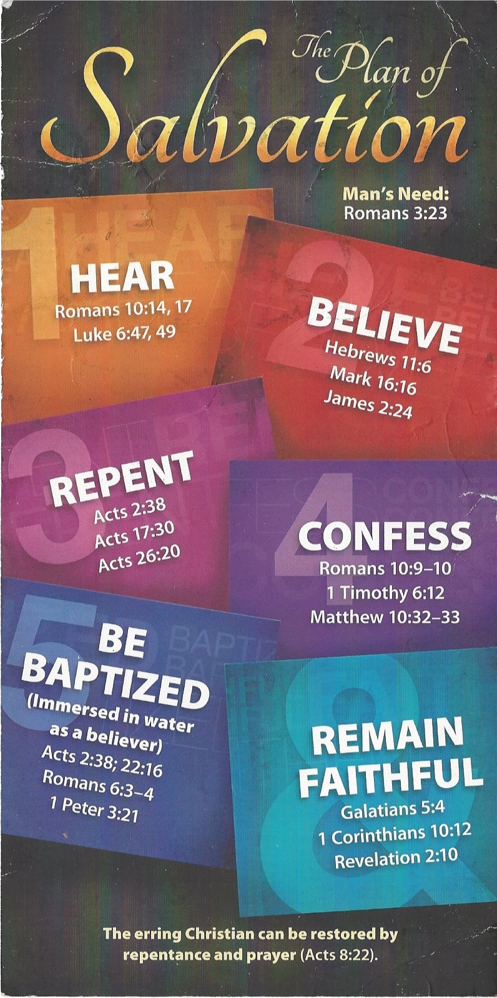
¹² Fight the good fight of the faith. Take hold of the eternal life to which you were called when you made your good confession in the presence of many witnesses.

Be Baptized - Acts 22:16 (NIV)
¹⁶ And now what are you waiting for? Get up, be baptized and wash your sins away, calling on his name.’
Remain Steadfast - Revelation 2:10 (NIV)
¹⁰ Do not be afraid of what you are about to suffer. I tell you, the devil will put some of you in prison to test you, and you will suffer persecution for ten days. Be faithful, even to the point of death, and I will give you life as your victor’s crown.

