Barry G. Johnson, Sr. / General
Discovering the Church / Salvation; Send; Direction; Evangelism; Evangelist / Acts 22:12–21
The Saved and Sent bring Paul into the faith and now Paul becomes the Saved and Sent just like we are to be.
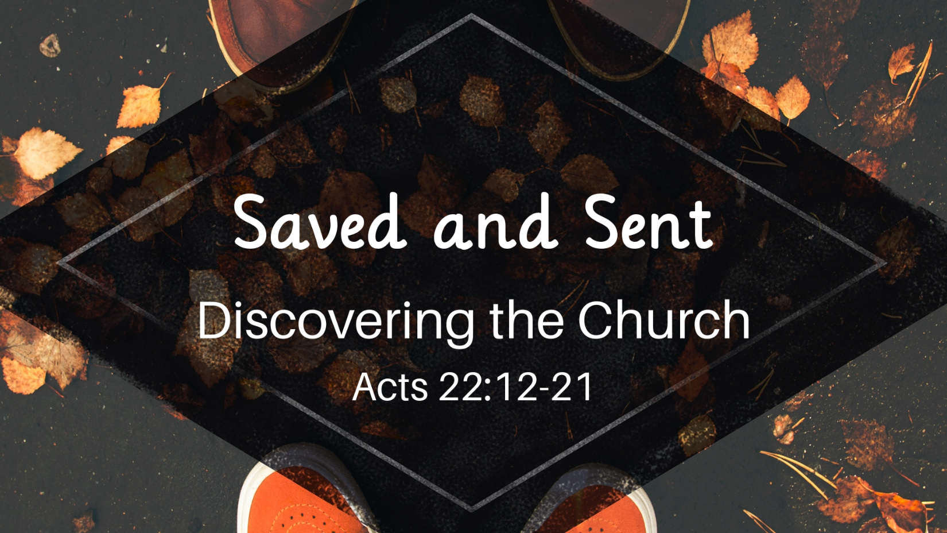

I. Saved

A. The Saved was Sent
Acts 22:12 ESV
¹² “And one Ananias, a devout man according to the law, well spoken of by all the Jews who lived there,
Romans 10:15 ESV
¹⁵ And how are they to preach unless they are sent? As it is written, “How beautiful are the feet of those who preach the good news!”

B. How we are Saved
Acts 22:13 ESV
¹³ came to me, and standing by me said to me, ‘Brother Saul, receive your sight.’ And at that very hour I received my sight and saw him.
Romans 1:16 ESV
¹⁶ For I am not ashamed of the gospel, for it is the power of God for salvation to everyone who believes, to the Jew first and also to the Greek.

C. The Reason to Save
Acts 22:14–16 ESV
¹⁴ And he said, ‘The God of our fathers appointed you to know his will, to see the Righteous One and to hear a voice from his mouth; ¹⁵ for you will be a witness for him to everyone of what you have seen and heard. ¹⁶ And now why do you wait? Rise and be baptized and wash away your sins, calling on his name.’
Romans 6:3–4 ESV
³ Do you not know that all of us who have been baptized into Christ Jesus were baptized into his death? ⁴ We were buried therefore with him by baptism into death, in order that, just as Christ was raised from the dead by the glory of the Father, we too might walk in newness of life.

II. Sent

A. Role Reversal
Acts 22:17–18 ESV
¹⁷ “When I had returned to Jerusalem and was praying in the temple, I fell into a trance ¹⁸ and saw him saying to me, ‘Make haste and get out of Jerusalem quickly, because they will not accept your testimony about me.’

B. I am one of them
Acts 22:19–20 ESV
¹⁹ And I said, ‘Lord, they themselves know that in one synagogue after another I imprisoned and beat those who believed in you. ²⁰ And when the blood of Stephen your witness was being shed, I myself was standing by and approving and watching over the garments of those who killed him.’
Romans 10:1–2 ESV
¹ Brothers, my heart’s desire and prayer to God for them is that they may be saved. ² For I bear them witness that they have a zeal for God, but not according to knowledge.

C. Go to a place He will show you
Acts 22:21 ESV
²¹ And he said to me, ‘Go, for I will send you far away to the Gentiles.’ ”
Matthew 28:19–20 ESV
¹⁹ Go therefore and make disciples of all nations, baptizing them in the name of the Father and of the Son and of the Holy Spirit, ²⁰ teaching them to observe all that I have commanded you. And behold, I am with you always, to the end of the age.”

God’s Plan of Salvation

What we must do to be saved

Hear the Word of God
Romans 10:17 ESV
¹⁷ So faith comes from hearing, and hearing through the word of Christ.

Believe the Word of God
Hebrews 11:6 ESV
⁶ And without faith it is impossible to please him, for whoever would draw near to God must believe that he exists and that he rewards those who seek him.

Repent of your past ways
Acts 17:30 ESV
³⁰ The times of ignorance God overlooked, but now he commands all people everywhere to repent,

Confess Jesus as God’s Son
1 Timothy 6:12 ESV
¹² Fight the good fight of the faith. Take hold of the eternal life to which you were called and about which you made the good confession in the presence of many witnesses.

Be Baptized for the remission of your sins
Acts 22:16 ESV
¹⁶ And now why do you wait? Rise and be baptized and wash away your sins, calling on his name.’

Remain Faithful even unto death
Revelation 2:10 ESV
¹⁰ Do not fear what you are about to suffer. Behold, the devil is about to throw some of you into prison, that you may be tested, and for ten days you will have tribulation. Be faithful unto death, and I will give you the crown of life.

