Barry G. Johnson, Sr. / www.bgjsr22.com
Evangelism 2019 / False Teaching / 1 Timothy 1:3–7
Scripture repeatedly warns against false teachings, which deny or distort some aspect of the gospel. The origin of such teachings is attributed either to human error or to demonic inspiration.
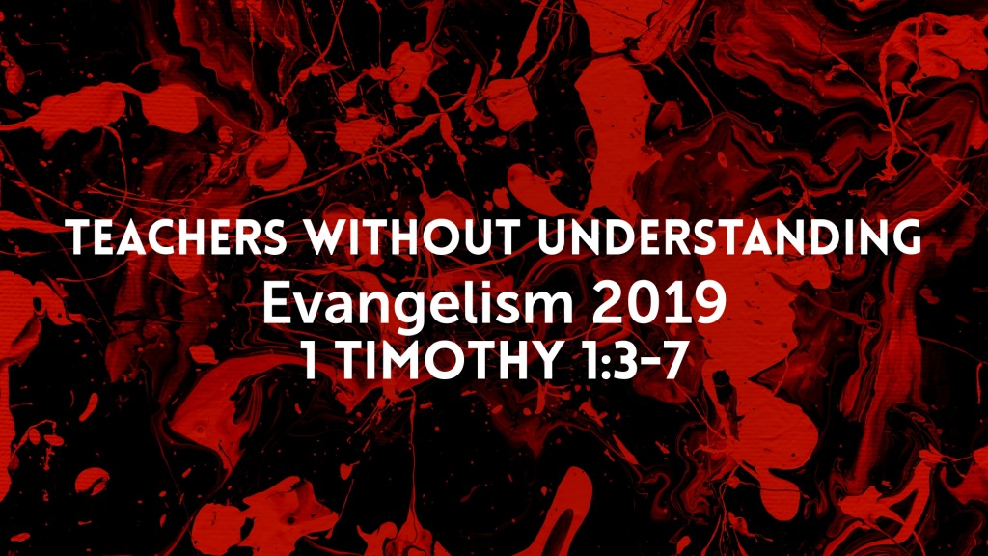
1 Timothy 1:3–7 ESV
As I urged you when I was going to Macedonia, remain at Ephesus so that you may charge certain persons not to teach any different doctrine, nor to devote themselves to myths and endless genealogies, which promote speculations rather than the stewardship from God that is by faith. The aim of our charge is love that issues from a pure heart and a good conscience and a sincere faith. Certain persons, by swerving from these, have wandered away into vain discussion, desiring to be teachers of the law, without understanding either what they are saying or the things about which they make confident assertions.

Qualities of false teachings

They are valueless
Matthew 15:9 ESV
in vain do they worship me,
teaching as doctrines the commandments of men.’ ”

They are destructive in their nature
2 Peter 2:1 ESV
But false prophets also arose among the people, just as there will be false teachers among you, who will secretly bring in destructive heresies, even denying the Master who bought them, bringing upon themselves swift destruction.

They have the capacity to lead people astray
Acts 20:30 ESV
and from among your own selves will arise men speaking twisted things, to draw away the disciples after them.

They may be popular
2 Peter 2:2 ESV
And many will follow their sensuality, and because of them the way of truth will be blasphemed.

They may be accompanied by miraculous signs
Matthew 24:24 ESV
For false christs and false prophets will arise and perform great signs and wonders, so as to lead astray, if possible, even the elect.

The origin of false teachings

Demonic inspiration
1 Timothy 4:1–2 ESV
Now the Spirit expressly says that in later times some will depart from the faith by devoting themselves to deceitful spirits and teachings of demons, through the insincerity of liars whose consciences are seared,

Human error
2 Peter 2:3 ESV
And in their greed they will exploit you with false words. Their condemnation from long ago is not idle, and their destruction is not asleep.

Discerning false teachings

By their content
1 John 4:2–3 ESV
By this you know the Spirit of God: every spirit that confesses that Jesus Christ has come in the flesh is from God, and every spirit that does not confess Jesus is not from God. This is the spirit of the antichrist, which you heard was coming and now is in the world already.

By the teacher’s lifestyle
Matthew 7:15–20 ESV
“Beware of false prophets, who come to you in sheep’s clothing but inwardly are ravenous wolves. You will recognize them by their fruits. Are grapes gathered from thornbushes, or figs from thistles? So, every healthy tree bears good fruit, but the diseased tree bears bad fruit. A healthy tree cannot bear bad fruit, nor can a diseased tree bear good fruit. Every tree that does not bear good fruit is cut down and thrown into the fire. Thus you will recognize them by their fruits.

By their effects
1 Timothy 6:3–5 ESV
If anyone teaches a different doctrine and does not agree with the sound words of our Lord Jesus Christ and the teaching that accords with godliness, he is puffed up with conceit and understands nothing. He has an unhealthy craving for controversy and for quarrels about words, which produce envy, dissension, slander, evil suspicions, and constant friction among people who are depraved in mind and deprived of the truth, imagining that godliness is a means of gain.

The antidote to false teachings

Holding fast to the true gospel
1 John 2:24 ESV
Let what you heard from the beginning abide in you. If what you heard from the beginning abides in you, then you too will abide in the Son and in the Father.

Shunning false teachers
Romans 16:17–18 ESV
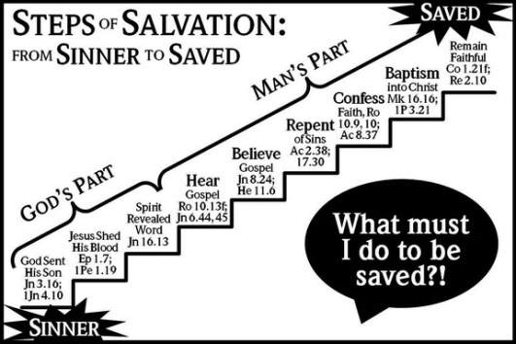
I appeal to you, brothers, to watch out for those who cause divisions and create obstacles contrary to the doctrine that you have been taught; avoid them. For such persons do not serve our Lord Christ, but their own appetites, and by smooth talk and flattery they deceive the hearts of the naive.

God’s Plan of Salvation

