Barry G. Johnson, Sr. / www.barrygjohnsonsr.com
Judges: A Modern Day Religious Spiral? / The Judges; Period of Judges; Baal (deity); Ashtaroth (Deity); Canaan / Judges 2:11–15
Men must avoid doing evil in the sight of the Lord and not fall prey to the gods around us.
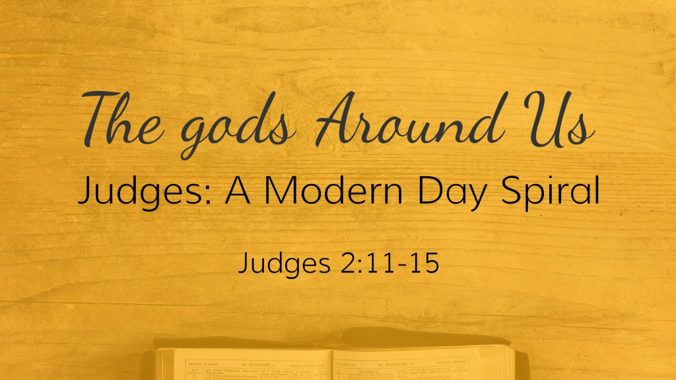
Judges 2:11–15 ESV
¹¹ And the people of Israel did what was evil in the sight of the Lord and served the Baals. ¹² And they abandoned the Lord, the God of their fathers, who had brought them out of the land of Egypt. They went after other gods, from among the gods of the peoples who were around them, and bowed down to them. And they provoked the Lord to anger. ¹³ They abandoned the Lord and served the Baals and the Ashtaroth. ¹⁴ So the anger of the Lord was kindled against Israel, and he gave them over to plunderers, who plundered them. And he sold them into the hand of their surrounding enemies, so that they could no longer withstand their enemies. ¹⁵ Whenever they marched out, the hand of the Lord was against them for harm, as the Lord had warned, and as the Lord had sworn to them. And they were in terrible distress.

I. Evil in the sight of the Lord
2 Chronicles 33:1–2 ESV
¹ Manasseh was twelve years old when he began to reign, and he reigned fifty-five years in Jerusalem. ² And he did what was evil in the sight of the Lord, according to the abominations of the nations whom the Lord drove out before the people of Israel.
Jeremiah 9:13–14 ESV
¹³ And the Lord says: “Because they have forsaken my law that I set before them, and have not obeyed my voice or walked in accord with it, ¹⁴ but have stubbornly followed their own hearts and have gone after the Baals, as their fathers taught them.

II. gods of the people around them
Deuteronomy 6:14 ESV
¹⁴ You shall not go after other gods, the gods of the peoples who are around you—
1 Corinthians 8:4–6 ESV
⁴ Therefore, as to the eating of food offered to idols, we know that “an idol has no real existence,” and that “there is no God but one.” ⁵ For although there may be so-called gods in heaven or on earth—as indeed there are many “gods” and many “lords”— ⁶ yet for us there is one God, the Father, from whom are all things and for whom we exist, and one Lord, Jesus Christ, through whom are all things and through whom we exist.
[NAME THE MODERN DAY CANAANITES] What modern day name would you give to the tribes in Canaan that God commanded to be driven out? Which would represent our struggle today. 1. Canaanites, 2. Jebusites, 3. Amorites, 4. Amalikites, 5. Perizzites, 6. Philistines, 7. Sidonians, 8. Hivites, 9. Hittites. Send me your suggestions at http://barrygjohnsonsrom.weebly.com/forms--surveys.html
Galatians 4:8 ESV
⁸ Formerly, when you did not know God, you were enslaved to those that by nature are not gods.

III. God raises up Judges
Ezekiel 22:30 ESV
³⁰ And I sought for a man among them who should build up the wall and stand in the breach before me for the land, that I should not destroy it, but I found none.
2 Corinthians 10:4–6 ESV
⁴ For the weapons of our warfare are not of the flesh but have divine power to destroy strongholds. ⁵ We destroy arguments and every lofty opinion raised against the knowledge of God, and take every thought captive to obey Christ, ⁶ being ready to punish every disobedience, when your obedience is complete.

God has raised up Jesus who Saves us
Hear - Romans 10:17 ESV
¹⁷ So faith comes from hearing, and hearing through the word of Christ.
Believe - James 2:24 ESV
²⁴ You see that a person is justified by works and not by faith alone.
Confess - Romans 10:9–10 ESV
⁹ because, if you confess with your mouth that Jesus is Lord and believe in your heart that God raised him from the dead, you will be saved. ¹⁰ For with the heart one believes and is justified, and with the mouth one confesses and is saved.
Repent - Acts 26:20 ESV
²⁰ but declared first to those in Damascus, then in Jerusalem and throughout all the region of Judea, and also to the Gentiles, that they should repent and turn to God, performing deeds in keeping with their repentance.
Be Baptized - 1 Peter 3:21 ESV
²¹ Baptism, which corresponds to this, now saves you, not as a removal of dirt from the body but as an appeal to God for a good conscience, through the resurrection of Jesus Christ,
Remain Faithful - 1 Corinthians 10:12 ESV
¹² Therefore let anyone who thinks that he stands take heed lest he fall.

