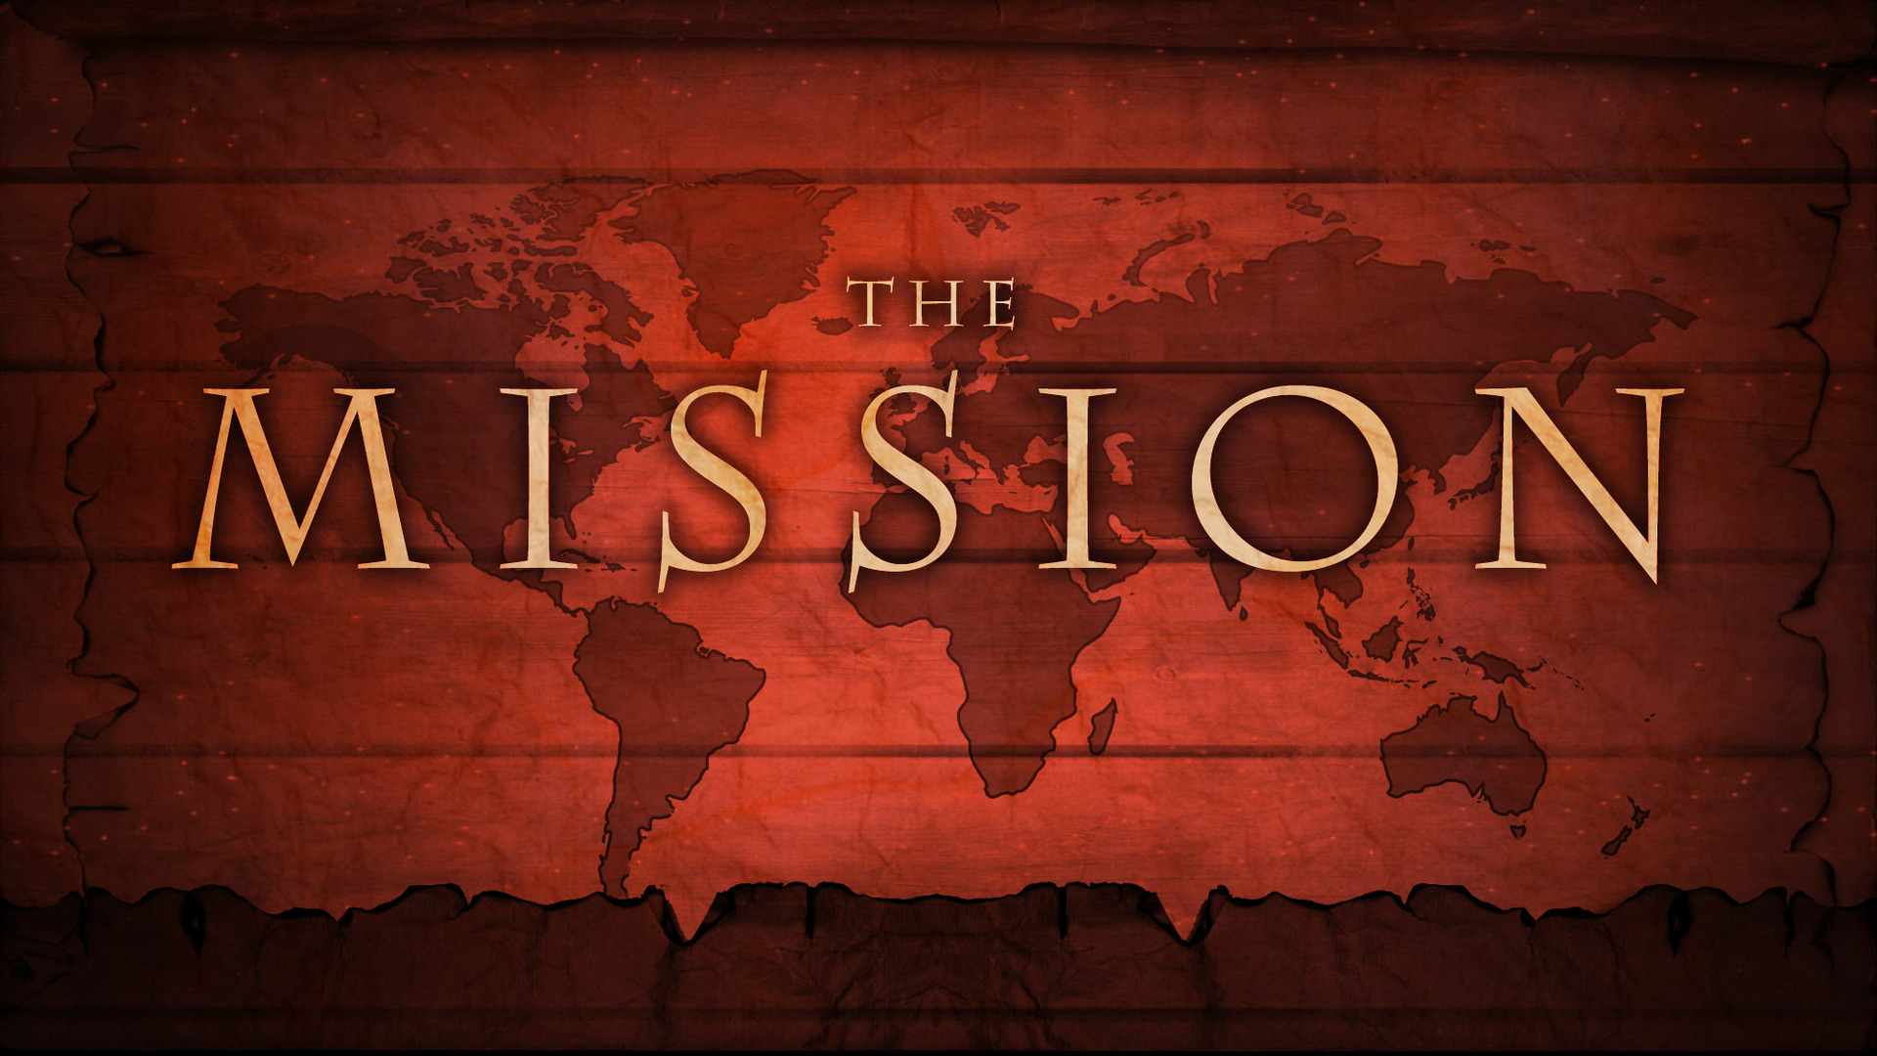
Thesis:

Jesus by His authority, has direct us to go our into the world and make disciples by teaching them the things they ought to obey.

Objectives:

- Jesus has All Authority
- Make Disciples and Baptize
- Teaching Them to Observe All

Sermon Outline:

- Jesus has All Authority

Daniel 7:13–14 (ESV)
13 “I saw in the night visions,
and behold, with the clouds of heaven
there came one like a son of man,
and he came to the Ancient of Days
and was presented before him.
14 And to him was given dominion
and glory and a kingdom,
that all peoples, nations, and languages
should serve him;
his dominion is an everlasting dominion,
which shall not pass away,
and his kingdom one
that shall not be destroyed.
Matthew 7:29 (ESV)
²⁹ for he was teaching them as one who had authority, and not as their scribes.
Matthew 8:9 (ESV)
⁹ For I too am a man under authority, with soldiers under me. And I say to one, ‘Go,’ and he goes, and to another, ‘Come,’ and he comes, and to my servant, ‘Do this,’ and he does it.”
Matthew 9:6 (ESV)
⁶ But that you may know that the Son of Man has authority on earth to forgive sins”—he then said to the paralytic—“Rise, pick up your bed and go home.”
Matthew 21:23 (ESV)
²³ And when he entered the temple, the chief priests and the elders of the people came up to him as he was teaching, and said, “By what authority are you doing these things, and who gave you this authority?”
Matthew 21:24 (ESV)
²⁴ Jesus answered them, “I also will ask you one question, and if you tell me the answer, then I also will tell you by what authority I do these things.
Matthew 21:27 (ESV)
²⁷ So they answered Jesus, “We do not know.” And he said to them, “Neither will I tell you by what authority I do these things.

- Make Disciples and Baptize

Matthew 13:52 (ESV)
⁵² And he said to them, “Therefore every scribe who has been trained for the kingdom of heaven is like a master of a house, who brings out of his treasure what is new and what is old.”
Matthew 24:14 (ESV)
¹⁴ And this gospel of the kingdom will be proclaimed throughout the whole world as a testimony to all nations, and then the end will come.

- Teaching Them to Observe All
Matthew 5:18–19 (ESV)
¹⁸ For truly, I say to you, until heaven and earth pass away, not an iota, not a dot, will pass from the Law until all is accomplished. ¹⁹ Therefore whoever relaxes one of the least of these commandments and teaches others to do the same will be called least in the kingdom of heaven, but whoever does them and teaches them will be called great in the kingdom of heaven.
Matthew 1:23 (ESV)
²³ “Behold, the virgin shall conceive and bear a son,
and they shall call his name Immanuel”
(which means, God with us).

Hear - Romans 10:17 (NIV)
¹⁷ Consequently, faith comes from hearing the message, and the message is heard through the word about Christ.
Believe - Hebrews 11:6 (NIV)
⁶ And without faith it is impossible to please God, because anyone who comes to him must believe that he exists and that he rewards those who earnestly seek him.
Repent - Acts 17:30 (NIV)
³⁰ In the past God overlooked such ignorance, but now he commands all people everywhere to repent.
Confess - 1 Timothy 6:12 (NIV)
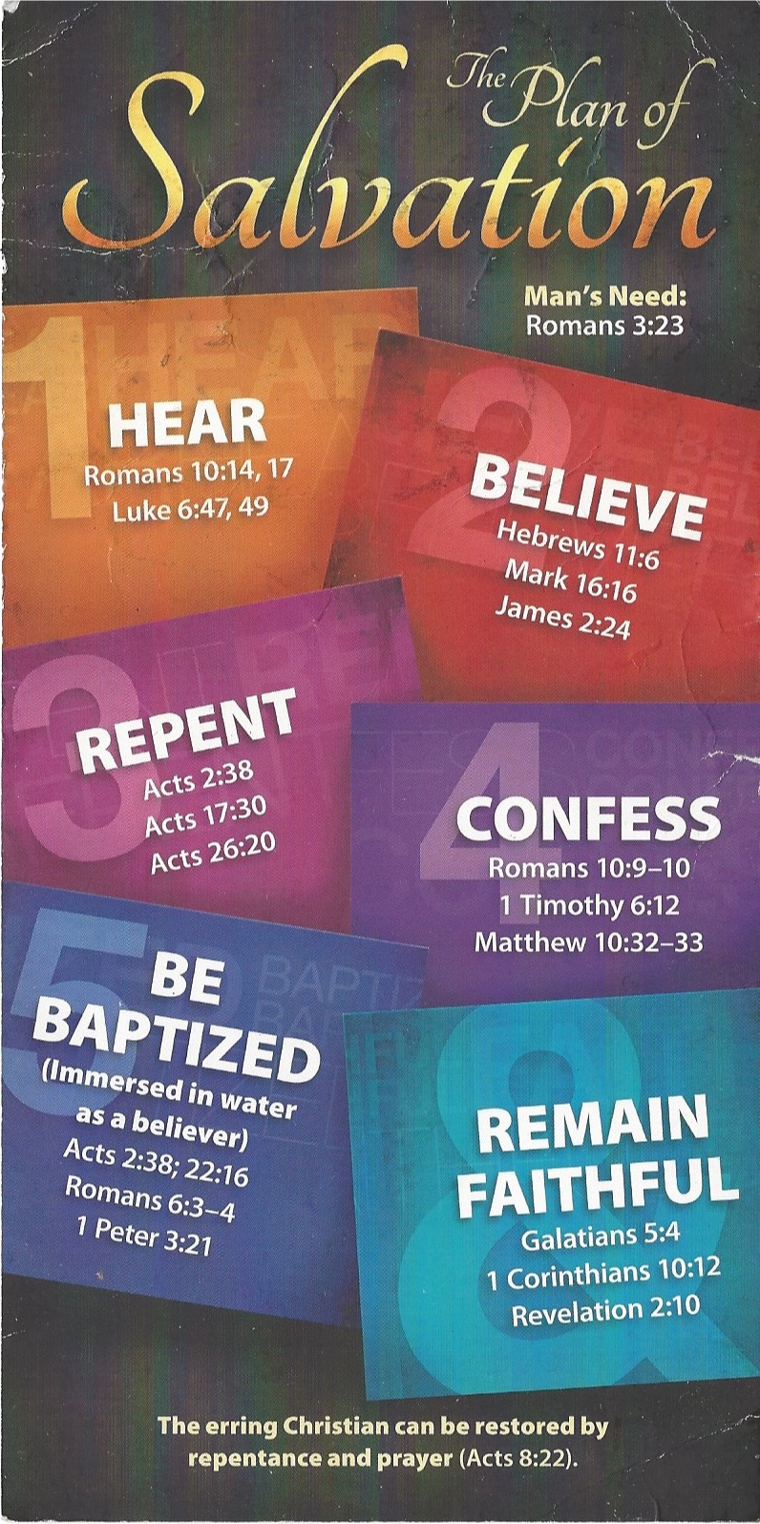
¹² Fight the good fight of the faith. Take hold of the eternal life to which you were called when you made your good confession in the presence of many witnesses.

Be Baptized - Acts 22:16 (NIV)
¹⁶ And now what are you waiting for? Get up, be baptized and wash your sins away, calling on his name.’
Remain Steadfast - Revelation 2:10 (NIV)
¹⁰ Do not be afraid of what you are about to suffer. I tell you, the devil will put some of you in prison to test you, and you will suffer persecution for ten days. Be faithful, even to the point of death, and I will give you life as your victor’s crown.

