Synopsis
The present and future realm in which Jesus Christ exercises full authority, and through which he triumphs over all opposition.

- Jesus Kingdom is heavenly
- It is not of this world
John 18:36 (NIV) — 36 Jesus said, “My kingdom is not of this world. If it were, my servants would fight to prevent my arrest by the Jewish leaders. But now my kingdom is from another place.”
- The Kingdom was given to Him by God
Daniel 7:14 (NIV) — 14 He was given authority, glory and sovereign power; all nations and peoples of every language worshiped him. His dominion is an everlasting dominion that will not pass away, and his kingdom is one that will never be destroyed.
Psalm 72:1 (NIV) — 1 Endow the king with your justice, O God, the royal son with your righteousness.
Daniel 2:44 (NIV) — 44 “In the time of those kings, the God of heaven will set up a kingdom that will never be destroyed, nor will it be left to another people. It will crush all those kingdoms and bring them to an end, but it will itself endure forever.
Matthew 28:18 (NIV) — 18 Then Jesus came to them and said, “All authority in heaven and on earth has been given to me.
John 16:15 (NIV) — 15 All that belongs to the Father is mine. That is why I said the Spirit will receive from me what he will make known to you.”
- The Kingdom is His by Right
Colossians 1:15–16 (NIV) — 15 The Son is the image of the invisible God, the firstborn over all creation. 16 For in him all things were created: things in heaven and on earth, visible and invisible, whether thrones or powers or rulers or authorities; all things have been created through him and for him.
Hebrews 1:8 (NIV) — 8 But about the Son he says, “Your throne, O God, will last for ever and ever; a scepter of justice will be the scepter of your kingdom.
Psalm 45:6 (NIV) — 6 Your throne, O God, will last for ever and ever; a scepter of justice will be the scepter of your kingdom.
Revelation 22:13 (NIV) — 13 I am the Alpha and the Omega, the First and the Last, the Beginning and the End.
- Jesus inherits kingdom promised to David
Luke 1:32 (NIV) — 32 He will be great and will be called the Son of the Most High. The Lord God will give him the throne of his father David,
Romans 15:12 (NIV) — 12 And again, Isaiah says, “The Root of Jesse will spring up, one who will arise to rule over the nations; in him the Gentiles will hope.”
Isaiah 11:10 (NIV) — 10 In that day the Root of Jesse will stand as a banner for the peoples; the nations will rally to him, and his resting place will be glorious.
Revelation 2:27 (NIV) — 27 that one ‘will rule them with an iron scepter and will dash them to pieces like pottery’—just as I have received authority from my Father.
Psalm 2:9 (NIV) — 9 You will break them with a rod of iron; you will dash them to pieces like pottery.”
- Jesus reveals kingdom on earth
- Jesus brought in God’s Kingdom
Mt 4:17 The expressions “kingdom of heaven” and the “kingdom of God” are interchangeable.
Matthew 4:17 (NIV) — 17 From that time on Jesus began to preach, “Repent, for the kingdom of heaven has come near.”
Matthew 3:2 (NIV) — 2 and saying, “Repent, for the kingdom of heaven has come near.”
Matthew 10:7 (NIV) — 7 As you go, proclaim this message: ‘The kingdom of heaven has come near.’
Matthew 12:28 (NIV) — 28 But if it is by the Spirit of God that I drive out demons, then the kingdom of God has come upon you.
Mark 1:15 (NIV) — 15 “The time has come,” he said. “The kingdom of God has come near. Repent and believe the good news!”
- Miracles are a sign of the Kingdom
John 6:14–15 (NIV) — 14 After the people saw the sign Jesus performed, they began to say, “Surely this is the Prophet who is to come into the world.” 15 Jesus, knowing that they intended to come and make him king by force, withdrew again to a mountain by himself.
Matthew 8:26–27 (NIV) — 26 He replied, “You of little faith, why are you so afraid?” Then he got up and rebuked the winds and the waves, and it was completely calm. 27 The men were amazed and asked, “What kind of man is this? Even the winds and the waves obey him!”
- Authority over Life and Death:
Luke 7:11–15 (NIV) — 11 Soon afterward, Jesus went to a town called Nain, and his disciples and a large crowd went along with him. 12 As he approached the town gate, a dead person was being carried out—the only son of his mother, and she was a widow. And a large crowd from the town was with her. 13 When the Lord saw her, his heart went out to her and he said, “Don’t cry.” 14 Then he went up and touched the bier they were carrying him on, and the bearers stood still. He said, “Young man, I say to you, get up!” 15 The dead man sat up and began to talk, and Jesus gave him back to his mother.
- Parables are a sign of the Kingdom
Matthew 13:1–52 (NIV) See also Mk 4:1–34 ; Lk 8:4–15 ; Lk 13:18–21
- Jesus exercises kingdom authority today
- Believers enter Jesus Kingdom Immediately
Luke 23:42–43 (NIV) — 42 Then he said, “Jesus, remember me when you come into your kingdom.” 43 Jesus answered him, “Truly I tell you, today you will be with me in paradise.”
- Believers are Redeemed from the Kingdom of Darkness
Colossians 1:12–13 (NIV) — 12 and giving joyful thanks to the Father, who has qualified you to share in the inheritance of his holy people in the kingdom of light. 13 For he has rescued us from the dominion of darkness and brought us into the kingdom of the Son he loves,
- Believers Enjoy the Blessings of Jesus Kingdom Now
Matthew 16:19 (NIV) — 19 I will give you the keys of the kingdom of heaven; whatever you bind on earth will be bound in heaven, and whatever you loose on earth will be loosed in heaven.”
Luke 12:32 (NIV) — 32 “Do not be afraid, little flock, for your Father has been pleased to give you the kingdom.
Luke 22:29–30 (NIV) — 29 And I confer on you a kingdom, just as my Father conferred one on me, 30 so that you may eat and drink at my table in my kingdom and sit on thrones, judging the twelve tribes of Israel.
James 2:5 (NIV) — 5 Listen, my dear brothers and sisters: Has not God chosen those who are poor in the eyes of the world to be rich in faith and to inherit the kingdom he promised those who love him?
Revelation 1:5–6 (NIV) — 5 and from Jesus Christ, who is the faithful witness, the firstborn from the dead, and the ruler of the kings of the earth. To him who loves us and has freed us from our sins by his blood, 6 and has made us to be a kingdom and priests to serve his God and Father—to him be glory and power for ever and ever! Amen.
Revelation 1:9 (NIV) — 9 I, John, your brother and companion in the suffering and kingdom and patient endurance that are ours in Jesus, was on the island of Patmos because of the word of God and the testimony of Jesus.
- Jesus Rules over every Authority now
1 Peter 3:22 (NIV) — 22 who has gone into heaven and is at God’s right hand—with angels, authorities and powers in submission to him.
Ephesians 1:20–23 (NIV) — 20 he exerted when he raised Christ from the dead and seated him at his right hand in the heavenly realms, 21 far above all rule and authority, power and dominion, and every name that is invoked, not only in the present age but also in the one to come. 22 And God placed all things under his feet and appointed him to be head over everything for the church, 23 which is his body, the fullness of him who fills everything in every way.
Philippians 2:9 (NIV) — 9 Therefore God exalted him to the highest place and gave him the name that is above every name,
Colossians 2:10 (NIV) — 10 and in Christ you have been brought to fullness. He is the head over every power and authority.
Revelation 19:16 (NIV) — 16 On his robe and on his thigh he has this name written: king of kings and lord of lords.
- Jesus kingdom fully established at his return
- His Kingdom will come with Power at a specific moment
Matthew 25:31 (NIV) — 31 “When the Son of Man comes in his glory, and all the angels with him, he will sit on his glorious throne.
2 Timothy 4:1 (NIV) — 1 In the presence of God and of Christ Jesus, who will judge the living and the dead, and in view of his appearing and his kingdom, I give you this charge:
- His Kingdom will replace all earthly authority
1 Corinthians 15:24–25 (NIV) — 24 Then the end will come, when he hands over the kingdom to God the Father after he has destroyed all dominion, authority and power. 25 For he must reign until he has put all his enemies under his feet.
1 Corinthians 15:50–52 (NIV) — 50 I declare to you, brothers and sisters, that flesh and blood cannot inherit the kingdom of God, nor does the perishable inherit the imperishable. 51 Listen, I tell you a mystery: We will not all sleep, but we will all be changed—52 in a flash, in the twinkling of an eye, at the last trumpet. For the trumpet will sound, the dead will be raised imperishable, and we will be changed.
- All Creation will acknowledge Jesus Kingship
Philippians 2:10–11 (NIV) — 10 that at the name of Jesus every knee should bow, in heaven and on earth and under the earth, 11 and every tongue acknowledge that Jesus Christ is Lord, to the glory of God the Father.
Psalm 2:6–8 (NIV) — 6 “I have installed my king on Zion, my holy mountain.” 7 I will proclaim the Lord’s decree: He said to me, “You are my son; today I have become your father. 8 Ask me, and I will make the nations your inheritance, the ends of the earth your possession.
- His Kingdom lasts for ever
Luke 1:33 (NIV) — 33 and he will reign over Jacob’s descendants forever; his kingdom will never end.”
Isaiah 9:7 (NIV) — 7 Of the greatness of his government and peace there will be no end. He will reign on David’s throne and over his kingdom, establishing and upholding it with justice and righteousness from that time on and forever. The zeal of the Lord Almighty will accomplish this.

Invitation
Hear
Romans 10:17 (NIV)
¹⁷ Consequently, faith comes from hearing the message, and the message is heard through the word about Christ.
Believe
Hebrews 11:6 (NIV)
⁶ And without faith it is impossible to please God, because anyone who comes to him must believe that he exists and that he rewards those who earnestly seek him.
Repent
Acts 17:30 (NIV)
³⁰ In the past God overlooked such ignorance, but now he commands all people everywhere to repent.
Confess
Matthew 10:32–33 (NIV)
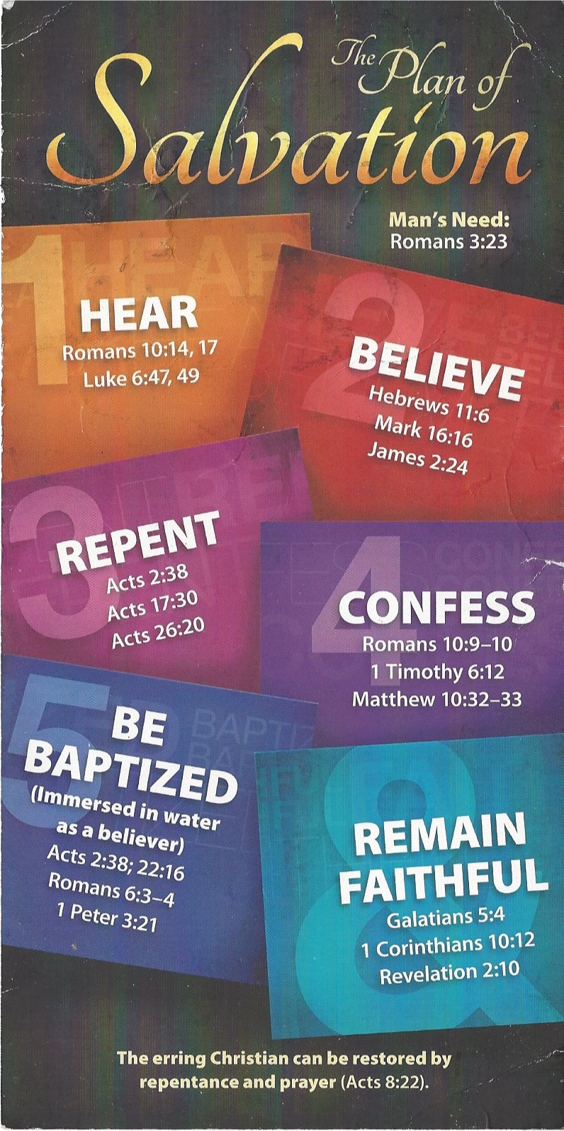
³² “Whoever acknowledges me before others, I will also acknowledge before my Father in heaven. ³³ But whoever disowns me before others, I will disown before my Father in heaven.
Be Baptized
1 Peter 3:21 (NIV)
²¹ and this water symbolizes baptism that now saves you also—not the removal of dirt from the body but the pledge of a clear conscience toward God. It saves you by the resurrection of Jesus Christ,
Remain Faithful
1 Corinthians 10:12 (NIV)
¹² So, if you think you are standing firm, be careful that you don’t fall!

