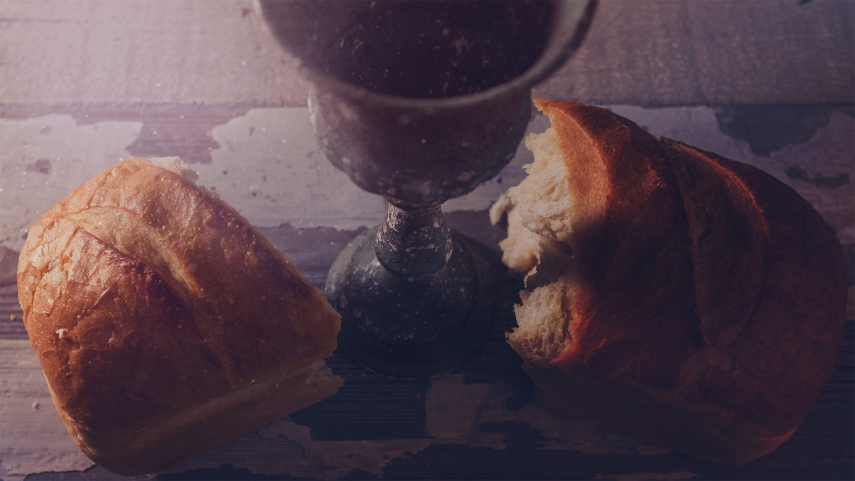
Synopsis
The commemoration and remembrance of Jesus Christ’s last supper, and all the benefits that result to believers. Other terms have been used subsequently by Christians, including “Communion” and “Eucharist”.
- Terms for the Lord’s Supper in the NT
Acts 2:42 (NIV) — 42 They devoted themselves to the apostles’ teaching and to fellowship, to the breaking of bread and to prayer.
1 Corinthians 10:16 (NIV) — 16 Is not the cup of thanksgiving for which we give thanks a participation in the blood of Christ? And is not the bread that we break a participation in the body of Christ?
1 Corinthians 11:20 (NIV) — 20 So then, when you come together, it is not the Lord’s Supper you eat,
1 Corinthians 11:24 (NIV) — 24 and when he had given thanks, he broke it and said, “This is my body, which is for you; do this in remembrance of me.”
- Jesus Christ’s institution of the Lord’s Supper
1 Corinthians 11:23–25 (NIV) — 23 For I received from the Lord what I also passed on to you: The Lord Jesus, on the night he was betrayed, took bread, 24 and when he had given thanks, he broke it and said, “This is my body, which is for you; do this in remembrance of me.” 25 In the same way, after supper he took the cup, saying, “This cup is the new covenant in my blood; do this, whenever you drink it, in remembrance of me.”
- Celebrating the Lord’s Supper in the NT
- On the Lord’s day
Acts 20:7 (NIV) — 7 On the first day of the week we came together to break bread. Paul spoke to the people and, because he intended to leave the next day, kept on talking until midnight.
See also
John 20:26 (NIV) — 26 A week later his disciples were in the house again, and Thomas was with them. Though the doors were locked, Jesus came and stood among them and said, “Peace be with you!”
- A fourfold recipe as the Lord’s example
Matthew 26:26 (NIV) — 26 While they were eating, Jesus took bread, and when he had given thanks, he broke it and gave it to his disciples, saying, “Take and eat; this is my body.”
See also
Luke 24:30 (NIV) — 30 When he was at the table with them, he took bread, gave thanks, broke it and began to give it to them.
- The sharing of the cup
1 Corinthians 11:25 (NIV) — 25 In the same way, after supper he took the cup, saying, “This cup is the new covenant in my blood; do this, whenever you drink it, in remembrance of me.”
- Themes connected with the Lord’s Supper
- The Passover
1 Corinthians 5:7–8 (NIV) — 7 Get rid of the old yeast, so that you may be a new unleavened batch—as you really are. For Christ, our Passover lamb, has been sacrificed. 8 Therefore let us keep the Festival, not with the old bread leavened with malice and wickedness, but with the unleavened bread of sincerity and truth.
See also
John 11:50 (NIV) — 50 You do not realize that it is better for you that one man die for the people than that the whole nation perish.”
John 13:1 (NIV) — 1 It was just before the Passover Festival. Jesus knew that the hour had come for him to leave this world and go to the Father. Having loved his own who were in the world, he loved them to the end.
John 19:14 (NIV) — 14 It was the day of Preparation of the Passover; it was about noon. “Here is your king,” Pilate said to the Jews.
John 19:33 (NIV) — 33 But when they came to Jesus and found that he was already dead, they did not break his legs.
John 19:36 (NIV) — 36 These things happened so that the scripture would be fulfilled: “Not one of his bones will be broken,”
Exodus 12:46 (NIV) — 46 “It must be eaten inside the house; take none of the meat outside the house. Do not break any of the bones.
Numbers 9:12 (NIV) — 12 They must not leave any of it till morning or break any of its bones. When they celebrate the Passover, they must follow all the regulations.
- The New Covenant
1 Corinthians 11:25 (NIV) — 25 In the same way, after supper he took the cup, saying, “This cup is the new covenant in my blood; do this, whenever you drink it, in remembrance of me.”
- Remembrance
1 Corinthians 11:24 (NIV) — 24 and when he had given thanks, he broke it and said, “This is my body, which is for you; do this in remembrance of me.”
- Thanksgiving, fellowship and unity
1 Corinthians 10:16 (NIV) — 16 Is not the cup of thanksgiving for which we give thanks a participation in the blood of Christ? And is not the bread that we break a participation in the body of Christ?
See also
Matthew 26:26–27 (NIV) — 26 While they were eating, Jesus took bread, and when he had given thanks, he broke it and gave it to his disciples, saying, “Take and eat; this is my body.” 27 Then he took a cup, and when he had given thanks, he gave it to them, saying, “Drink from it, all of you.
- The Lord’s return
1 Corinthians 11:26 (NIV) — 26 For whenever you eat this bread and drink this cup, you proclaim the Lord’s death until he comes.
See also
Matthew 26:29 (NIV) — 29 I tell you, I will not drink from this fruit of the vine from now on until that day when I drink it new with you in my Father’s kingdom.”
1 Corinthians 16:22 (NIV) — 22 If anyone does not love the Lord, let that person be cursed! Come, Lord!
Revelation 22:20 (NIV) — 20 He who testifies to these things says, “Yes, I am coming soon.” Amen. Come, Lord Jesus.
- Separation from sin
1 Corinthians 10:21 (NIV) — 21 You cannot drink the cup of the Lord and the cup of demons too; you cannot have a part in both the Lord’s table and the table of demons.
See also
1 Corinthians 11:27–32 (NIV) — 27 So then, whoever eats the bread or drinks the cup of the Lord in an unworthy manner will be guilty of sinning against the body and blood of the Lord. 28 Everyone ought to examine themselves before they eat of the bread and drink from the cup. 29 For those who eat and drink without discerning the body of Christ eat and drink judgment on themselves. 30 That is why many among you are weak and sick, and a number of you have fallen asleep. 31 But if we were more discerning with regard to ourselves, we would not come under such judgment. 32 Nevertheless, when we are judged in this way by the Lord, we are being disciplined so that we will not be finally condemned with the world.
- A foretaste of heaven
Matthew 26:29 (NIV) — 29 I tell you, I will not drink from this fruit of the vine from now on until that day when I drink it new with you in my Father’s kingdom.”

