Synopsis
A symbolic portrayal of the blessings of the age to come in which those chosen by God share in a rich feast with the Messiah. In the NT this is often pictured as a marriage supper with Jesus Christ as the groom and the church as both bride and invited guests. The feast, which will take place after the consummation of God’s kingdom, is prefigured in the Lord’s Supper.

- The Messianic Banquet Promised
Isaiah 25:6 (NIV) — 6 On this mountain the Lord Almighty will prepare a feast of rich food for all peoples, a banquet of aged wine— the best of meats and the finest of wines.
Luke 14:15 (NIV) — 15 When one of those at the table with him heard this, he said to Jesus, “Blessed is the one who will eat at the feast in the kingdom of God.”
- Why Go to the Banquet?
- It is a sign of spiritual blessing
Psalm 23:5 (NIV) — 5 You prepare a table before me in the presence of my enemies. You anoint my head with oil; my cup overflows.
- It is a sign of spiritual satisfaction
Psalm 63:5 (NIV) — 5 I will be fully satisfied as with the richest of foods; with singing lips my mouth will praise you.
John 7:37–38 (NIV) — 37 On the last and greatest day of the festival, Jesus stood and said in a loud voice, “Let anyone who is thirsty come to me and drink. 38 Whoever believes in me, as Scripture has said, rivers of living water will flow from within them.”
- It is a sign of fellowship with God
Revelation 3:20 (NIV) — 20 Here I am! I stand at the door and knock. If anyone hears my voice and opens the door, I will come in and eat with that person, and they with me.
- The Messianic Banquet as a Wedding Feast
- The invitation to participate
Matthew 22:2 (NIV) — 2 “The kingdom of heaven is like a king who prepared a wedding banquet for his son.
Revelation 19:7–9 (NIV) — 7 Let us rejoice and be glad and give him glory! For the wedding of the Lamb has come, and his bride has made herself ready. 8 Fine linen, bright and clean, was given her to wear.” (Fine linen stands for the righteous acts of God’s holy people.) 9 Then the angel said to me, “Write this: Blessed are those who are invited to the wedding supper of the Lamb!” And he added, “These are the true words of God.”
- The invitation rejected
Matthew 22:3–6 (NIV) — 3 He sent his servants to those who had been invited to the banquet to tell them to come, but they refused to come. 4 “Then he sent some more servants and said, ‘Tell those who have been invited that I have prepared my dinner: My oxen and fattened cattle have been butchered, and everything is ready. Come to the wedding banquet.’ 5 “But they paid no attention and went off—one to his field, another to his business. 6 The rest seized his servants, mistreated them and killed them.
Luke 14:16–20 (NIV) — 16 Jesus replied: “A certain man was preparing a great banquet and invited many guests. 17 At the time of the banquet he sent his servant to tell those who had been invited, ‘Come, for everything is now ready.’ 18 “But they all alike began to make excuses. The first said, ‘I have just bought a field, and I must go and see it. Please excuse me.’ 19 “Another said, ‘I have just bought five yoke of oxen, and I’m on my way to try them out. Please excuse me.’ 20 “Still another said, ‘I just got married, so I can’t come.’
- The invitation given to others
Matthew 8:11–12 (NIV) — 11 I say to you that many will come from the east and the west, and will take their places at the feast with Abraham, Isaac and Jacob in the kingdom of heaven. 12 But the subjects of the kingdom will be thrown outside, into the darkness, where there will be weeping and gnashing of teeth.”
- Anticipation of the Messianic Banquet
- Celebrating God’s goodness
Deuteronomy 16:15 (NIV) — 15 For seven days celebrate the festival to the Lord your God at the place the Lord will choose. For the Lord your God will bless you in all your harvest and in all the work of your hands, and your joy will be complete.
- It is prefigured in the Lord’s Supper
Luke 22:15–16 (NIV) — 15 And he said to them, “I have eagerly desired to eat this Passover with you before I suffer. 16 For I tell you, I will not eat it again until it finds fulfillment in the kingdom of God.”
Matthew 26:27–29 (NIV) — 27 Then he took a cup, and when he had given thanks, he gave it to them, saying, “Drink from it, all of you. 28 This is my blood of the covenant, which is poured out for many for the forgiveness of sins. 29 I tell you, I will not drink from this fruit of the vine from now on until that day when I drink it new with you in my Father’s kingdom.”
John 6:48–51 (NIV) — 48 I am the bread of life. 49 Your ancestors ate the manna in the wilderness, yet they died. 50 But here is the bread that comes down from heaven, which anyone may eat and not die. 51 I am the living bread that came down from heaven. Whoever eats this bread will live forever. This bread is my flesh, which I will give for the life of the world.”

Invitation
Hear
Romans 10:17 (NIV)
¹⁷ Consequently, faith comes from hearing the message, and the message is heard through the word about Christ.
Believe
Hebrews 11:6 (NIV)
⁶ And without faith it is impossible to please God, because anyone who comes to him must believe that he exists and that he rewards those who earnestly seek him.
Repent
Acts 17:30 (NIV)
³⁰ In the past God overlooked such ignorance, but now he commands all people everywhere to repent.
Confess
Romans 10:9–10 (NIV)
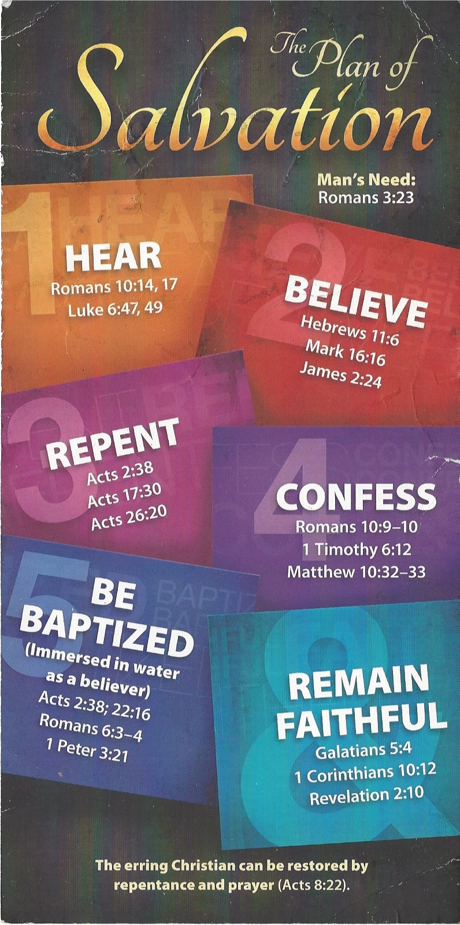
⁹ If you declare with your mouth, “Jesus is Lord,” and believe in your heart that God raised him from the dead, you will be saved. ¹⁰ For it is with your heart that you believe and are justified, and it is with your mouth that you profess your faith and are saved.
Be Baptized
1 Peter 3:21 (NIV)
²¹ and this water symbolizes baptism that now saves you also—not the removal of dirt from the body but the pledge of a clear conscience toward God. It saves you by the resurrection of Jesus Christ,
Remain Faithful
Galatians 5:4 (NIV)
⁴ You who are trying to be justified by the law have been alienated from Christ; you have fallen away from grace.

