Barry G. Johnson, Sr.www.barrygjohnsonsr.com
Discovering the Church / Gospel; Elder in the NT; Evangelism; Evangelist; Mission; Paul’s Missionary Journeys; Early Missionary Efforts / Acts 14:21–28

Coming to the end of Paul's first missionary journey the brethren are strengthened and Paul and Barnabas return to Antioch the beginning of their journey.
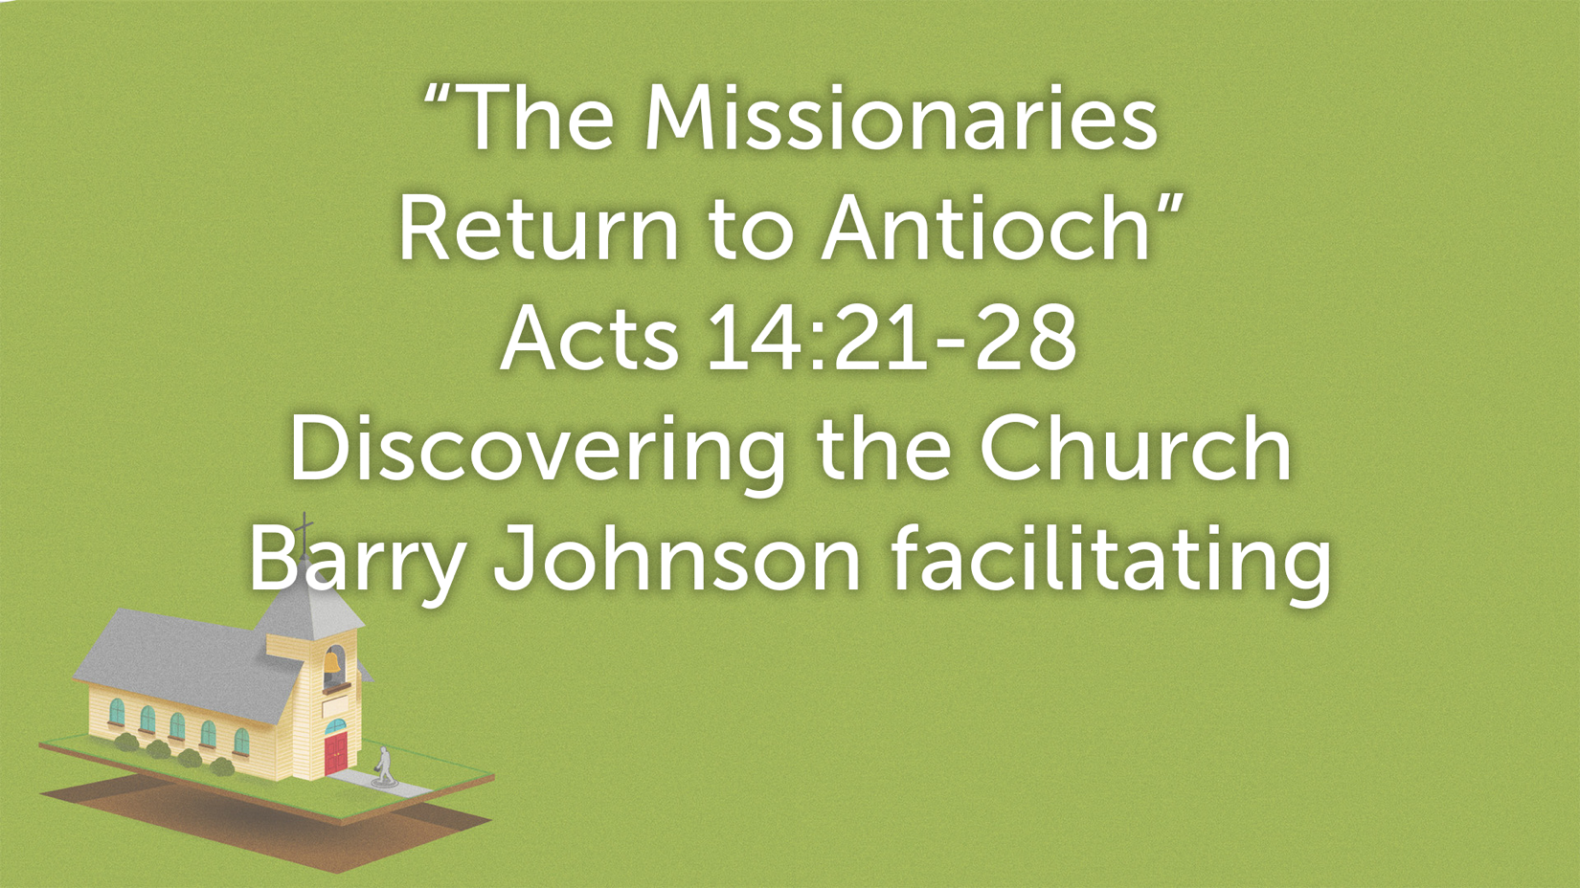

Strengthening the Brethren
Question v21: What was preached in Derbe?

Question: What is the Gospel and how do we preach it here in Brookfield?

Thought: What practices do we have today that follow this pattern?

Cf. Heb. 5:12; attitude we need Ezr. 7:10
Question v22: What must we go through to enter the Kingdom of Heaven?

Elders in every Church
Question v22-23: What 3 ministerial efforts do Paul and Barnabas employee when they go back to the Churches?

Returning to Antioch
Reminder: Whose idea was it for Paul’s first missionary journey?

Declared all that God had Done
Question v27: What did Paul and Barnabas tell the Church when they arrived?

Question v27: What had God done for the Gentiles?

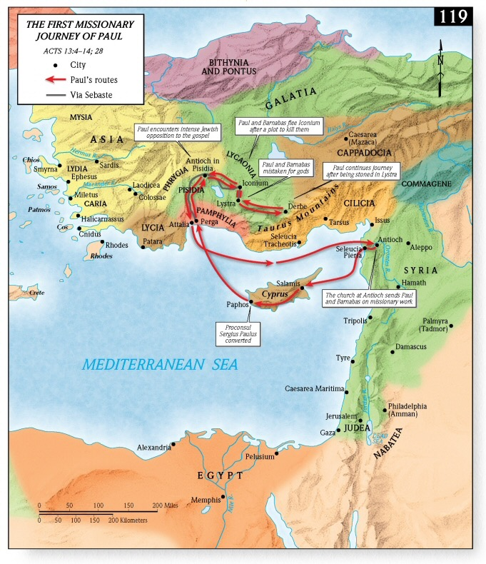

Acts 14:21-28 The Missionaries Return to Antioch

