Thesis / Central Idea:

The kingdom of God comes into being wherever the kingly authority of God is acknowledged. Although God is always sovereign, Scripture looks to a future “realm” or “reign” of salvation. This has come in Christ and yet will come in its fulness only when Jesus Christ returns.

Sermon Outline:

- God is sovereign over Israel and over the whole earth
Psalm 47:7–8 ESV
For God is the King of all the earth;
sing praises with a psalm!
God reigns over the nations;
God sits on his holy throne.
- The coming reign of God

  - Its expectation

Isaiah 51:4–5 ESV
“Give attention to me, my people,
and give ear to me, my nation;
for a law will go out from me,
and I will set my justice for a light to the peoples.
My righteousness draws near,
my salvation has gone out,
and my arms will judge the peoples;
the coastlands hope for me,
and for my arm they wait.
Mark 15:43 ESV
Joseph of Arimathea, a respected member of the council, who was also himself looking for the kingdom of God, took courage and went to Pilate and asked for the body of Jesus.
  - Its association with the coming of the Messiah

Isaiah 9:6–7 ESV
For to us a child is born,
to us a son is given;
and the government shall be upon his shoulder,
and his name shall be called
Wonderful Counselor, Mighty God,
Everlasting Father, Prince of Peace.
Of the increase of his government and of peace
there will be no end,
on the throne of David and over his kingdom,
to establish it and to uphold it
with justice and with righteousness
from this time forth and forevermore.
The zeal of the LORD of hosts will do this.
Daniel 7:14 ESV
And to him was given dominion
and glory and a kingdom,
that all peoples, nations, and languages
should serve him;
his dominion is an everlasting dominion,
which shall not pass away,
and his kingdom one
that shall not be destroyed.
- The kingdom of God was central in the preaching of Jesus Christ and the apostles
Matthew 24:14 ESV
And this gospel of the kingdom will be proclaimed throughout the whole world as a testimony to all nations, and then the end will come.
Luke 8:1 ESV
Soon afterward he went on through cities and villages, proclaiming and bringing the good news of the kingdom of God. And the twelve were with him,
Acts 28:31 ESV
proclaiming the kingdom of God and teaching about the Lord Jesus Christ with all boldness and without hindrance.
- The kingdom of God has come in Christ: it is present
Matthew 11:12 ESV
From the days of John the Baptist until now the kingdom of heaven has suffered violence, and the violent take it by force.
- The kingdom of God will come in its fulness only when Jesus Christ returns: it is future
Luke 22:18 ESV
For I tell you that from now on I will not drink of the fruit of the vine until the kingdom of God comes.”

Hear - Romans 10:17 (NIV)
¹⁷ Consequently, faith comes from hearing the message, and the message is heard through the word about Christ.
Believe - Hebrews 11:6 (NIV)
⁶ And without faith it is impossible to please God, because anyone who comes to him must believe that he exists and that he rewards those who earnestly seek him.
Repent - Acts 17:30 (NIV)
³⁰ In the past God overlooked such ignorance, but now he commands all people everywhere to repent.
Confess - 1 Timothy 6:12 (NIV)
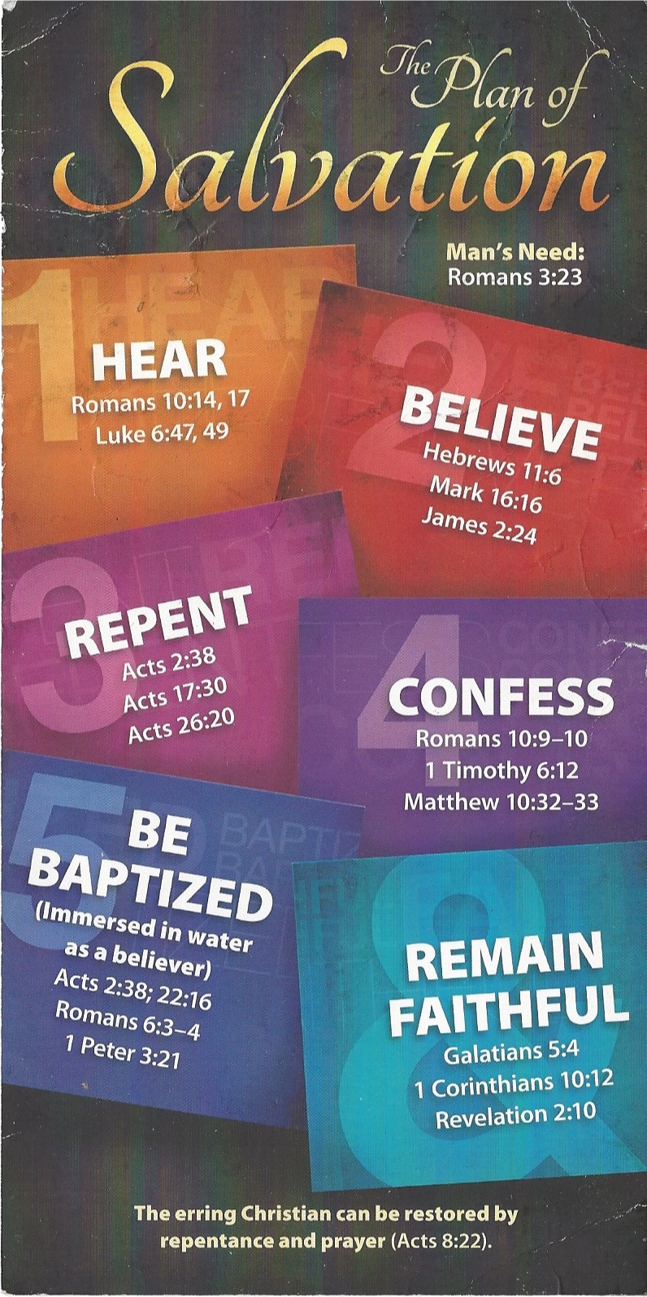
¹² Fight the good fight of the faith. Take hold of the eternal life to which you were called when you made your good confession in the presence of many witnesses.

Be Baptized - Acts 22:16 (NIV)
¹⁶ And now what are you waiting for? Get up, be baptized and wash your sins away, calling on his name.’
Remain Steadfast - Revelation 2:10 (NIV)
¹⁰ Do not be afraid of what you are about to suffer. I tell you, the devil will put some of you in prison to test you, and you will suffer persecution for ten days. Be faithful, even to the point of death, and I will give you life as your victor’s crown.

