Synopsis
The future event of finally being raised to glory with Jesus Christ. Believers may rest assured that, on account of their faith, they will share in the resurrection and glory of Christ and be with him for ever.
- The Nature of the Resurrection of Believers
- Resurrection to Eternal Life
John 11:25–26 (NIV) — 25 Jesus said to her, “I am the resurrection and the life. The one who believes in me will live, even though they die; 26 and whoever lives by believing in me will never die. Do you believe this?”
- Completely United to Jesus Christ
Romans 6:5 (NIV) — 5 For if we have been united with him in a death like his, we will certainly also be united with him in a resurrection like his.
- Leads to Becoming Like Jesus Christ
1 Corinthians 15:49 (NIV) — 49 And just as we have borne the image of the earthly man, so shall we bear the image of the heavenly man.
- The Resurrection is a Future Hope of Believers
In the NT the death of believers is often likened to sleep.
1 Corinthians 15:19 (NIV) — 19 If only for this life we have hope in Christ, we are of all people most to be pitied.
1 Thessalonians 4:13–14 (NIV) — 13 Brothers and sisters, we do not want you to be uninformed about those who sleep in death, so that you do not grieve like the rest of mankind, who have no hope. 14 For we believe that Jesus died and rose again, and so we believe that God will bring with Jesus those who have fallen asleep in him.
- The Resurrection is Incentive for Godliness and Perseverance
1 Corinthians 15:58 (NIV) — 58 Therefore, my dear brothers and sisters, stand firm. Let nothing move you. Always give yourselves fully to the work of the Lord, because you know that your labor in the Lord is not in vain.
- The Resurrection is Incentive to Endurance Suffering
Romans 8:17 (NIV) — 17 Now if we are children, then we are heirs—heirs of God and co-heirs with Christ, if indeed we share in his sufferings in order that we may also share in his glory.
2 Timothy 2:11–12 (NIV) — 11 Here is a trustworthy saying: If we died with him, we will also live with him; 12 if we endure, we will also reign with him. If we disown him, he will also disown us;

Invitation
Hear
Romans 10:17 (NIV)
¹⁷ Consequently, faith comes from hearing the message, and the message is heard through the word about Christ.
Believe
Hebrews 11:6 (NIV)
⁶ And without faith it is impossible to please God, because anyone who comes to him must believe that he exists and that he rewards those who earnestly seek him.
Repent
Acts 17:30 (NIV)
³⁰ In the past God overlooked such ignorance, but now he commands all people everywhere to repent.
Confess
Matthew 10:32–33 (NIV)
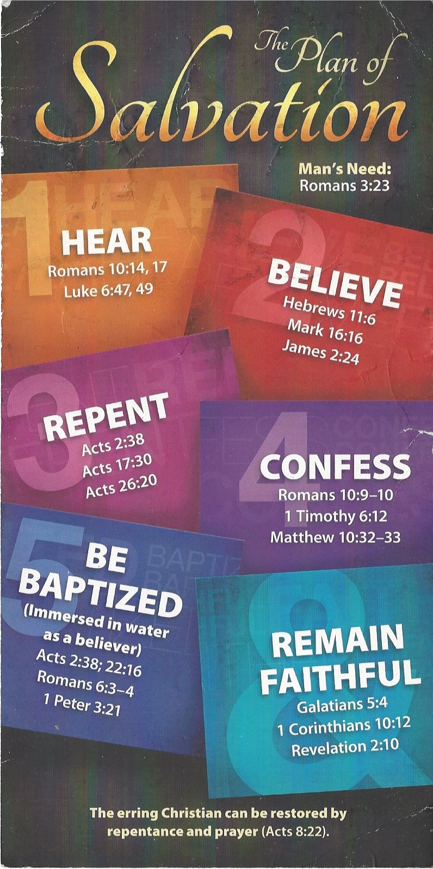
³² “Whoever acknowledges me before others, I will also acknowledge before my Father in heaven. ³³ But whoever disowns me before others, I will disown before my Father in heaven.
Be Baptized
1 Peter 3:21 (NIV)
²¹ and this water symbolizes baptism that now saves you also—not the removal of dirt from the body but the pledge of a clear conscience toward God. It saves you by the resurrection of Jesus Christ,
Remain Faithful
1 Corinthians 10:12 (NIV)
¹² So, if you think you are standing firm, be careful that you don’t fall!

