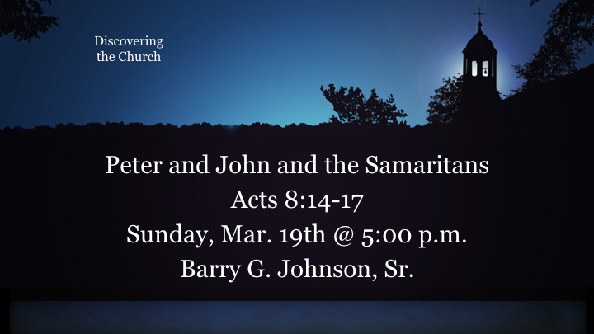
Thesis/ Central Idea:
The Word and the Spirit are connected in bringing salvation to mankind through the Gospel of Jesus the Christ.
Questions:
- Who had the keys to the Kingdom of God to usher men into the Church?
- Why was it a good idea that the Apostle John was sent to Samaria?
- How did the Lord prophesy that Gospel would be spread throughout men?

- Peter uses the keys to the Kingdom…
  - The apostles in Jerusalem heard that Samaria had accepted the word of God (14). This is more than a matter-of-fact statement; it seems to be almost a technical expression by which Luke signals an important new stage in the advance of the gospel.
    - He has used it in reference to the Day of Pentecost when three thousand Jews ‘accepted his [Peter’s] message’ (2:41).
Acts 2:41 (ESV)
⁴¹ So those who received his word were baptized, and there were added that day about three thousand souls.
    - He uses it here of the first Samaritans who ‘accepted the word of God’.
    - And he will use it again after the conversion of Cornelius, when the apostles heard that ‘the Gentiles also had received the word of God’ (11:1). Further, in all three developments Peter played a decisive role, using the keys of the kingdom (though Luke does not refer to this) to open it successively to Jews, Samaritans and Gentiles.
Acts 11:1 (ESV)
¹¹ Now the apostles and the brothers who were throughout Judea heard that the Gentiles also had received the word of God.
  - Remember the Lord’s command to the Apostles…
Acts 1:1–5 (ESV)
¹ In the first book, O Theophilus, I have dealt with all that Jesus began to do and teach, ² until the day when he was taken up, after he had given commands through the Holy Spirit to the apostles whom he had chosen. ³ He presented himself alive to them after his suffering by many proofs, appearing to them during forty days and speaking about the kingdom of God.
⁴ And while staying with them he ordered them not to depart from Jerusalem, but to wait for the promise of the Father, which, he said, “you heard from me; ⁵ for John baptized with water, but you will be baptized with the Holy Spirit not many days from now.”
Acts 1:8 (ESV)
⁸ But you will receive power when the Holy Spirit has come upon you, and you will be my witnesses in Jerusalem and in all Judea and Samaria, and to the end of the earth.”
  - Peter was given the keys to the Kingdom by the Lord…
Matthew 16:19 (ESV)
¹⁹ I will give you the keys of the kingdom of heaven, and whatever you bind on earth shall be bound in heaven, and whatever you loose on earth shall be loosed in heaven.”
  - It was very appropriate that one of the Apostles sent was John…
Luke 9:51–54 (ESV)
⁵¹ When the days drew near for him to be taken up, he set his face to go to Jerusalem. ⁵² And he sent messengers ahead of him, who went and entered a village of the Samaritans, to make preparations for him. ⁵³ But the people did not receive him, because his face was set toward Jerusalem. ⁵⁴ And when his disciples James and John saw it, they said, “Lord, do you want us to tell fire to come down from heaven and consume them?”
- The Word and the Spirit are connected…
John 6:63 (ESV)
⁶³ It is the Spirit who gives life; the flesh is no help at all. The words that I have spoken to you are spirit and life.
  - God’s Word is Spirit and Life…
Hebrews 4:12 (ESV)
¹² For the word of God is living and active, sharper than any two-edged sword, piercing to the division of soul and of spirit, of joints and of marrow, and discerning the thoughts and intentions of the heart.
  - The word is like a scalpel the Spirit uses to discern the thoughts and intentions of the hearts of men.
  - Paul uses similar language of the word and Spirit as well…
Ephesians 6:17 (ESV)
¹⁷ and take the helmet of salvation, and the sword of the Spirit, which is the word of God,
  - Paul also describes the Spirit as a seal to those who receive the Word.
Ephesians 1:13 (ESV)
¹³ In him you also, when you heard the word of truth, the gospel of your salvation, and believed in him, were sealed with the promised Holy Spirit,

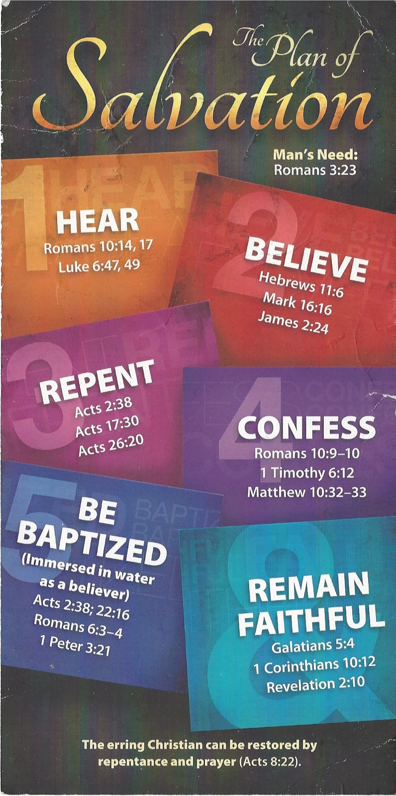
Hear - Romans 10:17 (NIV)
¹⁷ Consequently, faith comes from hearing the message, and the message is heard through the word about Christ.
Believe - Hebrews 11:6 (NIV)
⁶ And without faith it is impossible to please God, because anyone who comes to him must believe that he exists and that he rewards those who earnestly seek him.
Repent - Acts 17:30 (NIV)
³⁰ In the past God overlooked such ignorance, but now he commands all people everywhere to repent.
Confess - 1 Timothy 6:12 (NIV)
¹² Fight the good fight of the faith. Take hold of the eternal life to which you were called when you made your good confession in the presence of many witnesses.
Be Baptized - Acts 2:38 (ESV)
³⁸ And Peter said to them, “Repent and be baptized every one of you in the name of Jesus Christ for the forgiveness of your sins, and you will receive the gift of the Holy Spirit.
Remain Steadfast - Revelation 2:10 (NIV)
¹⁰ Do not be afraid of what you are about to suffer. I tell you, the devil will put some of you in prison to test you, and you will suffer persecution for ten days. Be faithful, even to the point of death, and I will give you life as your victor’s crown.

Coming in April
Sunday,Apr 2, 2017 Walking Christian on Single Parenting - (Lagenia & Tony Padgett)
Wednesday,Apr 5, 2017 Walking Christian on Terminal Illness - (Greg Gates)
 | IV. Peter Joins the Wider Witness (9:1–12:25)
 | 1. Paul’s New Witness to Christ (9:1–31)
 | (1) Paul the Converted (9:1–22)
Sun. Apr. 2, 2017 | Christ’s Appearance to Paul (9:1–9) | B. Johnson
Sun. Apr. 2, 2017 eve | The Call to Be Persecuted (9:10–19a) | D. Drozd
Wed. Apr. 5, 2017 | The Former Persecutor’s Witness to Christ (9:19b-22) | T. Padgett
 | (2) Paul the Persecuted (9:23–31)
Sun. Apr. 9, 2017 | Persecuted in Damascus (9:23–25) | B. Johnson
Sun. Apr. 9, 2017 eve | Persecuted in Jerusalem (9:26–31) | T. Padgett
 | 2. Peter’s Witness in the Coastal Towns (9:32–43)
Wed.. Apr. 12, 2017 | (1) The Healing of Aeneas (9:32–35) | B. Johnson
Sun. Apr. 16, 2017 | (2) The Raising of Dorcas (9:36–43) | B. Johnson
 | 3. Peter’s Witness to a Gentile God-fearer (10:1–11:18)
Wed. Apr. 19, 2017 | (1) The Vision of Cornelius (10:1–8) | B. Johnson
Sun. Apr. 23, 2017 | (2) The Vision of Peter (10:9–16) | T. Padgett
Sun. Apr. 23, 2017 eve. | (3) Peter's visit to Cornelius (10:18-23) | B. Johnson
Wed. Apr. 26, 2017 | (4) Shared Visions (10:24–33) | T. Padgett
Sun. Apr. 30, 2107 | (5) Peter’s Witness (10:34–43) | B. Johnson
 | (6) The Impartiality of the Spirit (10:44–48)

Stott, J. R. W. (1994). The message of Acts: the Spirit, the church & the world (pp. 149–150). Leicester, England; Downers Grove, IL: InterVarsity Press.

