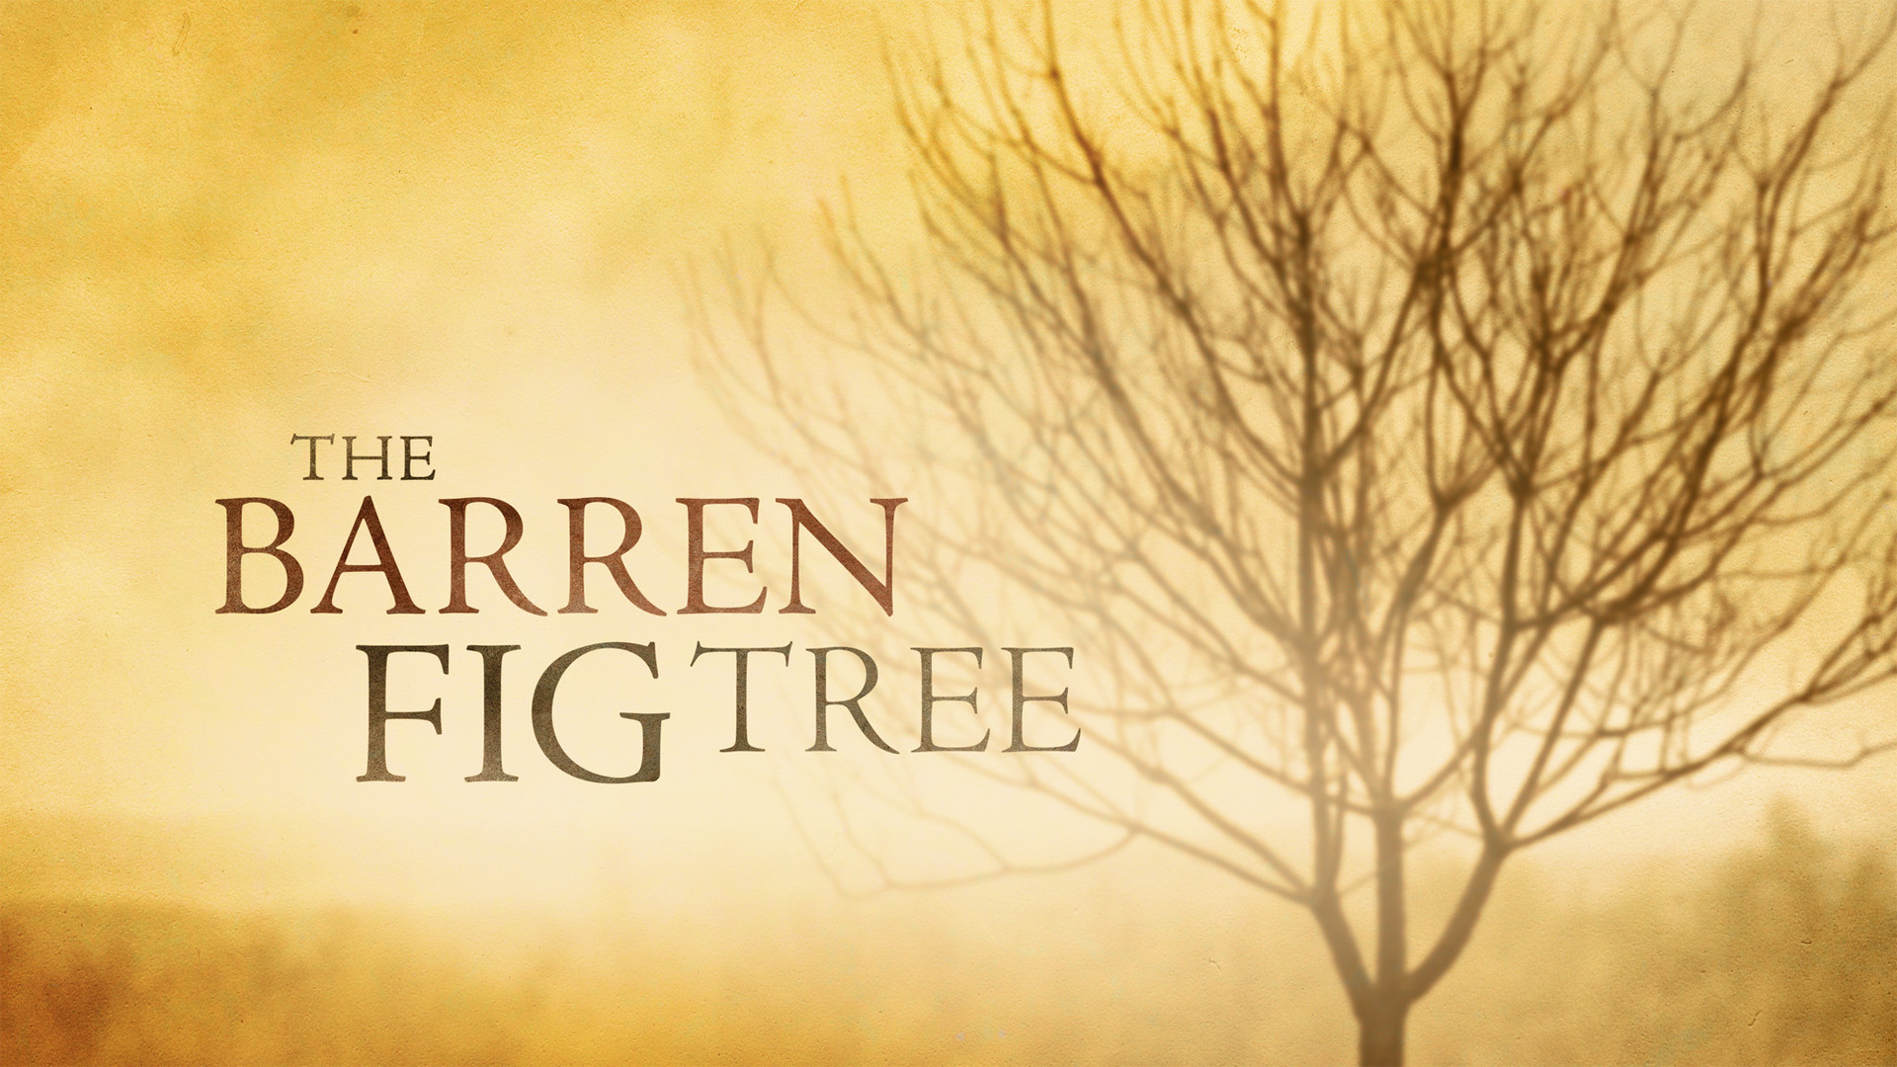
Unfruitfulness
Synopsis
A lack of fruitfulness, whether material or spiritual, which is often seen as a sign of God’s disfavour or anger.

- Unfruitfulness as a moral or spiritual condition
Matthew 21:19 (NIV) — 19 Seeing a fig tree by the road, he went up to it but found nothing on it except leaves. Then he said to it, “May you never bear fruit again!” Immediately the tree withered.
See also Job 15:32–33 ; Eze 17:9 ; Eze 19:10–12 ; Mt 21:43 ; Heb 6:7–8
Job 15:32–33 (NIV) — 32 Before his time he will wither, and his branches will not flourish. 33 He will be like a vine stripped of its unripe grapes, like an olive tree shedding its blossoms.
Ezekiel 17:9 (NIV) — 9 “Say to them, ‘This is what the Sovereign Lord says: Will it thrive? Will it not be uprooted and stripped of its fruit so that it withers? All its new growth will wither. It will not take a strong arm or many people to pull it up by the roots.
Ezekiel 19:10–12 (NIV) — 10 “ ‘Your mother was like a vine in your vineyard planted by the water; it was fruitful and full of branches because of abundant water. 11 Its branches were strong, fit for a ruler’s scepter. It towered high above the thick foliage, conspicuous for its height and for its many branches. 12 But it was uprooted in fury and thrown to the ground. The east wind made it shrivel, it was stripped of its fruit; its strong branches withered and fire consumed them.
Matthew 21:43 (NIV) — 43 “Therefore I tell you that the kingdom of God will be taken away from you and given to a people who will produce its fruit.
Hebrews 6:7–8 (NIV) — 7 Land that drinks in the rain often falling on it and that produces a crop useful to those for whom it is farmed receives the blessing of God. 8 But land that produces thorns and thistles is worthless and is in danger of being cursed. In the end it will be burned.
- Reasons for unfruitfulness
- Disobedience
Leviticus 26:18–20 (NIV) — 18 “ ‘If after all this you will not listen to me, I will punish you for your sins seven times over. 19 I will break down your stubborn pride and make the sky above you like iron and the ground beneath you like bronze. 20 Your strength will be spent in vain, because your soil will not yield its crops, nor will the trees of your land yield their fruit.
See also Dt 11:17 ; Dt 28:15–16 ; Ps 78:46 ; Ps 107:33–34 ; Is 5:10 ; Is 32:10 ; Ho 8:7 ; Hag 2:19
Deuteronomy 11:17 (NIV) — 17 Then the Lord’s anger will burn against you, and he will shut up the heavens so that it will not rain and the ground will yield no produce, and you will soon perish from the good land the Lord is giving you.
Deuteronomy 28:15–16 (NIV) — 15 However, if you do not obey the Lord your God and do not carefully follow all his commands and decrees I am giving you today, all these curses will come on you and overtake you: 16 You will be cursed in the city and cursed in the country.
Psalm 78:46 (NIV) — 46 He gave their crops to the grasshopper, their produce to the locust.
Psalm 107:33–34 (NIV) — 33 He turned rivers into a desert, flowing springs into thirsty ground, 34 and fruitful land into a salt waste, because of the wickedness of those who lived there.
Isaiah 5:10 (NIV) — 10 A ten-acre vineyard will produce only a bath of wine; a homer of seed will yield only an ephah of grain.”
Isaiah 32:10 (NIV) — 10 In little more than a year you who feel secure will tremble; the grape harvest will fail, and the harvest of fruit will not come.
Hosea 8:7 (NIV) — 7 “They sow the wind and reap the whirlwind. The stalk has no head; it will produce no flour. Were it to yield grain, foreigners would swallow it up.
Haggai 2:19 (NIV) — 19 Is there yet any seed left in the barn? Until now, the vine and the fig tree, the pomegranate and the olive tree have not borne fruit. “ ‘From this day on I will bless you.’ ”
- A continuing preoccupation with the world
Matthew 13:22 (NIV) — 22 The seed falling among the thorns refers to someone who hears the word, but the worries of this life and the deceitfulness of wealth choke the word, making it unfruitful.
- A broken relationship with Jesus Christ
John 15:4 (NIV) — 4 Remain in me, as I also remain in you. No branch can bear fruit by itself; it must remain in the vine. Neither can you bear fruit unless you remain in me.
See also Jn 15:6
John 15:6 (NIV) — 6 If you do not remain in me, you are like a branch that is thrown away and withers; such branches are picked up, thrown into the fire and burned.
- Some results of unfruitfulness
- Unfruitfulness condemned
Isaiah 5:1–7 (NIV) — 1 I will sing for the one I love a song about his vineyard: My loved one had a vineyard on a fertile hillside. 2 He dug it up and cleared it of stones and planted it with the choicest vines. He built a watchtower in it and cut out a winepress as well. Then he looked for a crop of good grapes, but it yielded only bad fruit. 3 “Now you dwellers in Jerusalem and people of Judah, judge between me and my vineyard. 4 What more could have been done for my vineyard than I have done for it? When I looked for good grapes, why did it yield only bad? 5 Now I will tell you what I am going to do to my vineyard: I will take away its hedge, and it will be destroyed; I will break down its wall, and it will be trampled. 6 I will make it a wasteland, neither pruned nor cultivated, and briers and thorns will grow there. I will command the clouds not to rain on it.” 7 The vineyard of the Lord Almighty is the nation of Israel, and the people of Judah are the vines he delighted in. And he looked for justice, but saw bloodshed; for righteousness, but heard cries of distress.
- Unfruitfulness leads to rejection
Matthew 3:8–10 (NIV) — 8 Produce fruit in keeping with repentance. 9 And do not think you can say to yourselves, ‘We have Abraham as our father.’ I tell you that out of these stones God can raise up children for Abraham. 10 The ax is already at the root of the trees, and every tree that does not produce good fruit will be cut down and thrown into the fire.
Matthew 7:19 (NIV) — 19 Every tree that does not bear good fruit is cut down and thrown into the fire.
- Unfruitfulness retrieved
Lk 13:6–9 The parable holds out the possibility of restoration.
Luke 13:6–9 (NIV) — 6 Then he told this parable: “A man had a fig tree growing in his vineyard, and he went to look for fruit on it but did not find any. 7 So he said to the man who took care of the vineyard, ‘For three years now I’ve been coming to look for fruit on this fig tree and haven’t found any. Cut it down! Why should it use up the soil?’ 8 “ ‘Sir,’ the man replied, ‘leave it alone for one more year, and I’ll dig around it and fertilize it. 9 If it bears fruit next year, fine! If not, then cut it down.’ ”
- Discipline with a view to renewed fruitfulness
John 15:2 (NIV) — 2 He cuts off every branch in me that bears no fruit, while every branch that does bear fruit he prunes so that it will be even more fruitful.

Hear - Romans 10:17 (NIV)
¹⁷ Consequently, faith comes from hearing the message, and the message is heard through the word about Christ.
Believe - Hebrews 11:6 (NIV)
⁶ And without faith it is impossible to please God, because anyone who comes to him must believe that he exists and that he rewards those who earnestly seek him.
Repent - Acts 17:30 (NIV)
³⁰ In the past God overlooked such ignorance, but now he commands all people everywhere to repent.
Confess - Matthew 10:32–33 (NIV)
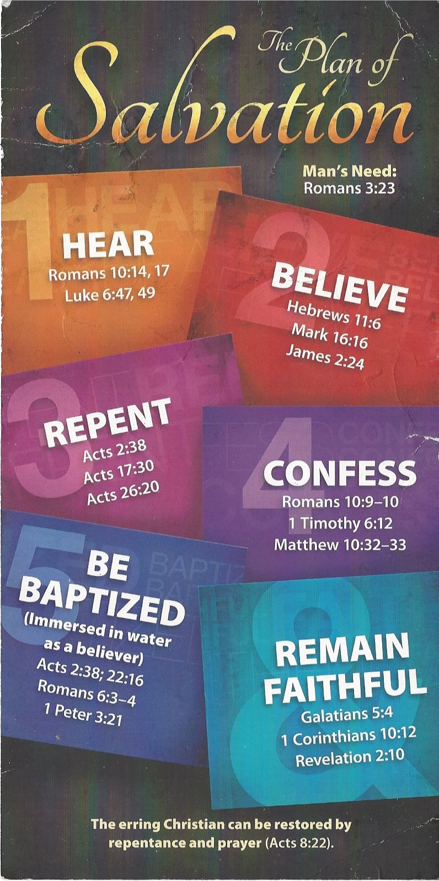
³² “Whoever acknowledges me before others, I will also acknowledge before my Father in heaven. ³³ But whoever disowns me before others, I will disown before my Father in heaven.
Be Baptized - Acts 22:16 (NIV)
¹⁶ And now what are you waiting for? Get up, be baptized and wash your sins away, calling on his name.’
Remain Steadfast - Revelation 2:10 (NIV)
¹⁰ Do not be afraid of what you are about to suffer. I tell you, the devil will put some of you in prison to test you, and you will suffer persecution for ten days. Be faithful, even to the point of death, and I will give you life as your victor’s crown.

