Walking Christian
Codependency - causes
Barry G. Johnson, Sr.
Church of Christ, Brookfield

III. Causes of Codependency
“Though by this time you ought to be teachers, you need someone to teach you the elementary truths of God’s word all over again. You need milk, not solid food! Anyone who lives on milk, being still an infant, is not acquainted with the teaching about righteousness.”
(Hebrews 5:12–13)
A. What Causes Codependency to Develop in Children?
“If anyone causes one of these little ones who believe in me to sin, it would be better for him to have a large millstone hung around his neck and to be drowned in the depths of the sea.”
(Matthew 18:6)
Five Stages of Childhood Development
God bestows on parents the major responsibility of nurturing their children so that they will not be love-starved—an emotional state that sets them up to “look for love in all the wrong places.”
#1 _________________________ Stage
_________________________ need to bond with their parents because they are helpless and totally dependent for all their basic needs (including the three inner needs for love, for significance, and for security). If your parents did not meet your needs, you may have grown into a needy adult who feels “empty” inside—as if there is a hole in your heart.
#2 _________________________ Stage
_________________________ need to begin to push away from their parents as a way of exploring their environment and setting boundaries. If your parents did not allow separation, you may have grown into an adult who manipulates others to gain some sense of control.
#3 _________________________ Stage
_________________________ need to learn proper ways of resolving conflict as they begin to test their parents’ rules. If you did not learn healthy conflict resolution skills, you may have grown into an adult who lacks problem-solving skills in your adult relationships.
#4 _________________________ Stage
_________________________ need to grow in independence, but they still need direction and support from their parents. If your parents stifled your assertiveness, you may have grown into a needy, unassertive adult who is dependent on others to validate you.
#5 _________________________ Stage
_________________________ need to learn mutual give-and-take and even sacrificial sharing from their parents as they begin to pursue involvement within their own groups. If you did not see a healthy give-and-take between your parents or see ways of sacrificially helping others, you may have grown into a self-focused adult who forms unequal relationships to feel some sense of significance.
Question: “As a parent, how can I keep my children from having an unhealthy dependence on me?”
Answer:

“Train a child in the way he should go, and when he is old he will not turn from it.” (Proverbs 22:6)
“He is like a tree planted by streams of water, which yields its fruit in season and whose leaf does not wither. Whatever he does prospers.”
(Psalm 1:3)
B. What Causes Repeated Cycles of Codependency?
“What I do is not the good I want to do; no, the evil I do not want to do—this I keep on doing.”
(Romans 7:19)
What Childhood Setup Leads to Adult Love Addiction?
• As a child, I had a “love bucket” that was empty.
• As an adult, I find that my “love bucket” has holes in it.
“I have loved you with an everlasting love; I have drawn you with loving-kindness.”
(Jeremiah 31:3)

The Cycle of the Weak One
Scenario #1
A woman appears weak because as a child her emotional needs were never met. She fantasizes about her “knight in shining armor,” who will one day sweep her away into romantic bliss. This love addict constantly yearns for someone to “complete” her as a person. She is drawn to “caregivers,” yet at the same time, she is terrified at the thought of true intimacy.
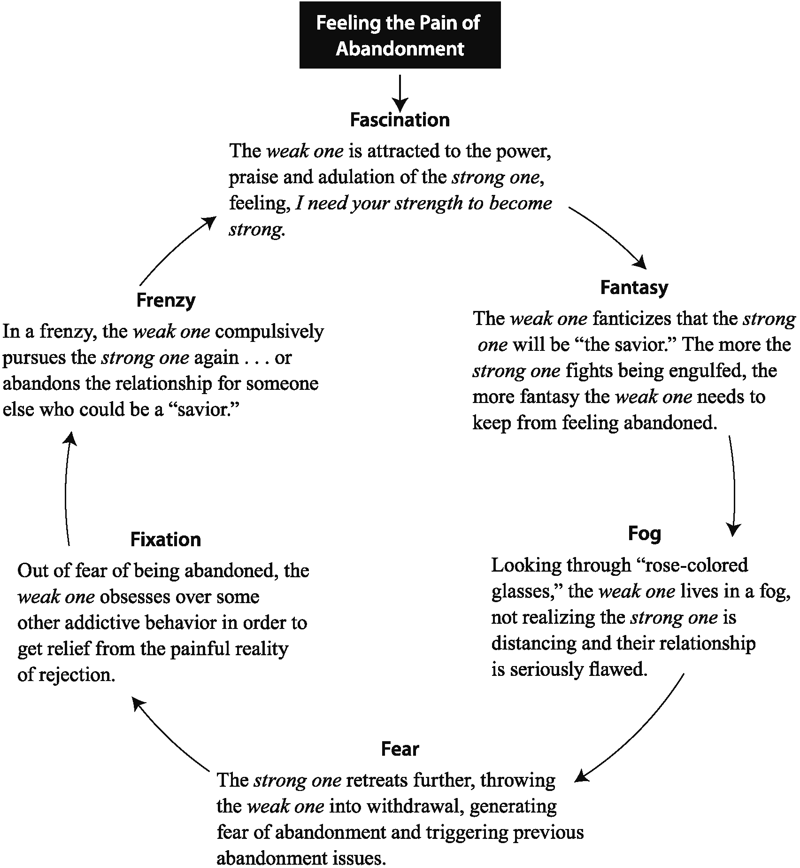

The Cycle of the Strong One
Scenario #2
A man appears strong because as a child he was in an enmeshed relationship with his mother. He was his mother’s “caregiver” and surrogate husband. (His father was emotionally or physically absent.) Now, as an adult, he is drawn to women who need to be “taken care of,” but he is terrified at the thought of being smothered again.
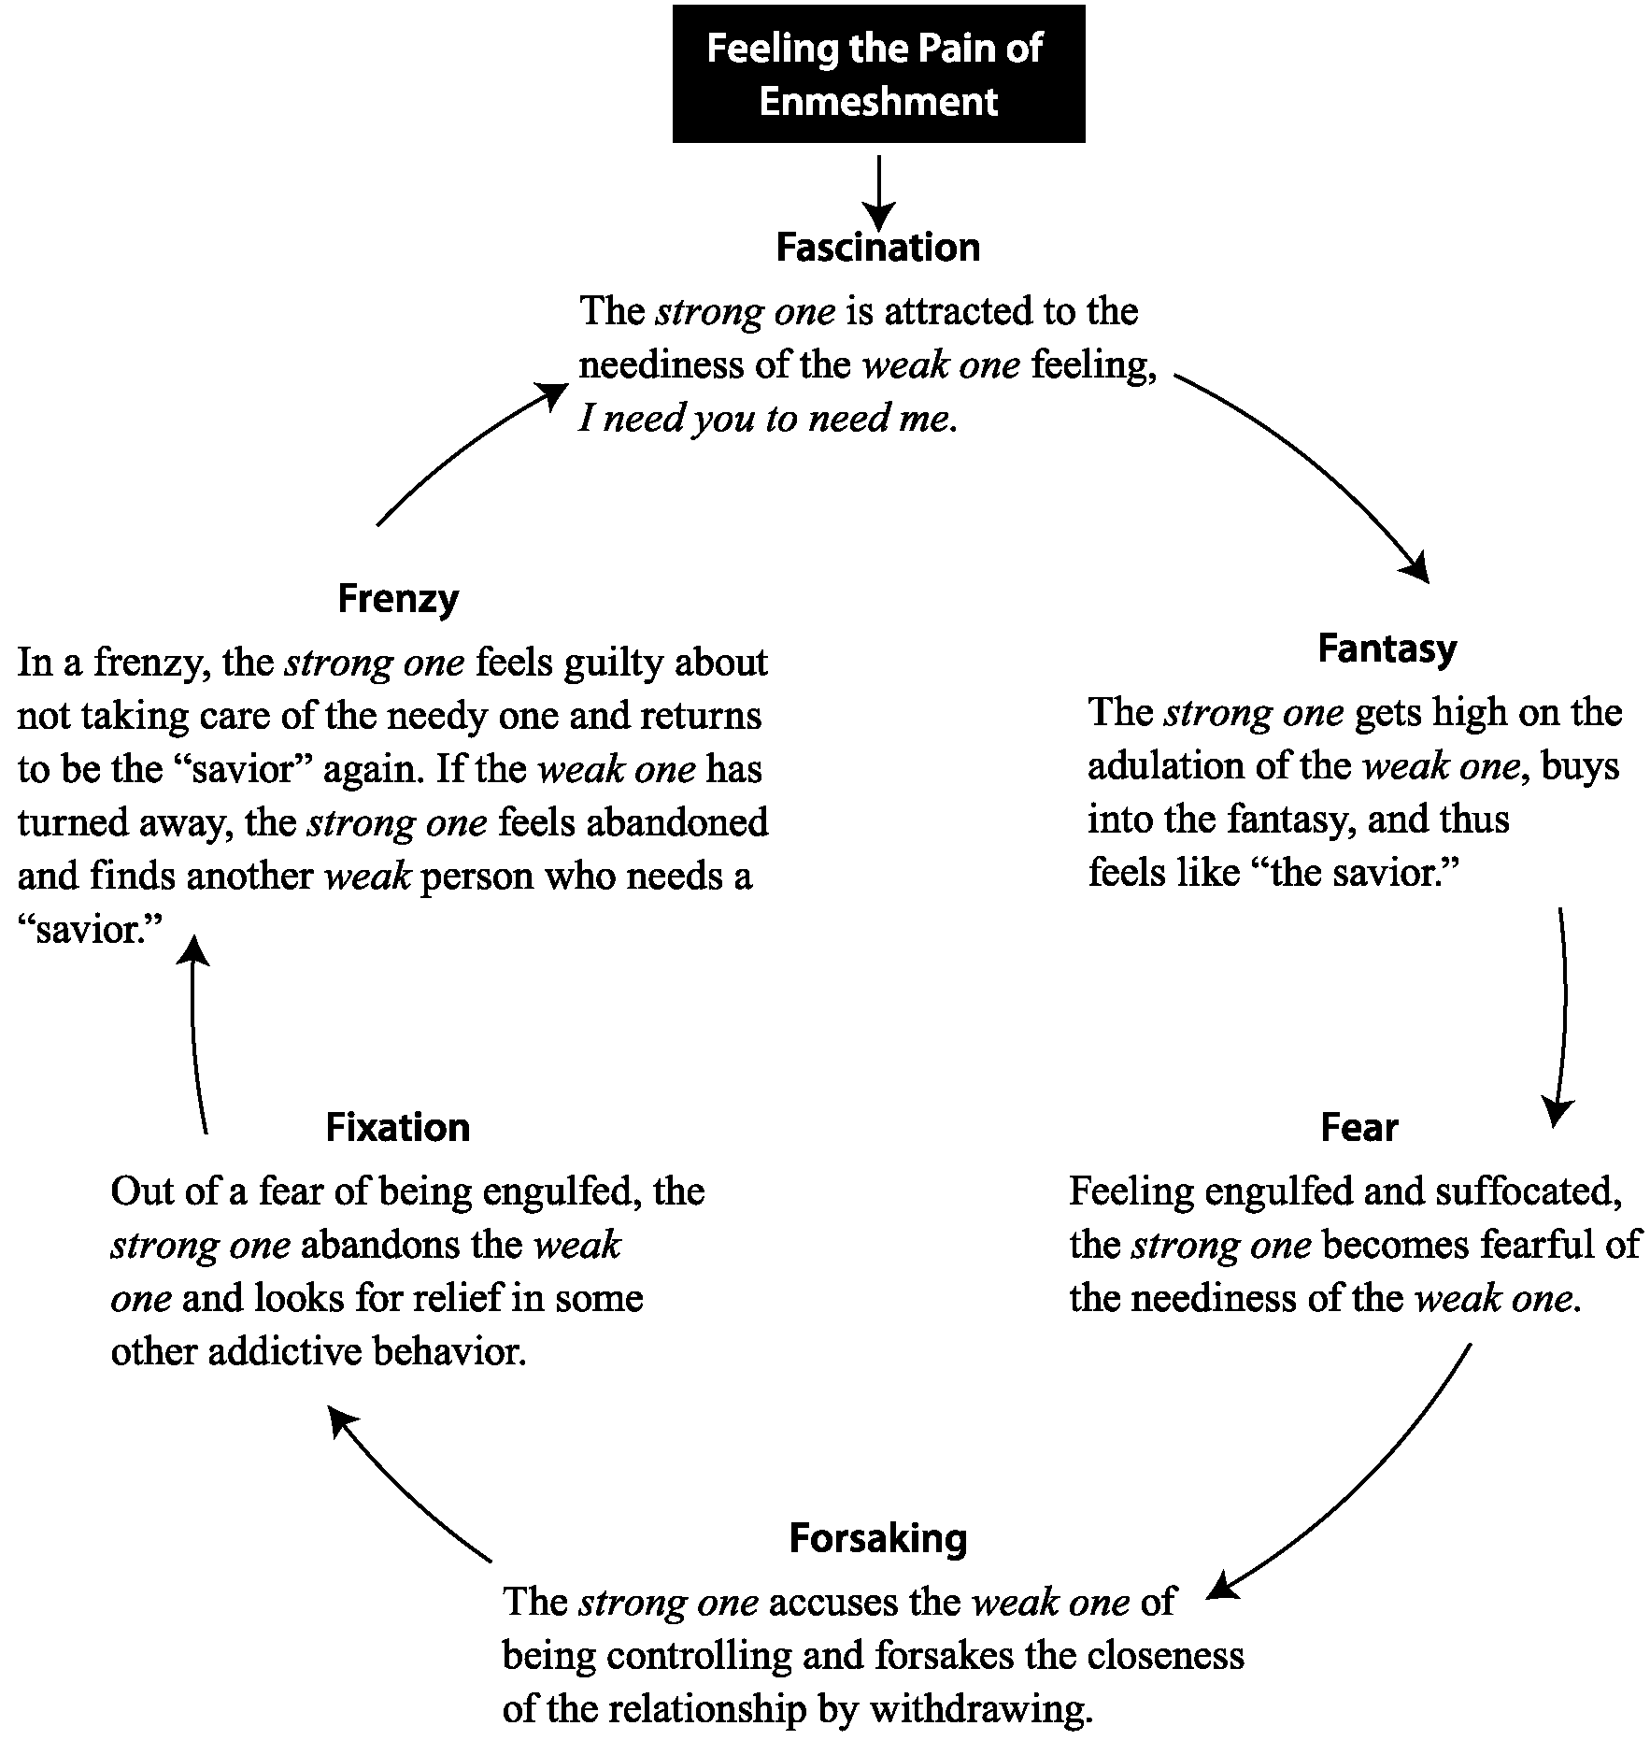
“Avoid all extremes.”
(Ecclesiastes 7:18)
Question: “Why do I keep getting into codependent relationships? I’m now wondering whether it is possible for me ever to break free and stay free?”
Answer:

“With God all things are possible.” (Matthew 19:26)
C. What Is the Most Dangerous Dependency?
How to Begin Depending on God Alone
If you have struggled with codependency, God has a solution for you—a solution that can be spelled out in four points.
#1 God’s Purpose for You … _________________________.
“God so loved the world that he gave his one and only Son, that whoever believes in him shall not perish but have eternal life. For God did not send his Son into the world to condemn the world, but to save the world through him.” (John 3:16–17)
“I [Jesus] have come that they may have life, and have it to the full.” (John 10:10)
#2 Your Problem … _________________________.
— What exactly is sin? Sin is living _________________________ of God’s standard—(commission and or omission.
“Anyone, then, who knows the good he ought to do and doesn’t do it, sins.” (James 4:17)
— What is the major consequence of sin? Spiritual _________________________, spiritual _________________________ from God.
“The wages of sin is death, but the gift of God is eternal life in Christ Jesus our Lord.” (Romans 6:23)
#3 God’s Provision for You … _________________________.
“God demonstrates his own love for us in this: While we were still sinners, Christ died for us.” (Romans 5:8)
“Jesus answered, ‘I am the way and the truth and the life. No one comes to the Father except through me.’ ” (John 14:6)
#4 Your Part … _________________________.
“It is by grace you have been saved, through faith—and this not from yourselves, it is the gift of God—not by works, so that no one can boast.” (Ephesians 2:8–9)
“Jesus said to his disciples, ‘If anyone would come after me, he must deny himself and take up his cross and follow me. For whoever wants to save his life will lose it, but whoever loses his life for me will find it. What good will it be for a man if he gains the whole world, yet forfeits his soul?’ ” (Matthew 16:24–26)
D. What Is the Root Cause of Codependency?
Everyone is created with three God-given inner needs—the needs for _________________________,
for _________________________,
and for _________________________. If we expect or demand that another person meet all our needs or if we become dependent on another person to do so, we have a misplaced dependency. The Bible makes it plain that …
“God will meet all your needs according to his glorious riches in Christ Jesus.”
(Philippians 4:19)
Wrong Belief for the Dependent:
“I need to be connected to a stronger person who will provide me with a sense of love and emotional security.”
Right Belief for the Dependent:
“While God often expresses His love through others, He doesn’t want me to live my life depending on another person. I need to live dependently on Jesus, who will meet my needs, give me healthy relationships, and make my life fruitful.” Jesus said,
“I am the vine; you are the branches. If a man remains in me and I in him, he will bear much fruit; apart from me you can do nothing.” (John 15:5)
Wrong Belief for the Codependent:
“I am responsible for meeting all the needs of this person whom I love, and that gives me a real sense of significance.”
Right Belief for the Codependent:
“If I try to meet all the needs of any other person, I’m taking the role that God alone should have. My need for significance cannot be met by pleasing another person, but it is met by pleasing God and finding my significance in Him.”
“We make it our goal to please him [God].” (2 Corinthians 5:9)
“Blessed is he whose help is the God of Jacob, whose hope is in the Lord his God.” (Psalm 146:5)
T | L | R | V | C | R | N | W | E | G | B | N | N | S | S
M | N | A | E | S | H | A | O | N | F | A | O | O | E | I
F | W | E | H | L | L | I | O | S | I | I | D | I | C | G
E | R | P | M | K | A | R | L | T | R | E | L | T | U | N
I | O | I | I | H | T | T | S | D | V | E | S | A | R | I
L | N | N | G | S | S | I | I | E | R | T | P | V | I | F
E | G | O | D | H | R | E | L | O | A | E | K | L | T | I
B | Z | Z | O | H | T | O | M | G | N | A | N | A | Y | C
O | D | S | C | C | P | S | E | N | E | S | E | S | U | A
E | V | O | L | M | F | I | M | W | E | M | H | O | S | N
C | O | D | E | P | E | N | D | E | N | C | Y | I | N | C
D | L | N | S | E | S | U | A | C | B | K | J | K | P | E
E | T | N | E | M | N | O | D | N | A | B | A | S | Y | M
E | D | M | X | C | V | X | I | V | D | A | D | U | L | T
N | A | D | D | I | C | T | I | O | N | C | W | C | V | P

ABANDONMENT | ADDICTION | ADULT
BELIEF | CAUSES | CHILDREN
CHRISTIAN | CODEPENDENCY | DEVELOPMENT
ENMESHMENT | GOD | LIFE
LOVE | NEED | ONE
PERSON | RELATIONSHIP | RIGHT
SALVATION | SECURITY | SIGNIFICANCE
SIN | STAGE | STRONG
WALKING | WEAK | WRONG

