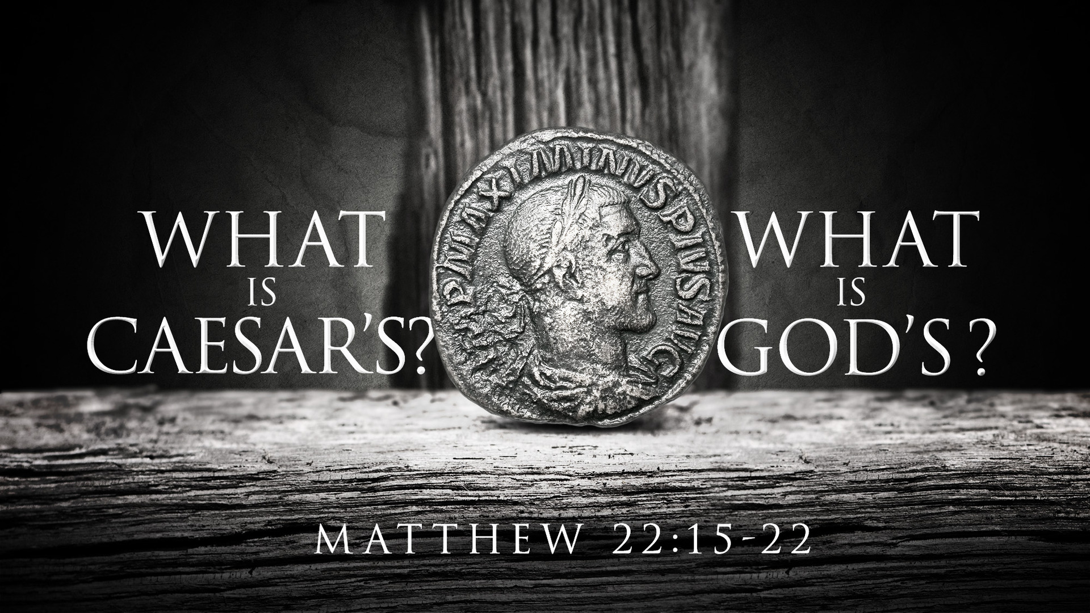
Synopsis:
The line between who owns what can get blurred so we should always remember that God owns it all.
What Belongs to the World
Matthew 6:19–21 ESV
“Do not lay up for yourselves treasures on earth, where moth and rust destroy and where thieves break in and steal, but lay up for yourselves treasures in heaven, where neither moth nor rust destroys and where thieves do not break in and steal. For where your treasure is, there your heart will be also.
1 Corinthians 6:9–11 ESV
Or do you not know that the unrighteous will not inherit the kingdom of God? Do not be deceived: neither the sexually immoral, nor idolaters, nor adulterers, nor men who practice homosexuality, nor thieves, nor the greedy, nor drunkards, nor revilers, nor swindlers will inherit the kingdom of God. And such were some of you. But you were washed, you were sanctified, you were justified in the name of the Lord Jesus Christ and by the Spirit of our God.
1 Corinthians 15:50 ESV
I tell you this, brothers: flesh and blood cannot inherit the kingdom of God, nor does the perishable inherit the imperishable.
Galatians 5:19–21 ESV
Now the works of the flesh are evident: sexual immorality, impurity, sensuality, idolatry, sorcery, enmity, strife, jealousy, fits of anger, rivalries, dissensions, divisions, envy, drunkenness, orgies, and things like these. I warn you, as I warned you before, that those who do such things will not inherit the kingdom of God.

What Belongs to You
Matthew 12:36 ESV
I tell you, on the day of judgment people will give account for every careless word they speak,
Revelation 20:13 ESV
And the sea gave up the dead who were in it, Death and Hades gave up the dead who were in them, and they were judged, each one of them, according to what they had done.
Romans 2:15–16 ESV
They show that the work of the law is written on their hearts, while their conscience also bears witness, and their conflicting thoughts accuse or even excuse them on that day when, according to my gospel, God judges the secrets of men by Christ Jesus.
What Belongs to God
Exodus 9:29 ESV
Moses said to him, “As soon as I have gone out of the city, I will stretch out my hands to the LORD. The thunder will cease, and there will be no more hail, so that you may know that the earth is the LORD’s.
Exodus 19:5 ESV
Now therefore, if you will indeed obey my voice and keep my covenant, you shall be my treasured possession among all peoples, for all the earth is mine;
Deuteronomy 10:14 ESV
Behold, to the LORD your God belong heaven and the heaven of heavens, the earth with all that is in it.
Job 41:11 ESV
Who has first given to me, that I should repay him?
Whatever is under the whole heaven is mine.
Psalm 24:1 ESV
The earth is the LORD’s and the fullness thereof,
the world and those who dwell therein,
Psalm 50:7–12 ESV
“Hear, O my people, and I will speak;
O Israel, I will testify against you.
I am God, your God.
Not for your sacrifices do I rebuke you;
your burnt offerings are continually before me.
I will not accept a bull from your house
or goats from your folds.
For every beast of the forest is mine,
the cattle on a thousand hills.
I know all the birds of the hills,
and all that moves in the field is mine.
“If I were hungry, I would not tell you,
for the world and its fullness are mine.
Psalm 89:11 ESV
The heavens are yours; the earth also is yours;
the world and all that is in it, you have founded them.
1 Corinthians 10:26 ESV
For “the earth is the Lord’s, and the fullness thereof.”
Hear - Romans 10:17 (NIV)
¹⁷ Consequently, faith comes from hearing the message, and the message is heard through the word about Christ.
Believe - Hebrews 11:6 (NIV)
⁶ And without faith it is impossible to please God, because anyone who comes to him must believe that he exists and that he rewards those who earnestly seek him.
Repent - Acts 17:30 (NIV)
³⁰ In the past God overlooked such ignorance, but now he commands all people everywhere to repent.
Confess - Matthew 10:32–33 (NIV)
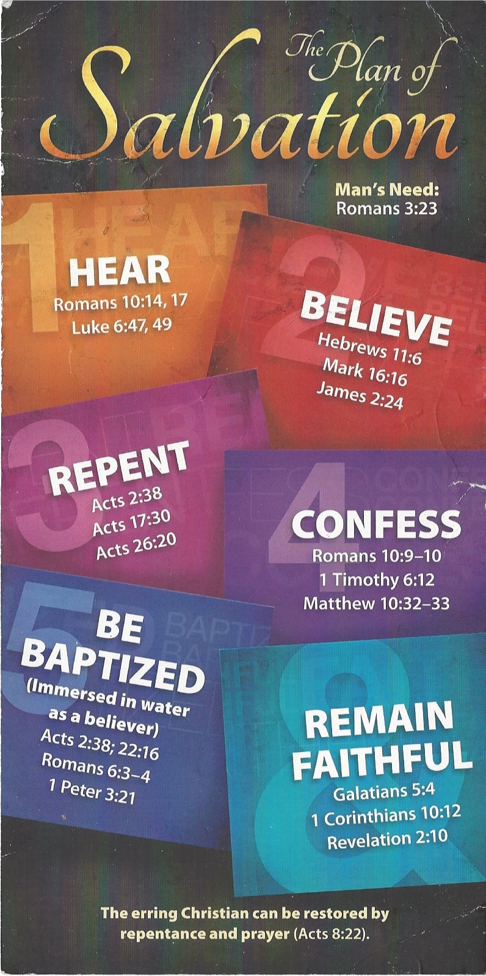
³² “Whoever acknowledges me before others, I will also acknowledge before my Father in heaven. ³³ But whoever disowns me before others, I will disown before my Father in heaven.
Be Baptized - Acts 22:16 (NIV)
¹⁶ And now what are you waiting for? Get up, be baptized and wash your sins away, calling on his name.’
Remain Steadfast - Revelation 2:10 (NIV)
¹⁰ Do not be afraid of what you are about to suffer. I tell you, the devil will put some of you in prison to test you, and you will suffer persecution for ten days. Be faithful, even to the point of death, and I will give you life as your victor’s crown.

