Barry G. Johnson, Sr. / www.bgjsr22.com
Christian is Reality / Realism; Truth; Fact; Faithfulness; Lie; Gospel of Truth / John 18:37–38
Scripture encompasses the idea of truth as reality, as well as the concepts of faithfulness and reliability. Jesus Christ is shown as “the Truth” and the Apostles present the Gospel as “Truth”.
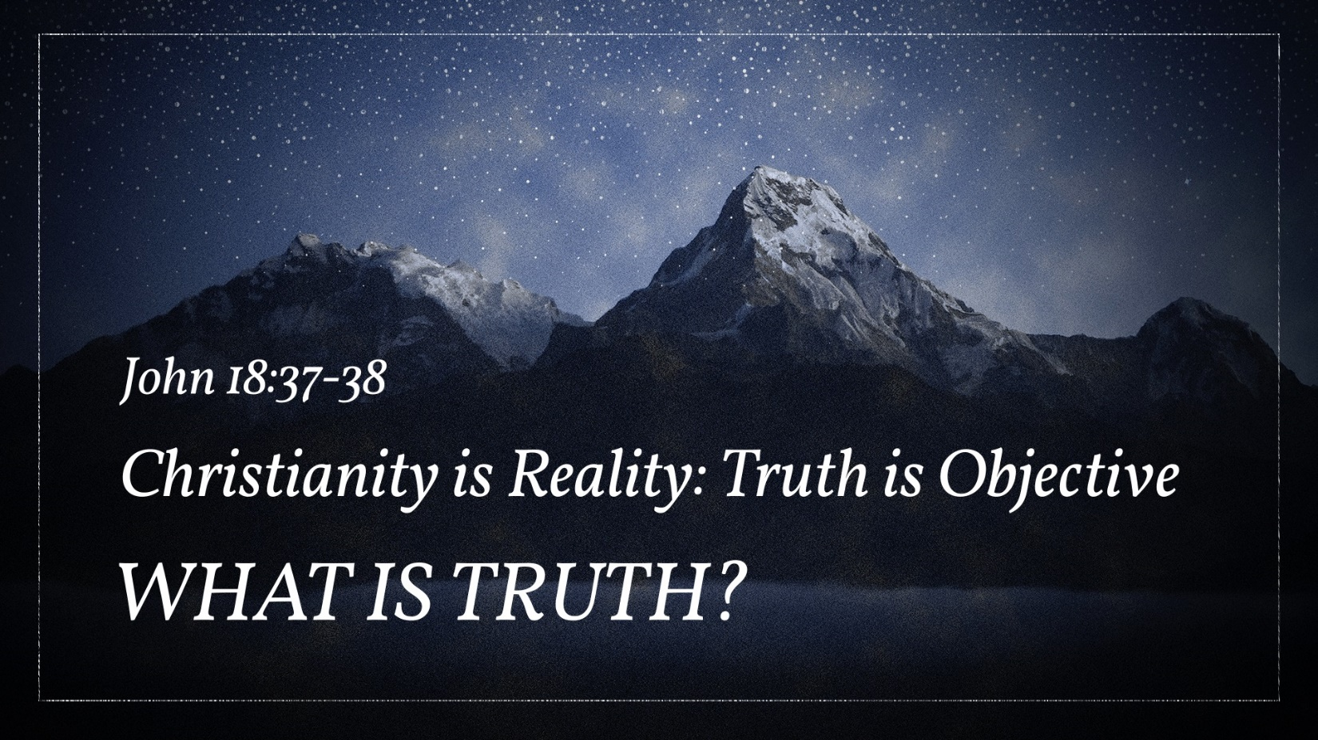
John 18:37–38 ESV
³⁷ Then Pilate said to him, “So you are a king?” Jesus answered, “You say that I am a king. For this purpose I was born and for this purpose I have come into the world—to bear witness to the truth. Everyone who is of the truth listens to my voice.” ³⁸ Pilate said to him, “What is truth?”
After he had said this, he went back outside to the Jews and told them, “I find no guilt in him.

Truth versus Falsehood
Ephesians 4:25 ESV
²⁵ Therefore, having put away falsehood, let each one of you speak the truth with his neighbor, for we are members one of another.

Truth as Reality
Hebrews 9:24 ESV
²⁴ For Christ has entered, not into holy places made with hands, which are copies of the true things, but into heaven itself, now to appear in the presence of God on our behalf.

Truth as Affirmations
John 6:47 ESV
⁴⁷ Truly, truly, I say to you, whoever believes has eternal life.

Truth as Reliability

The quality of truth
Philippians 4:8 ESV
⁸ Finally, brothers, whatever is true, whatever is honorable, whatever is just, whatever is pure, whatever is lovely, whatever is commendable, if there is any excellence, if there is anything worthy of praise, think about these things.

Truth and the Character of God
Romans 3:3–4 ESV
³ What if some were unfaithful? Does their faithlessness nullify the faithfulness of God? ⁴ By no means! Let God be true though every one were a liar, as it is written,
“That you may be justified in your words,
and prevail when you are judged.”

Truth as a human quality
1 John 1:8 ESV
⁸ If we say we have no sin, we deceive ourselves, and the truth is not in us.

Jesus Christ the Truth
John 14:6 ESV
⁶ Jesus said to him, “I am the way, and the truth, and the life. No one comes to the Father except through me.

The Spirit of God as truth
John 16:13 ESV
¹³ When the Spirit of truth comes, he will guide you into all the truth, for he will not speak on his own authority, but whatever he hears he will speak, and he will declare to you the things that are to come.

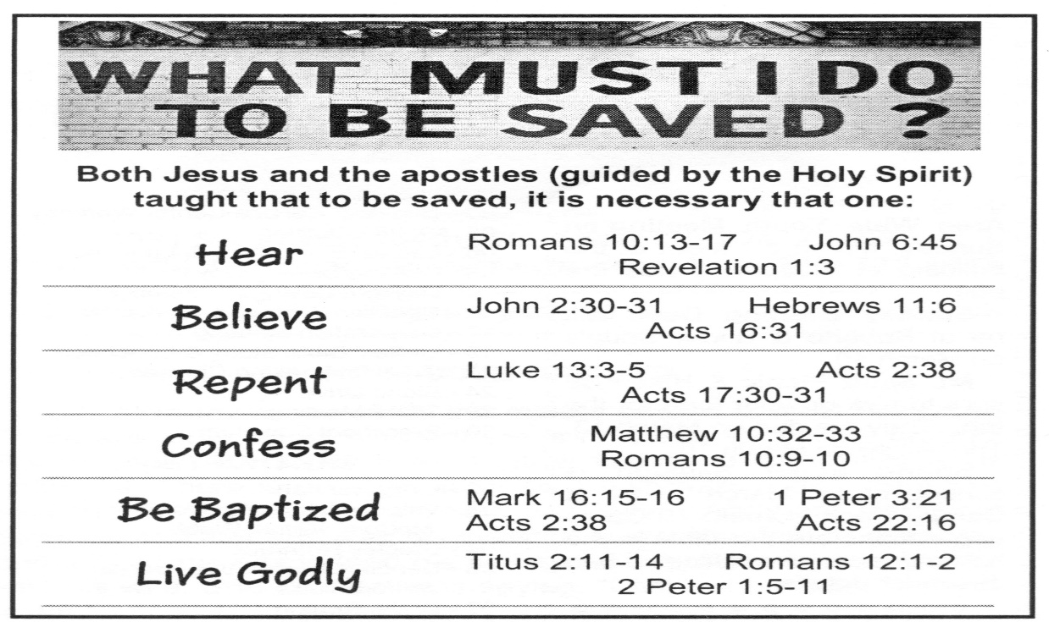
The Gospel and Christian Faith as Truth
Ephesians 1:13 ESV
¹³ In him you also, when you heard the word of truth, the gospel of your salvation, and believed in him, were sealed with the promised Holy Spirit,
The Reality of Salvation the Eternal Life

