Where Am I in Fellowship with Others?
Barry G. Johnson, Sr. / www.barrygjohnsonsr.com
5 Questions about your Spiritual Growth / Spiritual growth; Fellowship / Acts 2:42–47
Scripture teaches how to improve Fellowship which in turn improves our Spiritual Growth.
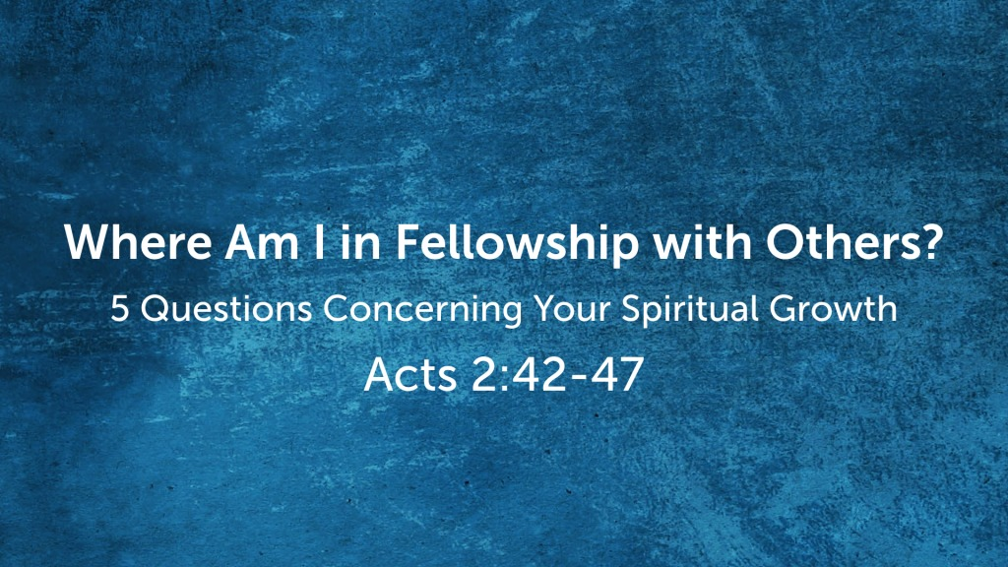
Acts 2:42–47 ESV
⁴² And they devoted themselves to the apostles’ teaching and the fellowship, to the breaking of bread and the prayers. ⁴³ And awe came upon every soul, and many wonders and signs were being done through the apostles. ⁴⁴ And all who believed were together and had all things in common. ⁴⁵ And they were selling their possessions and belongings and distributing the proceeds to all, as any had need. ⁴⁶ And day by day, attending the temple together and breaking bread in their homes, they received their food with glad and generous hearts, ⁴⁷ praising God and having favor with all the people. And the Lord added to their number day by day those who were being saved.
Psalm 133:1–3 ESV
¹ Behold, how good and pleasant it is
when brothers dwell in unity!
² It is like the precious oil on the head,
running down on the beard,
on the beard of Aaron,
running down on the collar of his robes!
³ It is like the dew of Hermon,
which falls on the mountains of Zion!
For there the Lord has commanded the blessing,
life forevermore.
John 13:35 ESV
³⁵ By this all people will know that you are my disciples, if you have love for one another.”

I. Bible Teaching leads to Bible Fellowship
Fellowship. The essence of the Christian life—fellowship with God and fellowship with other believers in Christ.
John 14:20 ESV
²⁰ In that day you will know that I am in my Father, and you in me, and I in you.
John 14:21 ESV
²¹ Whoever has my commandments and keeps them, he it is who loves me. And he who loves me will be loved by my Father, and I will love him and manifest myself to him.”
1 John 1:3 ESV
³ that which we have seen and heard we proclaim also to you, so that you too may have fellowship with us; and indeed our fellowship is with the Father and with his Son Jesus Christ.
Mark 14:22–25 ESV
²² And as they were eating, he took bread, and after blessing it broke it and gave it to them, and said, “Take; this is my body.” ²³ And he took a cup, and when he had given thanks he gave it to them, and they all drank of it. ²⁴ And he said to them, “This is my blood of the covenant, which is poured out for many. ²⁵ Truly, I say to you, I will not drink again of the fruit of the vine until that day when I drink it new in the kingdom of God.”

II. Divine principles for enhancing Fellowship

(1) Love one another with the same compassion that Christ displayed to his own (Jn 13:34, 35; 15:12). The law of the fellowship should be the rule of love (Heb 13:1).

(2) Cultivate that spirit of humility that seeks the other person’s honor (Phil 2:3–5).

(3) Lighten fellow believers’ load by bearing one another’s burdens (Gal 6:2).

(4) Share material blessings with brothers and sisters in need (2 Cor 9:13).

(5) Tenderly correct a sinner while helping to find solutions to the problems (Gal 6:1).

(6) Minister to a fellow believer in times of suffering (1 Cor 12:26).

(7) Pray for one another in the Spirit without ceasing (Eph 6:18).

III. Bible Fellowship adds to the number of those being saved

God’s Invitation and Plan of Salvation

Hear - Romans 10:17

Believe and Confess - Romans 10:9-10

Repent - Luke 13:3

Be Baptized - Acts 2:38

Remain Faithful - Revelation 2:10
New to the Faith?
• First Principles
Have you fallen away from Faith
• Need to be Restored
My Decision Today
• I would like to be baptized today I would like to renew my life to Christ
• I would like to learn more about Jesus and the Bible
Questions: What are my next steps?
• Come forward to be baptized
• Request a Bible Study to learn more
• Attend Bible Class to grow and mature
• Find a place to serve others
• Apply today’s lesson to my life

