Barry G. Johnson, Sr. / www.barrygjohnsonsr.com
5 Questions Concerning Your Spiritual Growth / Spiritual; Mature; God: Knowledge; Knowledge; Obey; Follow; Follow Christ; Assurance / Genesis 3:1–13; Psalm 139:1–24
God's knowledge of you, along with your knowledge of God can help you determine where you are at with God.
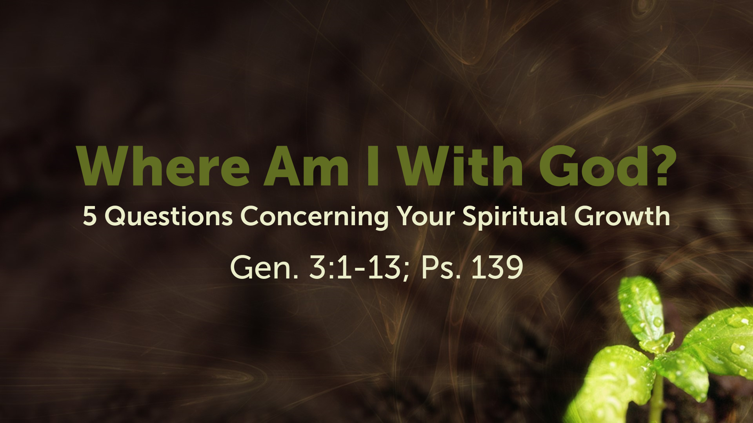

Introduction
5 Questions concerning your spiritual growth
1. Where am I with God?
2. Where am I with God’s Word?
3. Where am I in terms of worshipping God?
4. Where am I in fellowship with others?
5. Where am I in terms of Evangelism?

I. As far as God knowing me

A. God has intimate knowledge of us
Luke 12:6-7

B. God is Omniscient; Omnipresent and Omniscient
Psalm 139:1-24

II. As far as me knowing God

A. We know God by what He said.
Genesis 3:1-13

B. We know God by our love for Him.
Matthew 6:24

III. As far as me obeying/following God

A. Obedience produces listening
John 9:31

B. Obedience fosters love for God
1 John 2:5
Questions not to ask to know where you are with God...
1. How rich am I?
2. How healthy am I?
3. How many enemies do I have?
4. How often does God say yes to me?
5. How important am I?

God’s Invitation and Plan of Salvation

Hear - Romans 10:17

Believe and Confess - Romans 10:9-10

Repent - Luke 13:3

Be Baptized - Acts 2:38

Remain Faithful - Revelation 2:10
New to the Faith?
- First Principles
Have you fallen away from Faith
- Need to be Restored
My Decision Today
- I would like to be baptized today
- I would like to renew my life to Christ
- I would like to learn more about Jesus and the Bible
Questions: What are my next steps?
- Come forward to be baptized
- Request a Bible Study to learn more
- Attend Bible Class to grow and mature
- Find a place to serve others
- Apply today’s lesson to my life

