Barry G. Johnson, Sr. / www.barrygjohnsonsr.com or www.bgjsr22.com
Christianity is Reality: The Hell of Scripture / Hell; Heaven; Truth; Scripture; Void; Empty / Jeremiah 4:22–23
God is the reality, and those not accepting reality have chosen Hell.
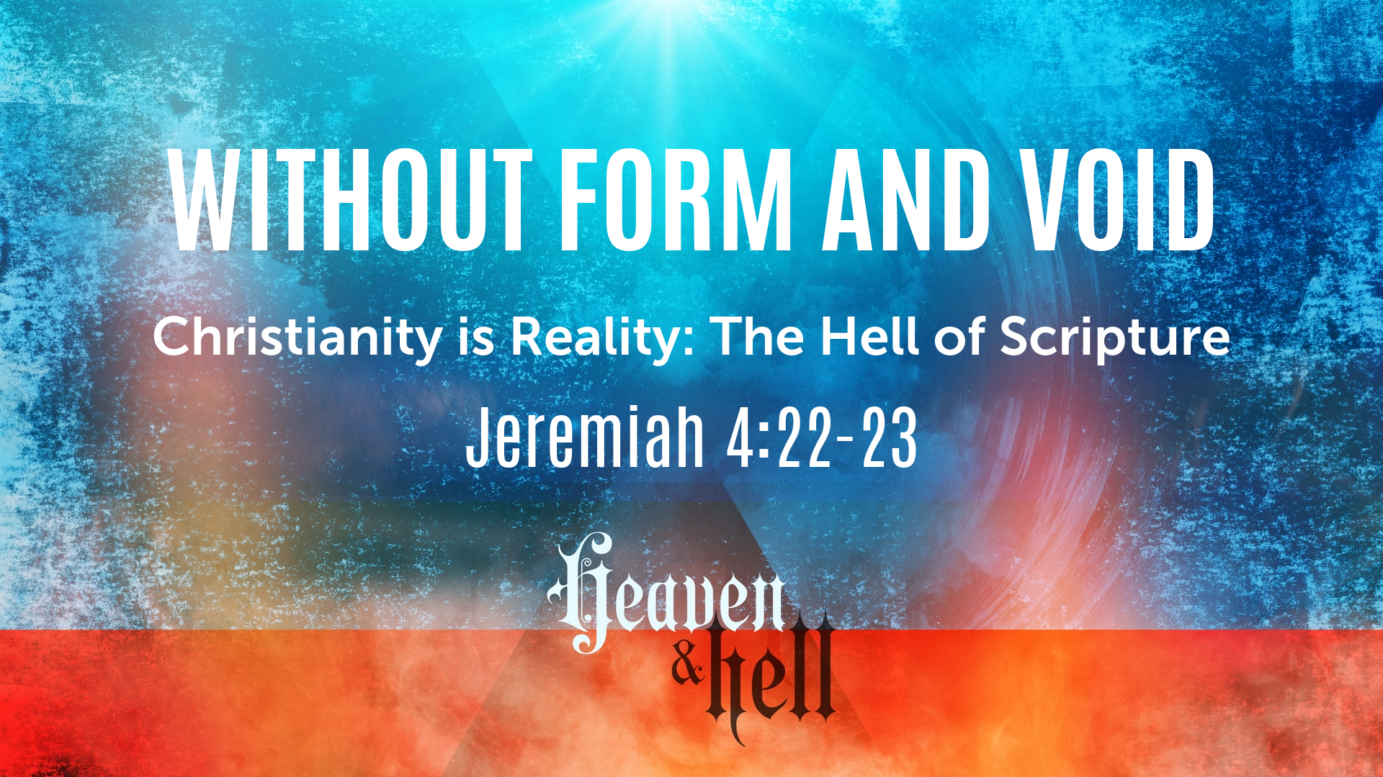
Jeremiah 4:22–23 ESV
“For my people are foolish; they know me not; they are stupid children; they have no understanding. They are ‘wise’—in doing evil! But how to do good they know not.” I looked on the earth, and behold, it was without form and void; and to the heavens, and they had no light.

Humanities attempt at Fulfillment Without God

Work
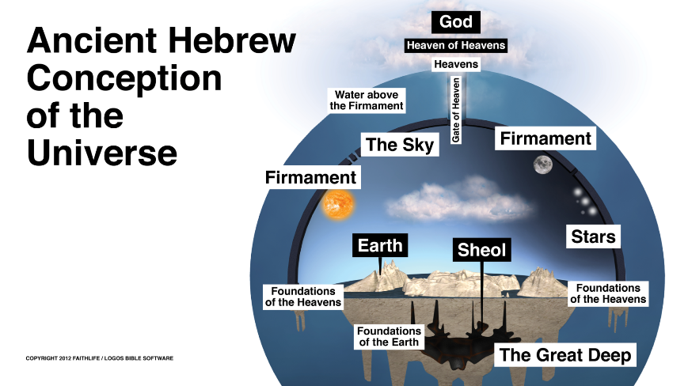
Psalm 127:1–2 ESV
¹ Unless the Lord builds the house,
those who build it labor in vain.
Unless the Lord watches over the city,
the watchman stays awake in vain.
² It is in vain that you rise up early
and go late to rest,
eating the bread of anxious toil;
for he gives to his beloved sleep.
Haggai 1:5–6 ESV
⁵ Now, therefore, thus says the Lord of hosts: Consider your ways. ⁶ You have sown much, and harvested little. You eat, but you never have enough; you drink, but you never have your fill. You clothe yourselves, but no one is warm. And he who earns wages does so to put them into a bag with holes.

Pleasure
Job 20:5 ESV
⁵ that the exulting of the wicked is short,
and the joy of the godless but for a moment?
Proverbs 21:17 ESV
¹⁷ Whoever loves pleasure will be a poor man;
he who loves wine and oil will not be rich.

Wealth
Ecclesiastes 5:10 ESV
¹⁰ He who loves money will not be satisfied with money, nor he who loves wealth with his income; this also is vanity.
Luke 12:15 ESV
¹⁵ And he said to them, “Take care, and be on your guard against all covetousness, for one’s life does not consist in the abundance of his possessions.”
1 Timothy 6:9–10 ESV
⁹ But those who desire to be rich fall into temptation, into a snare, into many senseless and harmful desires that plunge people into ruin and destruction. ¹⁰ For the love of money is a root of all kinds of evils. It is through this craving that some have wandered away from the faith and pierced themselves with many pangs.

Material Possessions are Unreliable
Luke 12:18–20 ESV
¹⁸ And he said, ‘I will do this: I will tear down my barns and build larger ones, and there I will store all my grain and my goods. ¹⁹ And I will say to my soul, “Soul, you have ample goods laid up for many years; relax, eat, drink, be merry.” ’ ²⁰ But God said to him, ‘Fool! This night your soul is required of you, and the things you have prepared, whose will they be?’
1 Timothy 6:7 ESV
⁷ for we brought nothing into the world, and we cannot take anything out of the world.

False Religion
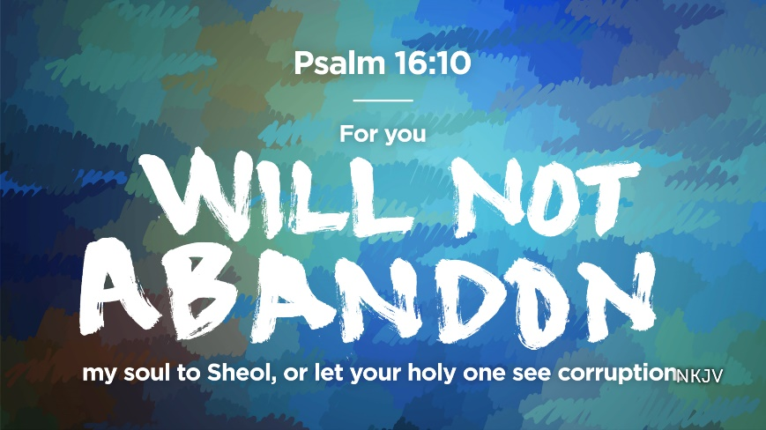
Isaiah 57:13 ESV
¹³ When you cry out, let your collection of idols deliver you!
The wind will carry them all off,
a breath will take them away.
But he who takes refuge in me shall possess the land
and shall inherit my holy mountain.

2 Peter 3:10 ESV
¹⁰ But the day of the Lord will come like a thief, and then the heavens will pass away with a roar, and the heavenly bodies will be burned up and dissolved, and the earth and the works that are done on it will be exposed.

God’s Plan of Salvation
