Barry G. Johnson, Sr. / www.barrygjohnsonsr.com
Proverbs / Wisdom; Instruct; Knowledge; Proverb / Proverbs 1:1–6
Central Idea: The fear of the Lord is the beginning of knowledge, an introduction.
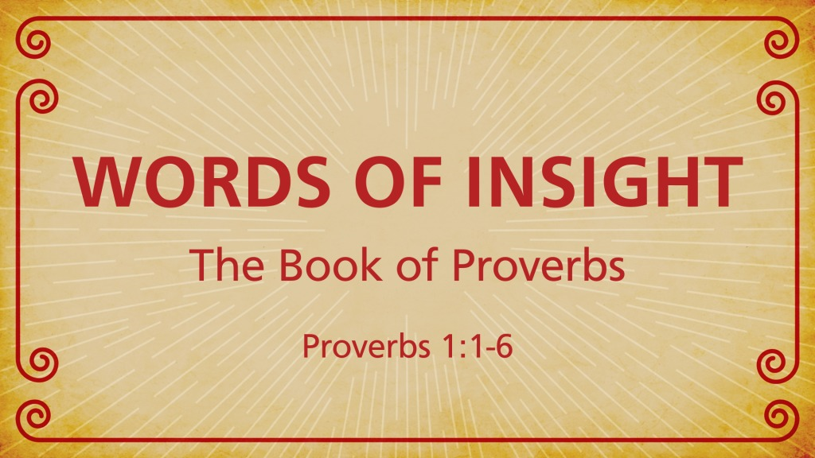
Proverbs 1:1–6 ESV
¹ The proverbs of Solomon, son of David, king of Israel: ² To know wisdom and instruction, to understand words of insight, ³ to receive instruction in wise dealing, in righteousness, justice, and equity; ⁴ to give prudence to the simple, knowledge and discretion to the youth— ⁵ Let the wise hear and increase in learning, and the one who understands obtain guidance, ⁶ to understand a proverb and a saying, the words of the wise and their riddles.
INTRODUCTION

1. There is a great need for wisdom in our society today…

2. The walk of the Christian is to be with wisdom as we go through life… - Ep 5:15-17

3. The Word of God equips man unto every good work… - 2 Ti 3:16-17

4. The book begins by identifying Solomon, son of David, king of Israel, as the author…

5. The book also contains proverbs and wisdom from other sources…

I. THE PURPOSE OF THE BOOK

A. STATED IN THE FIRST SIX VERSES...

1. “To know wisdom and instruction, to perceive the words of understanding”

2. “To receive the instruction of wisdom, justice, judgment, and equity”

B. THE BOOK IS DESIGNED...

To make a person wise!

II. THE DEFINITION AND VALUE OF WISDOM

A. DEFINING WISDOM...

1. “Wisdom...may be defined as a realistic approach to the problems of life...” - 20th Century Encyclopedia of Religious Knowledge

2. Homer Hailey offered this definition of wisdom: “Wisdom is insight into the underlying causes and significance or consequence of things, which insight enables one to apply to the best end the knowledge which he has.”

B. VALUATING WISDOM...

1. The first nine chapters of Proverbs are discourses extolling the value of wisdom

2. The virtue of wisdom is seen in the prosperous life it can produce - Pro 3:13-18

3. Its value is also found in guarding us against many pitfalls - Pro 3:21-26

4. Some “pitfalls” frequently warned against in The Book of Proverbs:

III.THE VALUE OF THE BOOK

A. WISDOM COMES FROM TWO SOURCES...

1. Trial and error (personal experience)

2. Counsel from others (proven experience)

B. THIS MAKES THE BOOK OF PROVERBS VALUABLE...

1. Instead of wasting our short time here on earth trying to discover wisdom through the process of trial and error, we can go straight to The Book Of Proverbs

2. There we can find wisdom that is:

3. Yes, the value of The Book Of Proverbs is that it provides the wisdom of God Himself!
Proverbs 1:7 ESV
⁷ The fear of the Lord is the beginning of knowledge; fools despise wisdom and instruction.
Colossians 2:3 ESV
³ in whom are hidden all the treasures of wisdom and knowledge.
The Wise Plan of Salvation
1. Hear - Rom. 10:17
2. Believe - Heb. 11:6
3. Repent - Acts 17:30
4. Confess - Mt. 10:32-33
5. Be Baptized - Acts 2:38
6. Remain Faithful - Rev. 2:10

